

CAPSTONE PROJECT REPORT
Report 4 - Software Design Document

- Ho Chi Minh, June 2026 -

Table of Contents
I. Record of Changes 3
II. Software Design Document 4
1. System Design 4
1.1 System Architecture 4
1.2 Package Diagram 4
2. Database Design 7
3. Detailed Design 20
3.1 Authentication Management 20
3.2 Profile Management 26
3.3 User and Role Management 29
3.4 HR Company Management 34
3.5 Job Description Management 39
3.6 Knowledge Base Management 44
3.7 AI Question Generation Management 49
3.8 Question Set Management 53
3.9 Marketplace Management 56
3.10 Practice Session Management 60
3.11 AI Answer Evaluation and Feedback Management 64
3.12 Candidate-HR Contact Management 68
3.13 HR Analytics Management 69
3.14 RAG Quality Evaluation Management 69
3.15 Subscription and Payment Management 75
3.16 Audit Log and Error Handling Management 76
3.17 System Configuration Management 78

I. Record of Changes
Date | A*  M, D | In charge | Change Description
15/07/2026 | A | NamNM | Initiate document; define Software Design Description structure
18/07/2026 | A | TuPT | Added System Architecture section (high-level component diagram, technology stack)
21/07/2026 | A | HienNT | Added Package Diagram and module dependency overview
24/07/2026 | A | KhoaHD | Added Database Design - Roles, Users, and Authentication-related tables
27/07/2026 | A | NamNM | Added Database Design - HR Company, Job Description, and Knowledge Base tables
30/07/2026 | A | TuPT | Added Database Design - Question Generation, Question Set, and Marketplace tables
02/08/2026 | A | HienNT | Added Detailed Design for Authentication, Profile, and User/Role Management modules
05/08/2026 | A | KhoaHD | Added Detailed Design for HR Company, Job Description, and Knowledge Base Management modules
07/08/2026 | A | NamNM | Added Detailed Design for AI Question Generation, Question Set, and Marketplace Management modules
09/08/2026 | A | TuPT | Added Detailed Design for Practice Session, AI Answer Evaluation, and Candidate-HR Contact Management modules
11/08/2026 | A | HienNT | Added Detailed Design for HR Analytics, RAG Quality Evaluation, and Subscription and Payment Management modules
13/08/2026 | M | KhoaHD | Added Detailed Design for Notification, Audit Log, and System Configuration Management modules; updated database ER references
14/08/2026 | M | NamNM | Review and finalize Software Design Description before submission
*A - Added M - Modified D - Deleted

II. Software Design Document

1. System Design

1.1 System Architecture

The system's Software Architecture uses a Client-Server model including a Frontend (React/Next.js SPA deployed on Cloudflare Workers) and a Backend (ASP.NET Core 8 Web API), integrated with a Python RAG microservice (FastAPI), an Azure PostgreSQL database with pgvector, Hangfire background workers, and external services including Google OAuth, Gmail SMTP, Ollama (LLM and embeddings), and Azure Blob Storage.
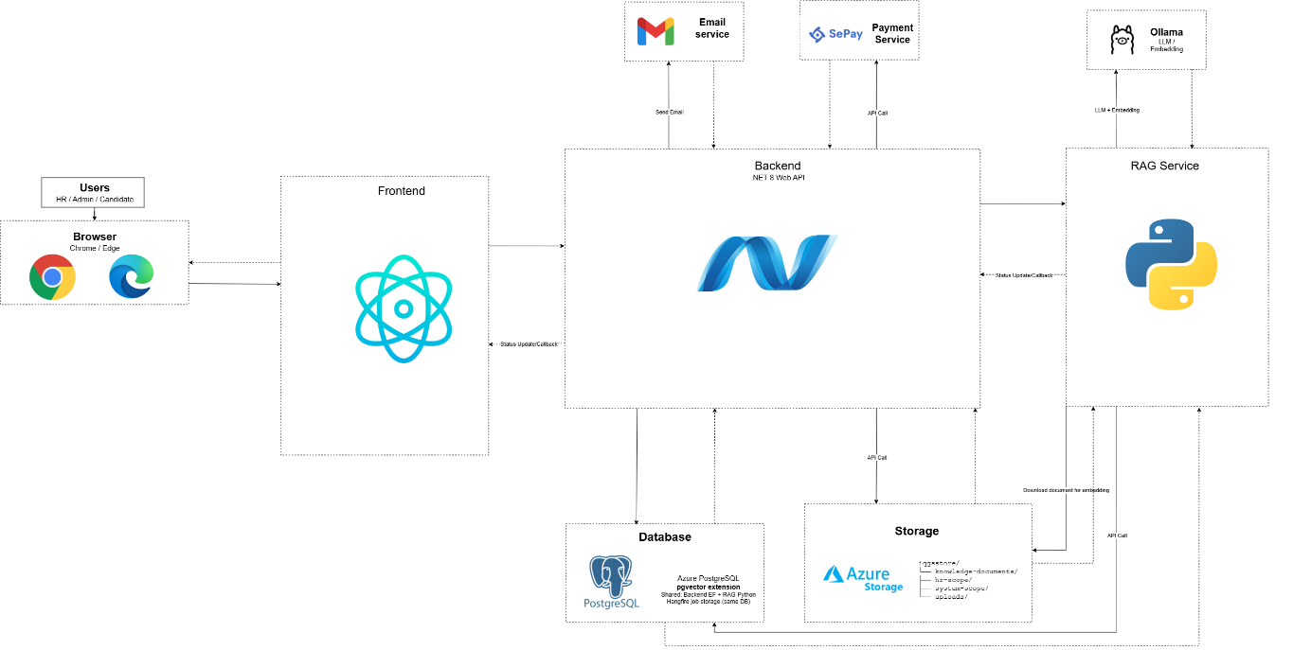

Figure 1.1: Software Architecture (Link)

1.2 Package Diagram

1.2.1 Front-end Package Diagram

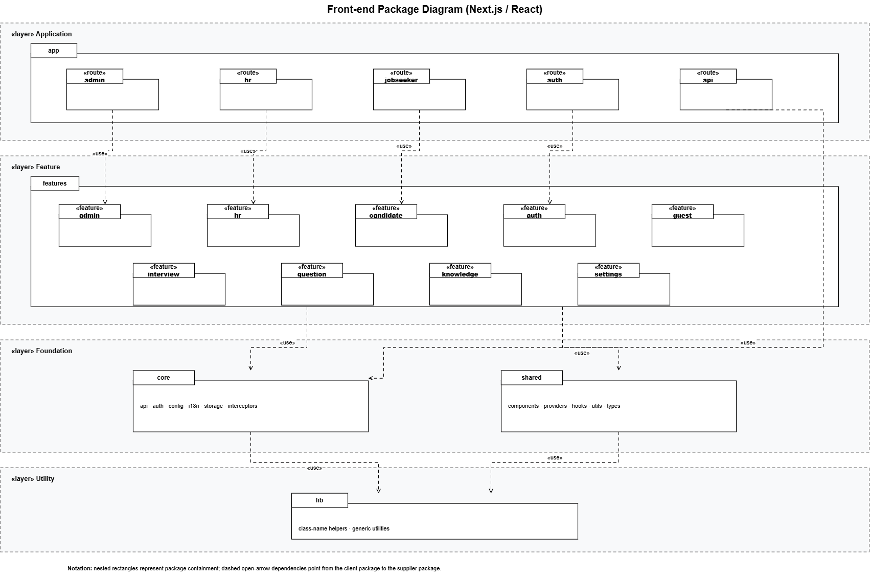
Figure 1.2.1: Front-end Package Diagram (Link)

1.2.2 Back-end Package Diagram
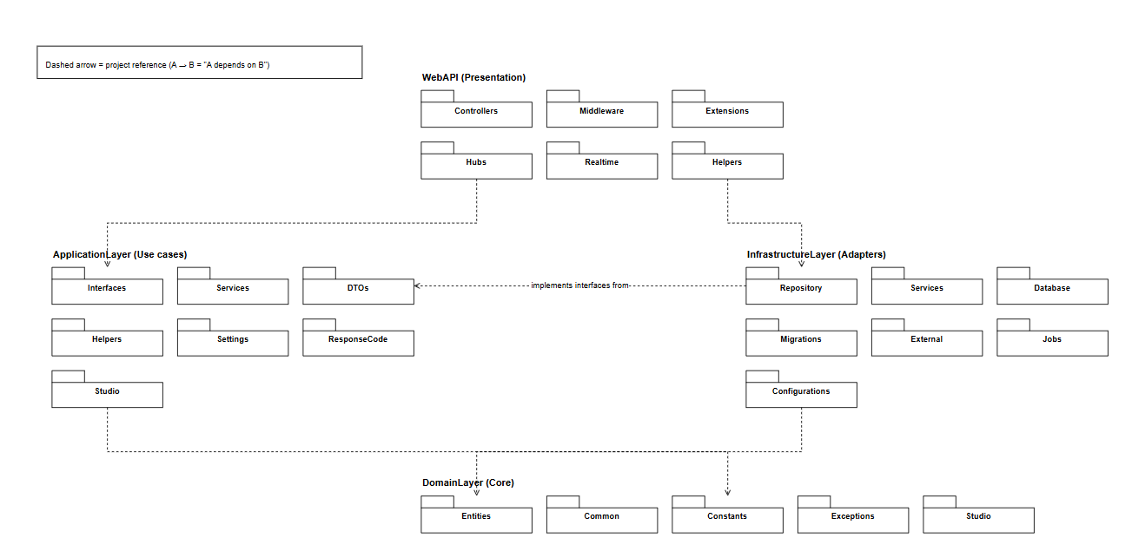
Figure 1.2.2: Back-end Package Diagram (Link)

1.2.3 AI/RAG Service Package Diagram
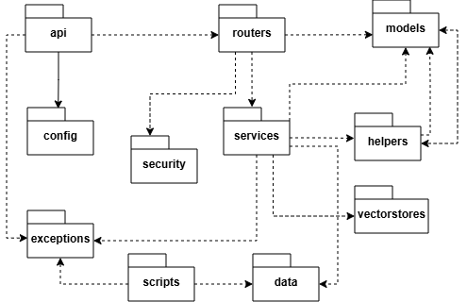
Figure 1.2.3: AI/RAG Service Package Diagram (Link)

Package Descriptions
No | Package | Description
1 | api | Starts the FastAPI app and sets up the RAG service.
2 | routers | Defines internal APIs for the Backend to call.
3 | services | Handles core logic: ingest, retrieval, plan, and question generation.
4 | models | Defines API request and response data structures.
5 | vectorstores | Stores and searches embeddings in PostgreSQL pgvector.
6 | config | Manages environment settings such as DB, Ollama, and API key.
7 | security | Validates the Internal API Key before processing requests.
8 | helpers | Helper functions for JD validation, text chunking, and file parsing.
9 | exceptions | Defines common errors used in the ingest flow.
10 | data | Sample data for testing (system, hr).
11 | scripts | Scripts for DB checks and manual testing.

2. Database Design
The following figure illustrates the database design of the system and provides a detailed description of each table. Tables 1.3.20-1.3.23 describe four additional entities introduced for HR JD-fit review and Candidate AI Coach (personal question-set generation jobs and per-skill improvement plans). Physical table names use the tbl_ prefix.

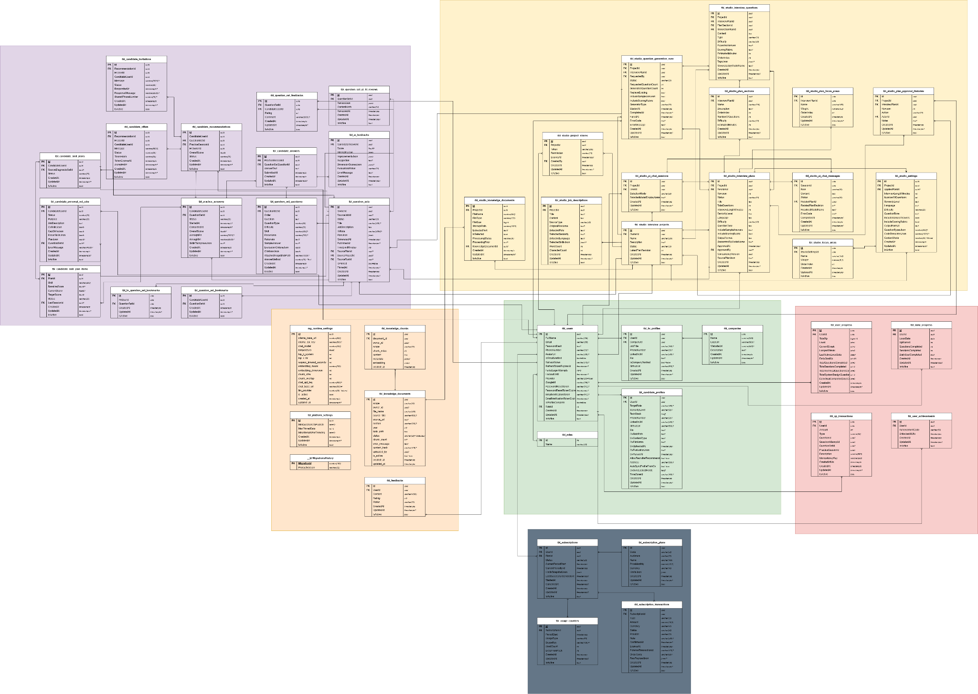
Figure 2: Database Design Diagram (Link)
1.3.1 Roles
No | Field | Type | PK | FK | UN | NN | Description
1 | Id | int | x |  |  | x | Primary key (seed: 1=Admin, 2=HR, 3=Candidate)
2 | Name | varchar |  |  | x | x | Role name (unique)
Table 1.3.1: Roles table
1.3.2 Users
No | Field | Type | PK | FK | UN | NN | Description
1 | Id | uuid | x |  |  | x | Primary key
2 | FullName | varchar |  |  |  | x | Full name
3 | Email | varchar |  |  | x | x | Login email (unique)
4 | PasswordHash | varchar |  |  |  |  | BCrypt hash. Null nếu Google OAuth
5 | PhoneNumber | varchar |  |  |  |  | Optional phone number
6 | AvatarUrl | varchar |  |  |  |  | Avatar image URL
7 | RoleId | int |  | x |  | x | FK → Roles.Id. Restrict delete
8 | IsEmailVerified | bool |  |  |  | x | Whether email is verified
9 | RefreshToken | varchar |  |  |  |  | Current JWT refresh token
10 | RefreshTokenExpiresAt | timestamptz |  |  |  |  | Refresh token expiry time
11 | FailedLoginAttempts | int |  |  |  | x | Consecutive failed login attempts
12 | LockoutUntil | timestamptz |  |  |  |  | Account unlock time
13 | Provider | varchar |  |  |  | x | 'local' | 'google'
14 | GoogleId | varchar |  |  | x |  | Google subject ID (unique, nullable)
15 | PasswordResetToken | varchar |  |  |  |  | SHA-256 hash token reset password
16 | PasswordResetTokenExpiresAt | timestamptz |  |  |  |  | Hạn sử dụng reset token
17 | EmailVerificationToken | varchar |  |  |  |  | SHA-256 hash token verify email
18 | EmailVerificationTokenExpiresAt | timestamptz |  |  |  |  | Hạn sử dụng verify token
19 | IsProfileComplete | bool |  |  |  | x | Profile đã điền đủ thông tin chưa
20 | CreatedAt | timestamptz |  |  |  | x | Created timestamp
21 | UpdatedAt | timestamptz |  |  |  |  | Last updated timestamp
22 | IsActive | bool |  |  |  | x | Whether account is active
Table 1.3.2: Users table
1.3.3 Companies
No | Field | Type | PK | FK | UN | NN | Description
1 | Id | uuid | x |  |  | x | Primary key
2 | Name | varchar |  |  |  | x | Company name
3 | LogoUrl | varchar |  |  |  |  | Company logo URL
4 | WebsiteUrl | varchar |  |  |  |  | Official website URL
5 | Description | text |  |  |  |  | Company description
6 | CreatedAt | timestamptz |  |  |  | x | Created timestamp
7 | UpdatedAt | timestamptz |  |  |  |  | Updated timestamp
8 | IsActive | bool |  |  |  | x | Whether record is active
Table 1.3.3: Companies table
1.3.4 HRProfiles
No | Field | Type | PK | FK | UN | NN | Description
1 | Id | uuid | x |  |  | x | Primary key
2 | UserId | uuid |  | x | x | x | FK → Users.Id (unique, cascade delete)
3 | CompanyId | uuid |  | x |  | x | FK → Companies.Id (restrict delete)
4 | JobTitle | varchar |  |  |  |  | Job title: Recruiter, HR Manager, etc.
5 | PhoneNumber | varchar |  |  |  |  | HR phone number
6 | LinkedInUrl | varchar |  |  |  |  | LinkedIn profile URL
7 | Bio | text |  |  |  |  | Short biography
8 | IsCompanyVerified | bool |  |  |  | x | Whether admin verified company membership
9 | CreatedAt | timestamptz |  |  |  | x | Created timestamp
10 | UpdatedAt | timestamptz |  |  |  |  | Updated timestamp
11 | IsActive | bool |  |  |  | x | Whether record is active
Table 1.3.4: HRProfiles table
1.3.5 CandidateProfiles
No | Field | Type | PK | FK | UN | NN | Description
1 | Id | uuid | x |  |  | x | Primary key
2 | UserId | uuid |  | x | x | x | FK → Users.Id (unique, cascade delete)
3 | TargetRole | varchar |  |  |  |  | Target role: Backend Dev, Frontend Dev, etc.
4 | SeniorityLevel | varchar |  |  |  |  | Intern|Fresher|Junior|Middle|Senior
5 | TechStack | text[] |  |  |  | x | Mảng kỹ thuật: ['React','TypeScript',...]
6 | PhoneNumber | varchar |  |  |  |  | Phone number
7 | LinkedInUrl | varchar |  |  |  |  | LinkedIn profile
8 | GithubUrl | varchar |  |  |  |  | GitHub profile
9 | Bio | text |  |  |  |  | Self introduction
10 | CreatedAt | timestamptz |  |  |  | x | Created timestamp
11 | UpdatedAt | timestamptz |  |  |  |  | Updated timestamp
12 | IsActive | bool |  |  |  | x | Whether record is active
Table 1.3.5: CandidateProfiles table
1.3.6 knowledge_documents
No | Field | Type | PK | FK | UN | NN | Description
1 | Id | uuid | x |  |  | x | Primary key
2 | scope | varchar |  |  |  | x | 'SYSTEM' | 'HR'
3 | owner_id | uuid |  |  |  |  | NULL nếu SYSTEM; HR userId nếu scope=HR
4 | file_name | varchar |  |  |  | x | Original file name
5 | blob_path | varchar |  |  |  | x | Path on Azure Blob Storage
6 | content_hash | varchar |  |  |  |  | SHA-256 content hash for deduplication
7 | source_title | varchar |  |  |  |  | Academic document title
8 | source_url | varchar |  |  |  |  | Source document URL
9 | section | varchar |  |  |  |  | Chapter/section in document
10 | year | int |  |  |  |  | Publication year
11 | status | varchar |  |  |  | x | QUEUED|PROCESSING|COMPLETED|FAILED
12 | chunk_count | int |  |  |  |  | Number of ingested chunks
13 | uploaded_by | uuid |  |  |  | x | Soft FK → Users.Id (ai upload)
14 | error_message | text |  |  |  |  | Error message when status is FAILED
15 | created_at | timestamptz |  |  |  | x | Created timestamp
16 | updated_at | timestamptz |  |  |  |  | Updated timestamp
17 | is_active | bool |  |  |  | x | Whether record is active
Table 1.3.6: knowledge_documents table
1.3.7 knowledge_chunks
No | Field | Type | PK | FK | UN | NN | Description
1 | Id | uuid | x |  |  | x | Primary key
2 | document_id | uuid |  | x |  | x | FK → knowledge_documents.id (cascade delete)
3 | owner_id | uuid |  |  |  |  | Soft FK → Users.Id (tối ưu filter theo HR)
4 | scope | varchar |  |  |  | x | 'SYSTEM' | 'HR'
5 | chunk_index | int |  |  |  | x | Chunk order within document
6 | content | text |  |  |  | x | Text chunk content
7 | metadata | jsonb |  |  |  |  | Metadata: source, page, section...
8 | embedding | vector(768) |  |  |  |  | 768-dim embedding (nomic-embed-text). HNSW index cosine
9 | created_at | timestamptz |  |  |  | x | Created timestamp
Table 1.3.7: knowledge_chunks table
1.3.8 question_generation_jobs
No | Field | Type | PK | FK | UN | NN | Description
1 | Id | uuid | x |  |  | x | Primary key
2 | OwnerId | uuid |  |  |  | x | Soft FK → Users.Id (HR owner)
3 | JobDescription | text |  |  |  | x | Job description content
4 | HrNote | text |  |  |  |  | Additional HR note
5 | JdInputType | varchar |  |  |  | x | 'text' | 'file'
6 | JdFileName | varchar |  |  |  |  | JD file name when uploaded
7 | NumberOfQuestions | int |  |  |  | x | Number of questions to generate
8 | Difficulty | varchar |  |  |  | x | 'easy' | 'medium' | 'hard'
9 | QuestionTypesJson | jsonb |  |  |  | x | Mảng loại câu hỏi: ['technical','behavioral']
10 | SkillsJson | jsonb |  |  |  | x | JSON array of focus skills
11 | Status | varchar |  |  |  | x | PLAN_QUEUED|PLAN_PROCESSING|WAITING_HR_APPROVAL|QUESTION_QUEUED|QUESTION_PROCESSING|COMPLETED|FAILED|CANCELLED
12 | ErrorMessage | text |  |  |  |  | Error message when status is FAILED
13 | CompletedAt | timestamptz |  |  |  |  | Completion timestamp
14 | CreatedAt | timestamptz |  |  |  | x | Created timestamp
15 | UpdatedAt | timestamptz |  |  |  |  | Updated timestamp
16 | IsActive | bool |  |  |  | x | Whether record is active
Table 1.3.8: question_generation_jobs table
1.3.9 question_generation_plans
No | Field | Type | PK | FK | UN | NN | Description
1 | Id | uuid | x |  |  | x | Primary key
2 | JobId | uuid |  | x | x | x | FK → question_generation_jobs.Id (unique, cascade)
3 | PlanJson | jsonb |  |  |  | x | Interview plan JSON: topics, skills, distribution
4 | IsApproved | bool |  |  |  | x | Whether HR approved the plan
5 | ApprovedAt | timestamptz |  |  |  |  | Approval timestamp
6 | CreatedAt | timestamptz |  |  |  | x | Created timestamp
7 | UpdatedAt | timestamptz |  |  |  |  | Updated timestamp
8 | IsActive | bool |  |  |  | x | Whether record is active
Table 1.3.9: question_generation_plans table
1.3.10 generated_questions
No | Field | Type | PK | FK | UN | NN | Description
1 | Id | uuid | x |  |  | x | Primary key
2 | JobId | uuid |  | x |  | x | FK → question_generation_jobs.Id (cascade)
3 | Order | int |  |  |  | x | Question order in the set
4 | Question | text |  |  |  | x | Question text
5 | QuestionType | varchar |  |  |  | x | 'technical' | 'behavioral' | 'situational'
6 | Difficulty | varchar |  |  |  | x | 'easy' | 'medium' | 'hard'
7 | Skill | varchar |  |  |  |  | Related skill
8 | FocusArea | varchar |  |  |  |  | Focus area
9 | Rationale | text |  |  |  |  | Rationale for selecting this question
10 | SampleAnswer | text |  |  |  |  | Sample answer hint
11 | EvaluationCriteriaJson | jsonb |  |  |  | x | Tiêu chí đánh giá câu trả lời
12 | CitationsJson | jsonb |  |  |  | x | Nguồn knowledge base tham chiếu
13 | CreatedAt | timestamptz |  |  |  | x | Created timestamp
14 | UpdatedAt | timestamptz |  |  |  |  | Updated timestamp
15 | IsActive | bool |  |  |  | x | Whether record is active
Table 1.3.10: generated_questions table
1.3.11 question_sets
No | Field | Type | PK | FK | UN | NN | Description
1 | Id | uuid | x |  |  | x | Primary key
2 | OwnerId | uuid |  |  |  | x | Soft FK → Users.Id (HR owner)
3 | SourceJobId | uuid |  | x | x | x | FK → question_generation_jobs.Id (unique, restrict)
4 | Status | varchar |  |  |  | x | DRAFT (planned: PUBLISHED, ARCHIVED)
5 | Title | varchar |  |  |  |  | Question set title
6 | JobDescription | text |  |  |  | x | Reference job description
7 | HrNote | text |  |  |  |  | HR note when saving draft
8 | PlanJson | jsonb |  |  |  | x | Reference interview plan JSON
9 | GeneratedAt | timestamptz |  |  |  |  | Timestamp when AI generation completed
10 | CreatedAt | timestamptz |  |  |  | x | Draft saved timestamp
11 | UpdatedAt | timestamptz |  |  |  |  | Updated timestamp
12 | IsActive | bool |  |  |  | x | Whether record is active
Table 1.3.11: question_sets table
1.3.12 question_set_questions
No | Field | Type | PK | FK | UN | NN | Description
1 | Id | uuid | x |  |  | x | Primary key
2 | QuestionSetId | uuid |  | x |  | x | FK → question_sets.Id (cascade delete)
3 | Order | int |  |  |  | x | Thứ tự câu hỏi
4 | Question | text |  |  |  | x | Question text (editable by HR)
5 | QuestionType | varchar |  |  |  | x | 'technical' | 'behavioral' | 'situational'
6 | Difficulty | varchar |  |  |  | x | 'easy' | 'medium' | 'hard'
7 | Skill | varchar |  |  |  |  | Related skill
8 | FocusArea | varchar |  |  |  |  | Focus area
9 | Rationale | text |  |  |  |  | Rationale for the question
10 | SampleAnswer | text |  |  |  |  | Sample answer hint
11 | EvaluationCriteriaJson | jsonb |  |  |  | x | Evaluation criteria JSON
12 | CitationsJson | jsonb |  |  |  | x | Referenced knowledge sources JSON
13 | CreatedAt | timestamptz |  |  |  | x | Created timestamp
14 | UpdatedAt | timestamptz |  |  |  |  | Updated timestamp
15 | IsActive | bool |  |  |  | x | Whether record is active
Table 1.3.12: question_set_questions table
1.3.13 practice_sessions
No | Field | Type | PK | FK | UN | NN | Description
1 | Id | uuid | x |  |  | x | Primary key
2 | candidate_id | uuid |  | x |  | x | FK → Users.Id
3 | question_set_id | uuid |  | x |  | x | FK → question_sets.Id
4 | status | varchar |  |  |  | x | IN_PROGRESS | COMPLETED | ABANDONED
5 | started_at | timestamptz |  |  |  | x | Start timestamp
6 | completed_at | timestamptz |  |  |  |  | End timestamp
7 | overall_score | float |  |  |  |  | Overall score
8 | created_at | timestamptz |  |  |  | x | Created timestamp
Table 1.3.13: practice_sessions table
1.3.14 candidate_answers
No | Field | Type | PK | FK | UN | NN | Description
1 | Id | uuid | x |  |  | x | Primary key
2 | session_id | uuid |  | x |  | x | FK → practice_sessions.id
3 | question_id | uuid |  | x |  | x | FK → question_set_questions.Id
4 | answer_text | text |  |  |  |  | Free-text answer
5 | submitted_at | timestamptz |  |  |  | x | Submission timestamp
Table 1.3.14: candidate_answers table
1.3.15 ai_feedbacks
No | Field | Type | PK | FK | UN | NN | Description
1 | Id | uuid | x |  |  | x | Primary key
2 | answer_id | uuid |  | x |  | x | FK → candidate_answers.id
3 | score | float |  |  |  |  | Điểm AI chấm (0-10)
4 | feedback_text | text |  |  |  |  | Detailed AI feedback text
5 | strengths | jsonb |  |  |  |  | Strengths JSON
6 | improvements | jsonb |  |  |  |  | Improvements JSON
7 | created_at | timestamptz |  |  |  | x | Created timestamp
Table 1.3.15: ai_feedbacks table
1.3.16 subscriptions
No | Field | Type | PK | FK | UN | NN | Description
1 | Id | uuid | x |  |  | x | Primary key
2 | user_id | uuid |  | x |  | x | FK → Users.Id
3 | plan_name | varchar |  |  |  | x | FREE | PRO | ENTERPRISE
4 | starts_at | timestamptz |  |  |  | x | Subscription start date
5 | expires_at | timestamptz |  |  |  |  | Subscription expiry date
6 | is_active | bool |  |  |  | x | Whether record is active
Table 1.3.16: subscriptions table
1.3.17 transactions
No | Field | Type | PK | FK | UN | NN | Description
1 | Id | uuid | x |  |  | x | Primary key
2 | user_id | uuid |  | x |  | x | FK → Users.Id
3 | amount | decimal |  |  |  | x | Transaction amount
4 | currency | varchar |  |  |  | x | 'VND' | 'USD'
5 | status | varchar |  |  |  | x | PENDING|COMPLETED|FAILED|REFUNDED
6 | payment_method | varchar |  |  |  |  | 'momo' | 'vnpay' | 'stripe'
7 | created_at | timestamptz |  |  |  | x | Created timestamp
Table 1.3.17: transactions table
1.3.18 evaluation_experiments
No | Field | Type | PK | FK | UN | NN | Description
1 | Id | uuid | x |  |  | x | Primary key
2 | name | varchar |  |  |  | x | Experiment name
3 | description | text |  |  |  |  | Description
4 | retrieval_k | int |  |  |  |  | Top-K retrieval
5 | created_by | uuid |  |  |  | x | Soft FK → Users.Id (Admin)
6 | created_at | timestamptz |  |  |  | x | Created timestamp
Table 1.3.18: evaluation_experiments table
1.3.19 reviewer_ratings
No | Field | Type | PK | FK | UN | NN | Description
1 | Id | uuid | x |  |  | x | Primary key
2 | experiment_id | uuid |  | x |  | x | FK → evaluation_experiments.id
3 | question_text | text |  |  |  | x | Question text being rated
4 | relevance_score | int |  |  |  |  | Relevance score (1-5)
5 | quality_score | int |  |  |  |  | Quality score (1-5)
6 | reviewer_id | uuid |  |  |  |  | Soft FK → Users.Id
7 | created_at | timestamptz |  |  |  | x | Created timestamp
Table 1.3.19: reviewer_ratings table
1.3.20 question_set_jd_fit_reviews
No | Field | Type | PK | FK | UN | NN | Description
1 | Id | uuid | x |  |  | x | Primary key
2 | QuestionSetId | uuid |  | x | x | x | FK → question_sets.Id; one latest JD-fit review per question set
3 | ReviewJson | jsonb |  |  |  | x | Qualitative JD-fit payload (verdict, summary, flags, topics, actions)
4 | ContentHash | varchar(64) |  |  |  | x | SHA-256 of JD + active questions; detects stale reviews
5 | ReviewedAt | timestamptz |  |  |  | x | When the latest review was produced
6 | CreatedAt | timestamptz |  |  |  | x | Record created timestamp
7 | UpdatedAt | timestamptz |  |  |  |  | Updated timestamp
8 | IsActive | bool |  |  |  | x | Whether record is active
Table 1.3.20: question_set_jd_fit_reviews table

1.3.21 candidate_personal_set_jobs
No | Field | Type | PK | FK | UN | NN | Description
1 | Id | uuid | x |  |  | x | Primary key
2 | CandidateUserId | uuid |  | x |  | x | Logical FK → Users.Id (candidate who requested generation)
3 | Status | varchar(20) |  |  |  | x | Hangfire job status: Queued, Running, Succeeded, Failed
4 | Purpose | varchar(20) |  |  |  | x | JdGap (CV+JD), CvDiagnostic, or CvDrill (AI Coach)
5 | JobDescription | text |  |  |  | x | Job description text; empty for CV-only Coach jobs
6 | CvSkillsJson | jsonb |  |  |  | x | Skills extracted from the candidate CV
7 | GapSkillsJson | jsonb |  |  |  | x | Gap skills versus JD (JdGap) or diagnostic weak skills
8 | FocusSkillsJson | jsonb |  |  |  | x | Target skill list for CvDrill (usually one skill)
9 | PlanJson | jsonb |  |  |  |  | Interview plan JSON produced by RAG (nullable until generated)
10 | QuestionSetId | uuid |  | x |  |  | FK → question_sets.Id; set when generation succeeds (Kind=Personal)
11 | ErrorMessage | varchar(4000) |  |  |  |  | Error message when generation fails
12 | CreatedAt | timestamptz |  |  |  | x | Job created timestamp
13 | UpdatedAt | timestamptz |  |  |  |  | Updated timestamp
14 | IsActive | bool |  |  |  | x | Whether record is active
Table 1.3.21: candidate_personal_set_jobs table

1.3.22 candidate_skill_plans
No | Field | Type | PK | FK | UN | NN | Description
1 | Id | uuid | x |  |  | x | Primary key
2 | CandidateUserId | uuid |  | x | x | x | Logical FK → Users.Id; one active skill plan per candidate
3 | SourceDiagnosticSetId | uuid |  | x |  |  | FK → question_sets.Id of the diagnostic Personal set
4 | Status | varchar(20) |  |  |  | x | Plan status (Active)
5 | CreatedAt | timestamptz |  |  |  | x | Plan created timestamp
6 | UpdatedAt | timestamptz |  |  |  |  | Updated timestamp
7 | IsActive | bool |  |  |  | x | Whether record is active
Table 1.3.22: candidate_skill_plans table

1.3.23 candidate_skill_plan_items
No | Field | Type | PK | FK | UN | NN | Description
1 | Id | uuid | x |  |  | x | Primary key
2 | PlanId | uuid |  | x |  | x | FK → candidate_skill_plans.Id (cascade delete)
3 | Skill | varchar(200) |  |  |  | x | Skill name; unique together with PlanId
4 | BaselineScore | float8 |  |  |  |  | Score after the diagnostic session
5 | CurrentScore | float8 |  |  |  |  | Latest drill-session score for this skill
6 | TargetScore | float8 |  |  |  | x | Target score (default 70)
7 | Status | varchar(20) |  |  |  | x | pending, in_progress, or done
8 | LastSessionId | uuid |  | x |  |  | FK → practice_sessions.Id of the latest related session
9 | CreatedAt | timestamptz |  |  |  | x | Item created timestamp
10 | UpdatedAt | timestamptz |  |  |  |  | Updated timestamp
11 | IsActive | bool |  |  |  | x | Whether record is active
Table 1.3.23: candidate_skill_plan_items table

3. Detailed Design

3.1 Authentication Management

3.1.1 Authentication Class Diagram
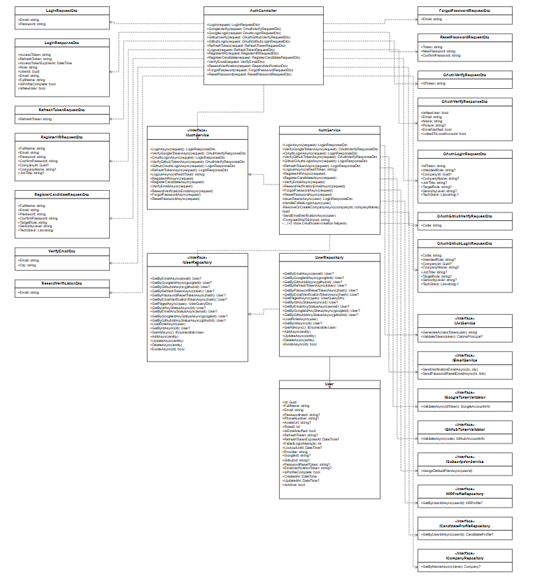
Figure 3.1.1: Authentication Class Diagram (Link)

3.1.2 Register Account
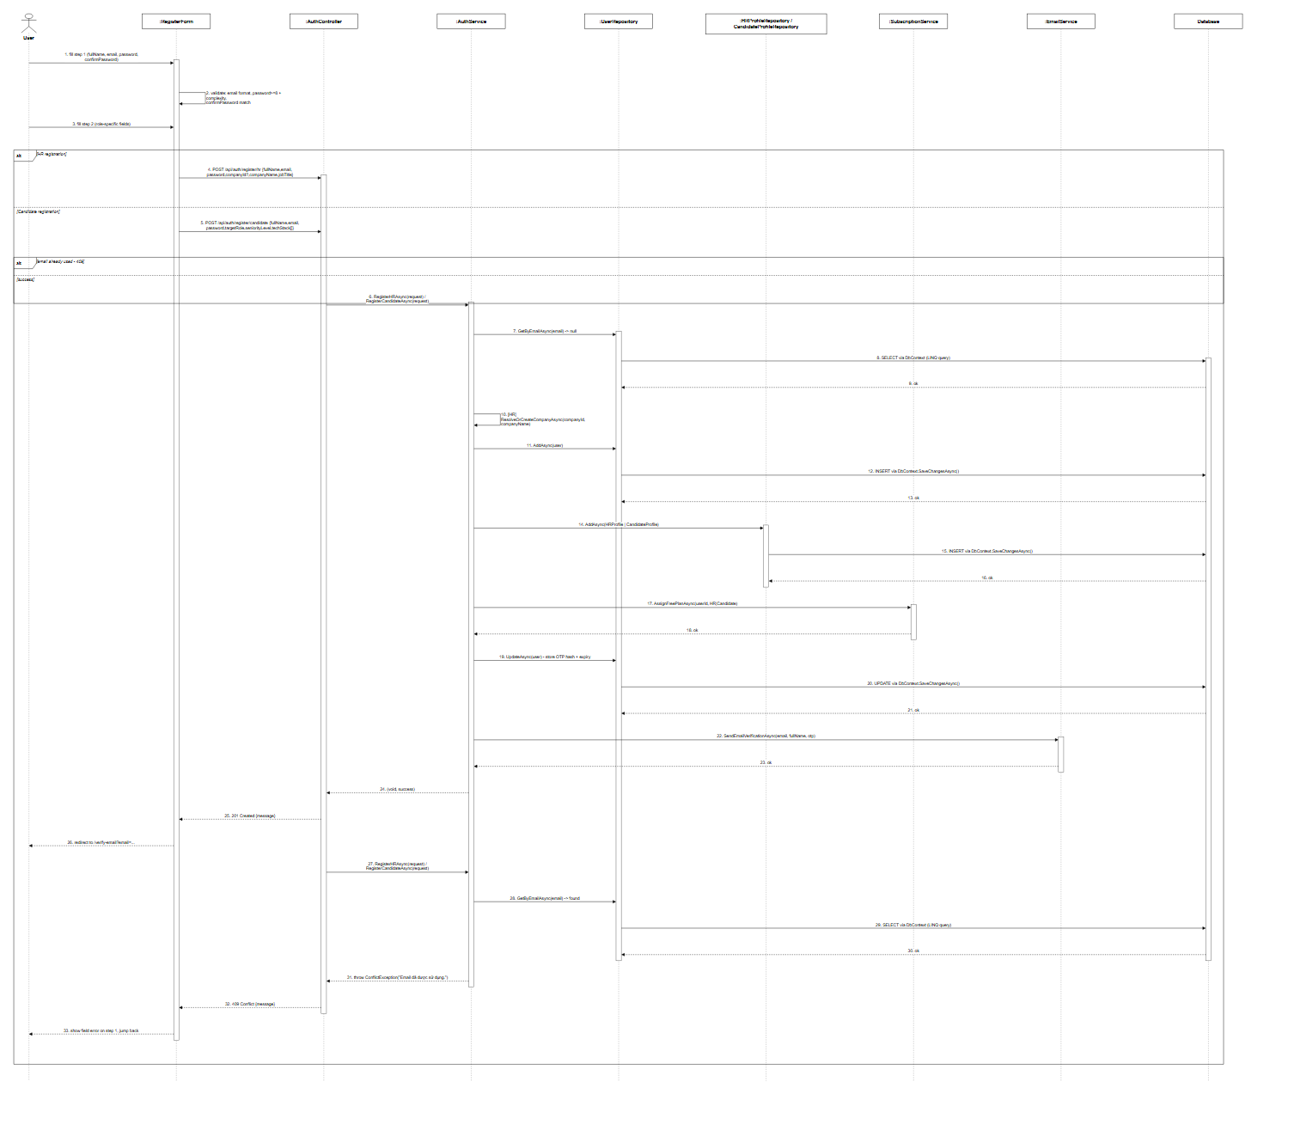
Figure 3.1.2: Register Account Sequence Diagram (Link)

3.1.3 Login
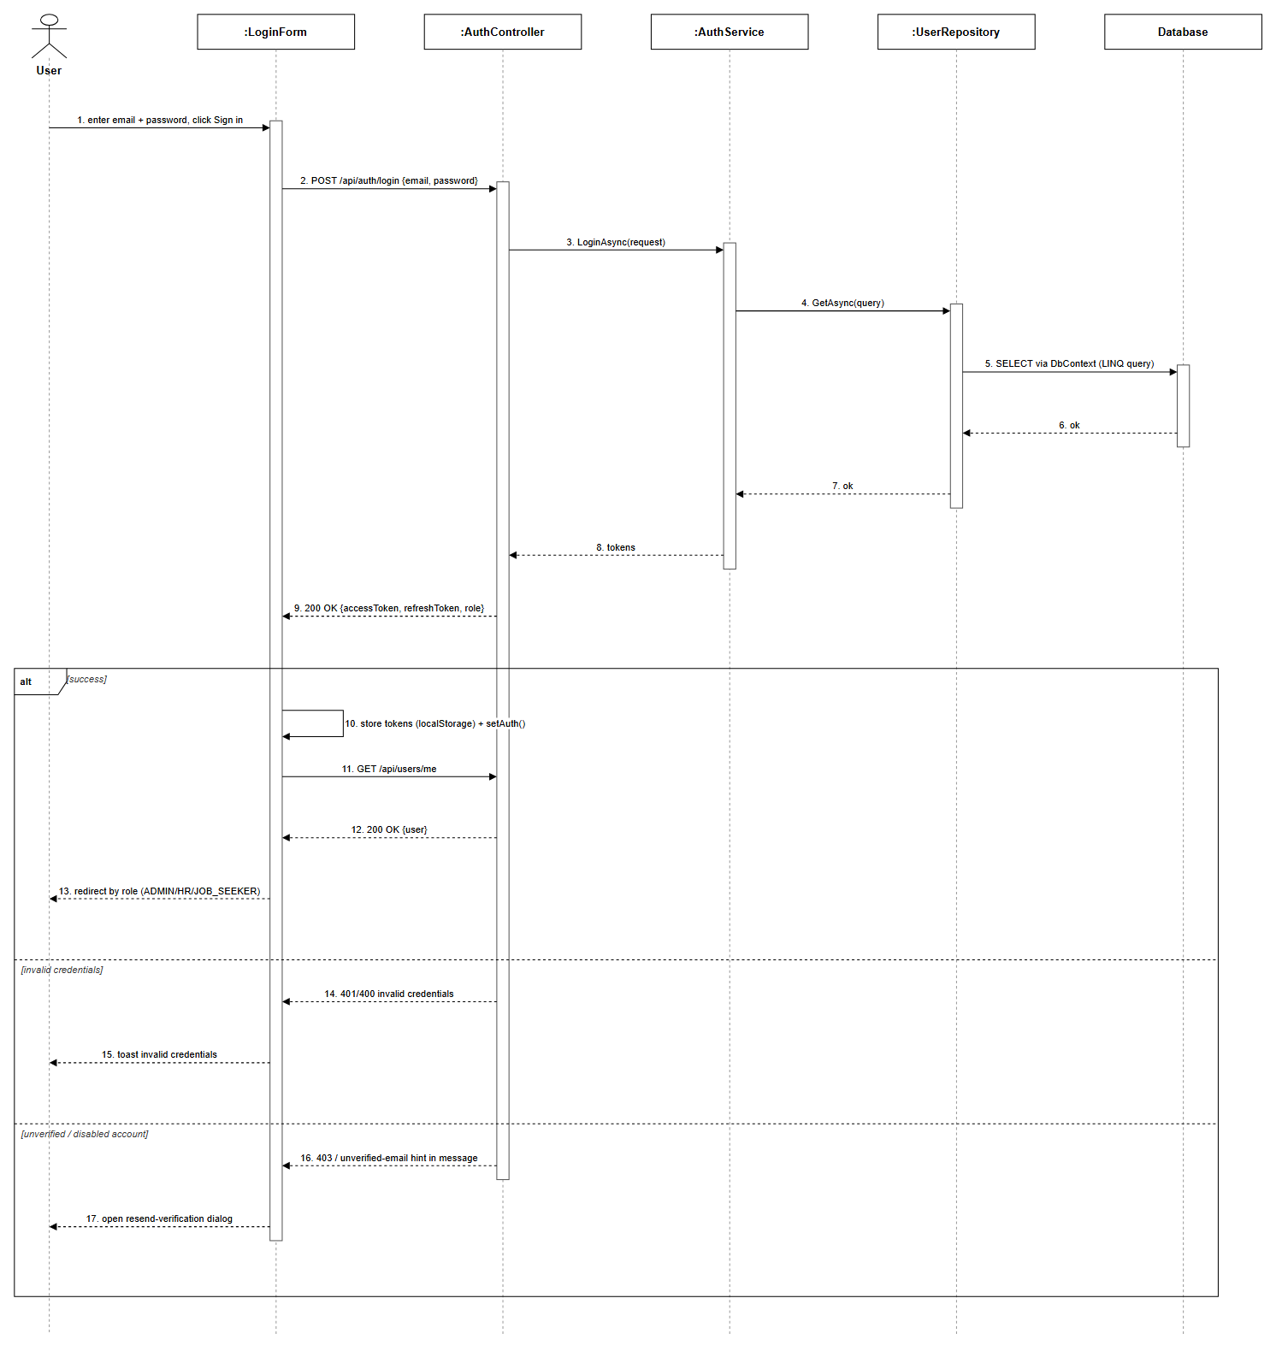
Figure 3.1.3: Login Sequence Diagram (Link)

3.1.4 Logout
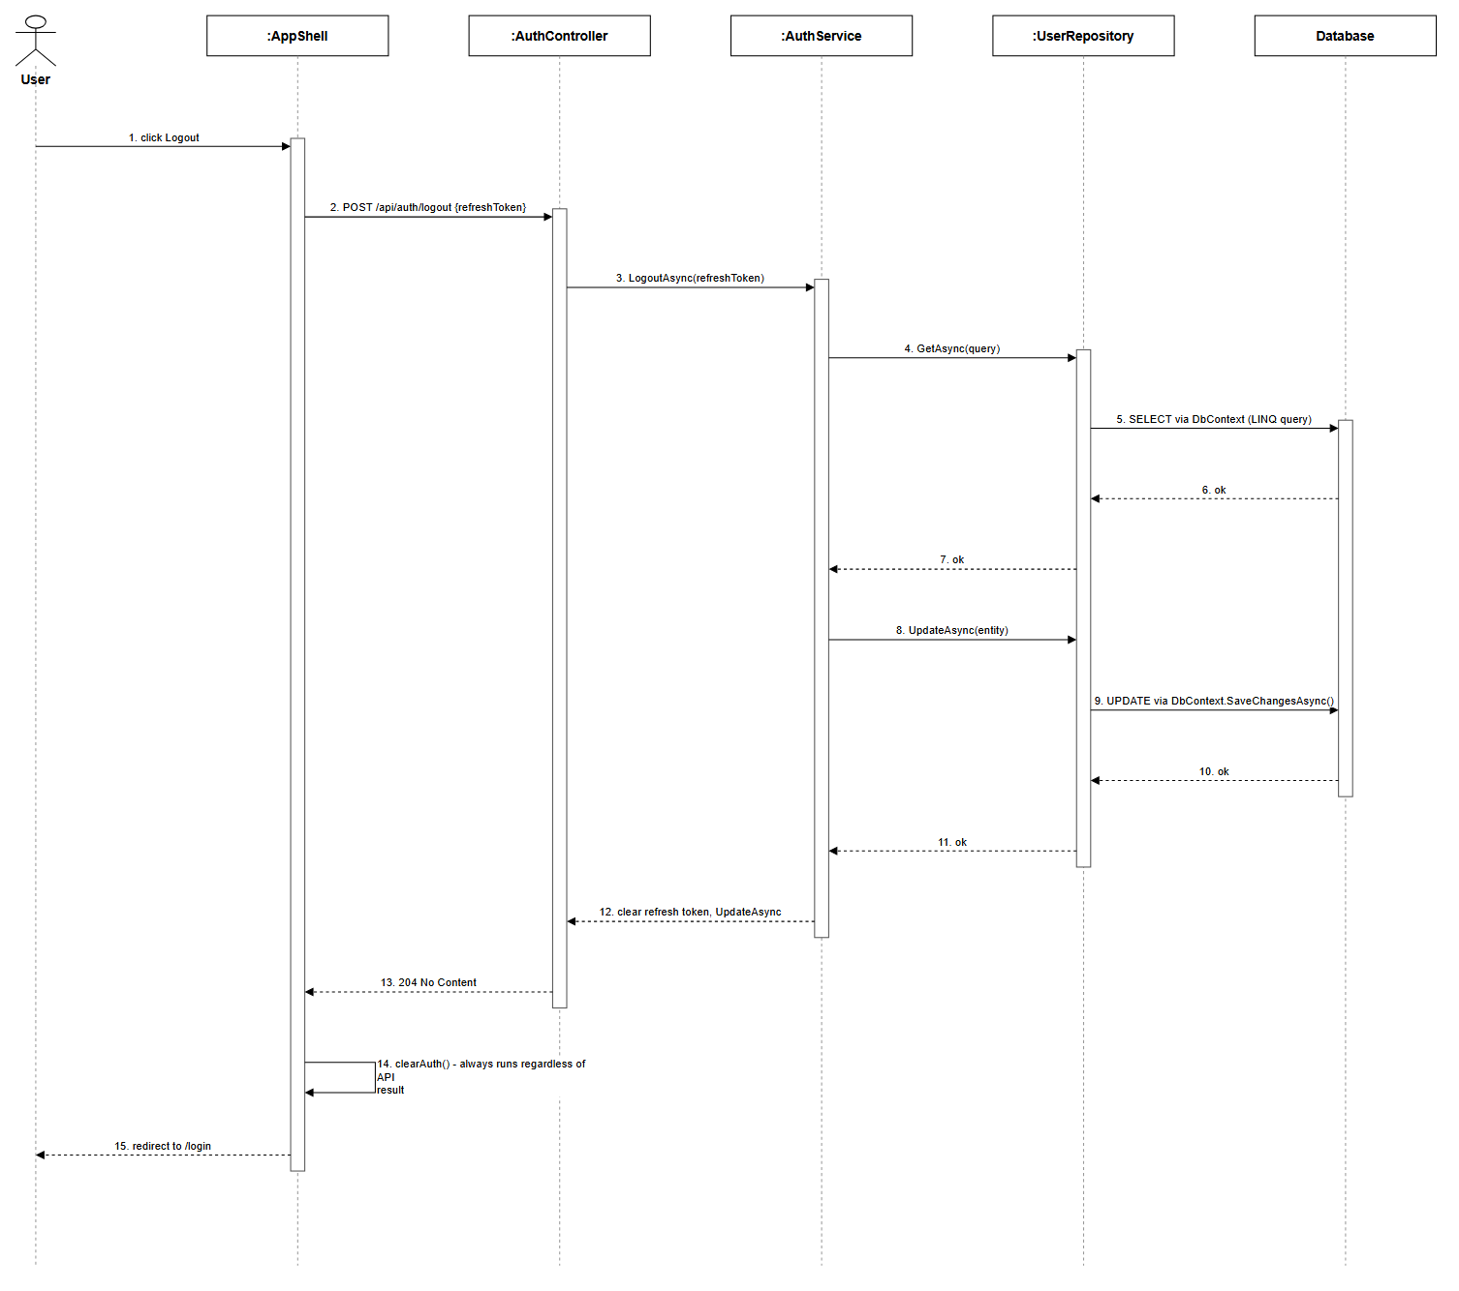
Figure 3.1.4: Logout Sequence Diagram (Link)

3.1.5 Forgot Password
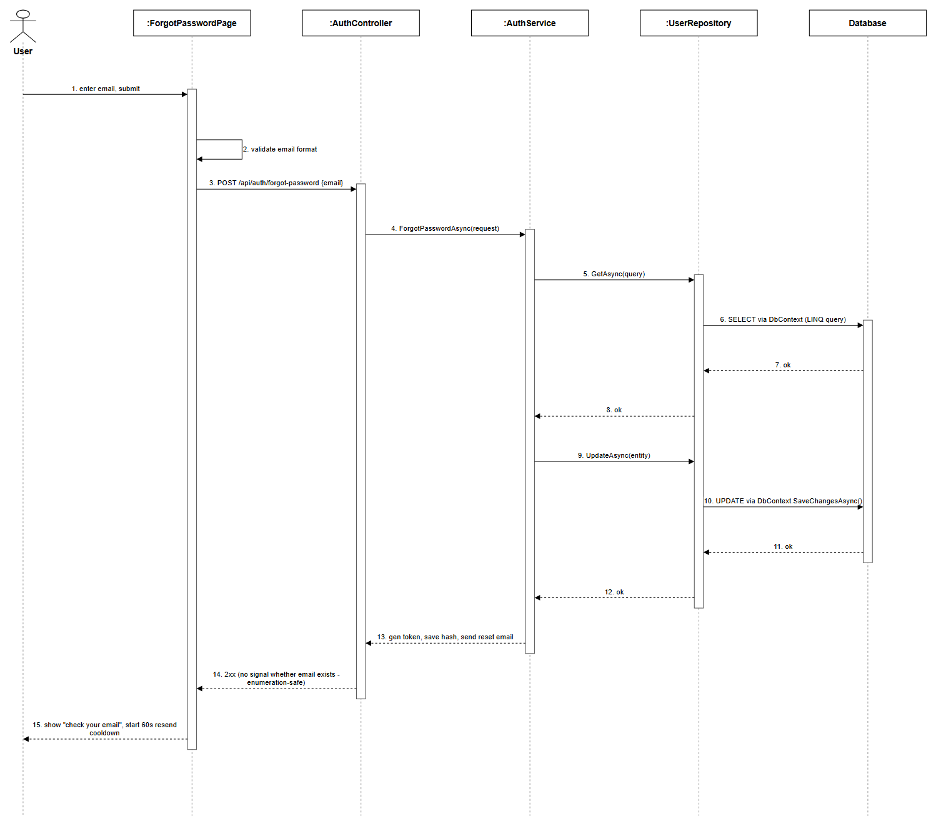
Figure 3.1.5: Forgot Password Sequence Diagram (Link)

3.1.6 Reset Password
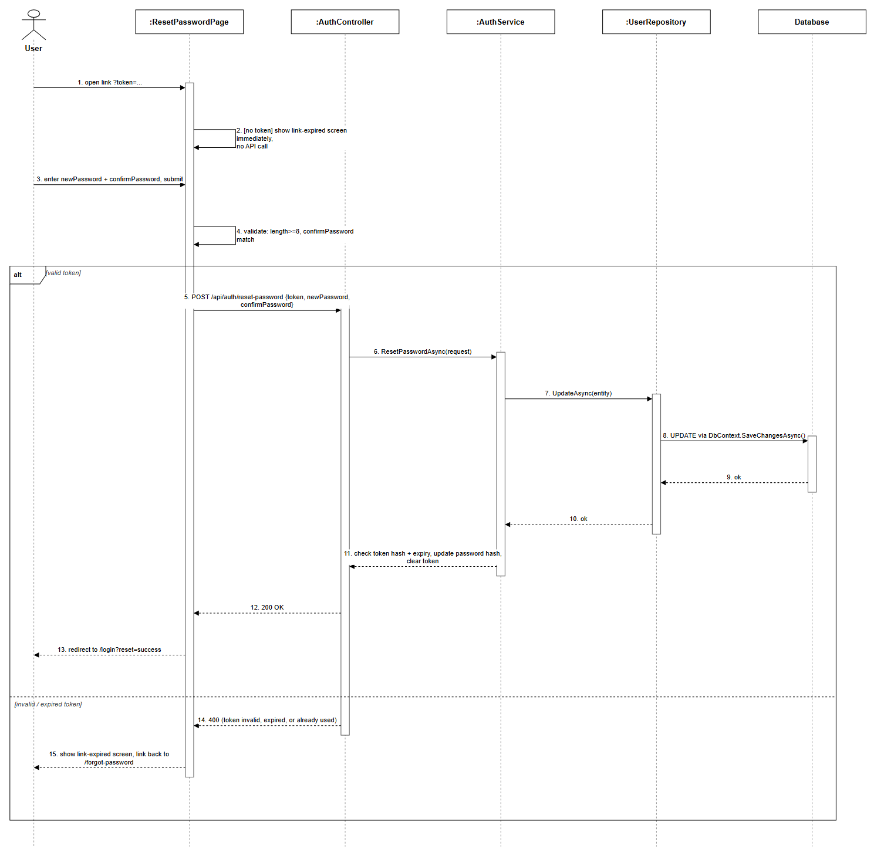
Figure 3.1.6: Reset Password Sequence Diagram (Link)

3.1.7 Email Verification
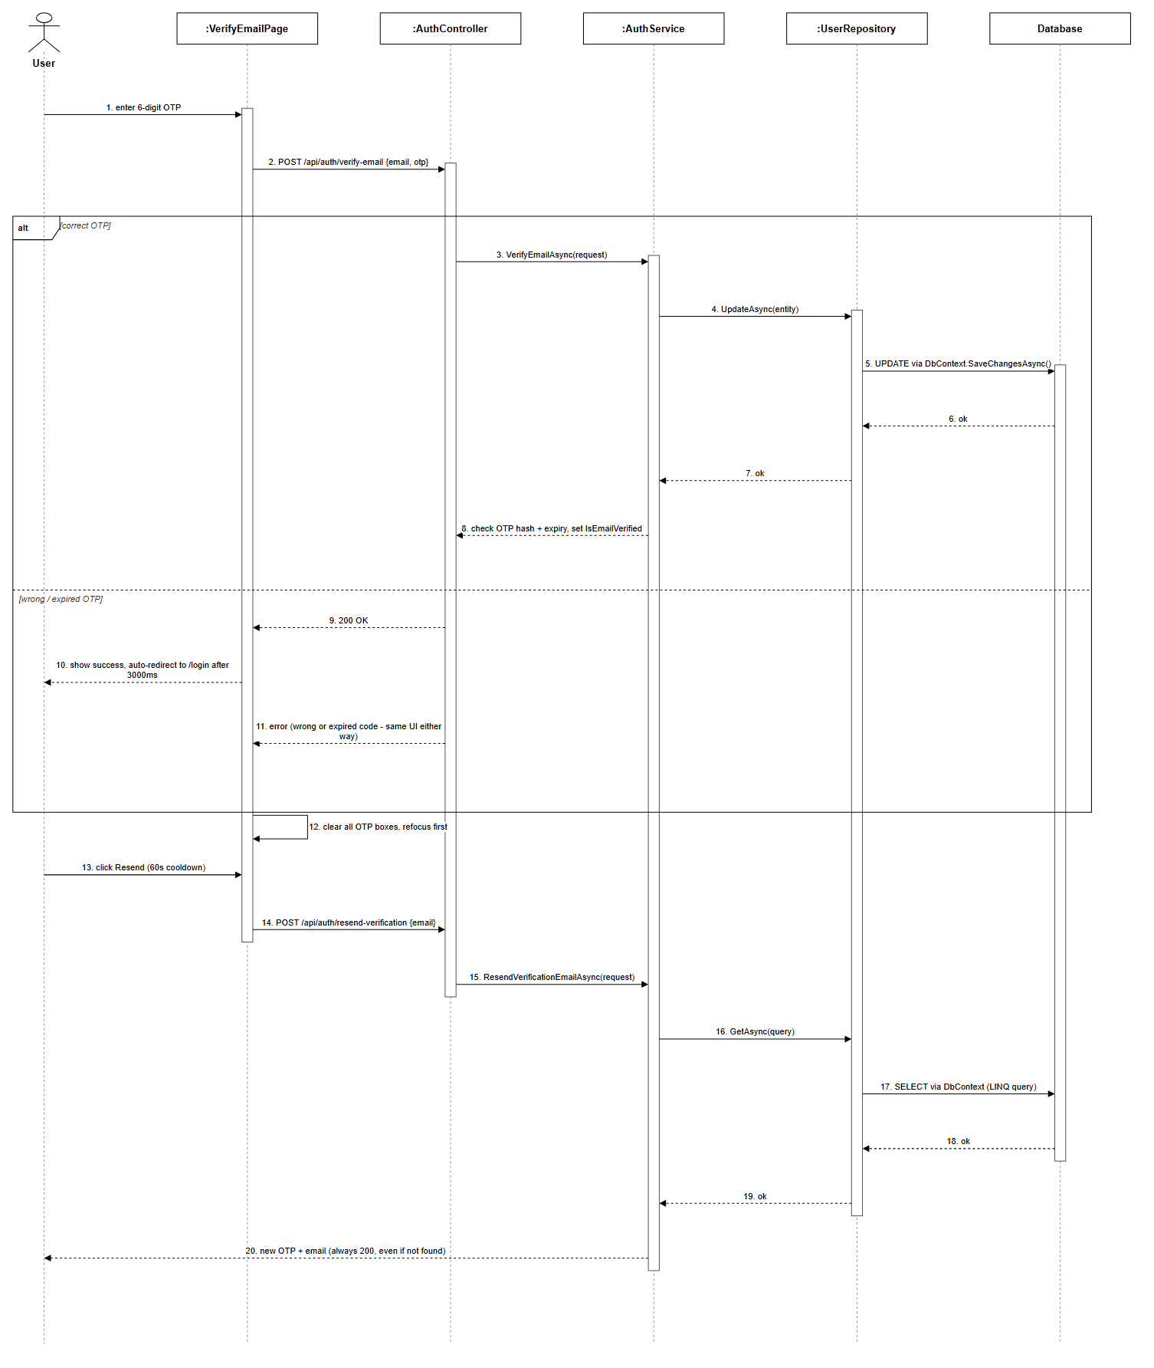
Figure 3.1.7: Email Verification Sequence Diagram (Link)

3.2 Profile Management

3.2.1 View Profile
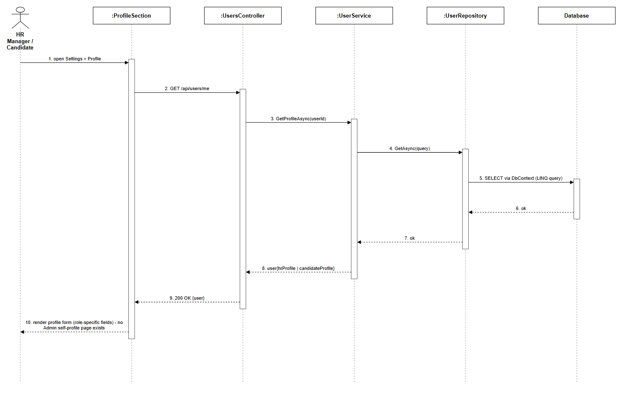
Figure 3.2.1: View Profile Sequence Diagram (Link)

3.2.2 Update Profile
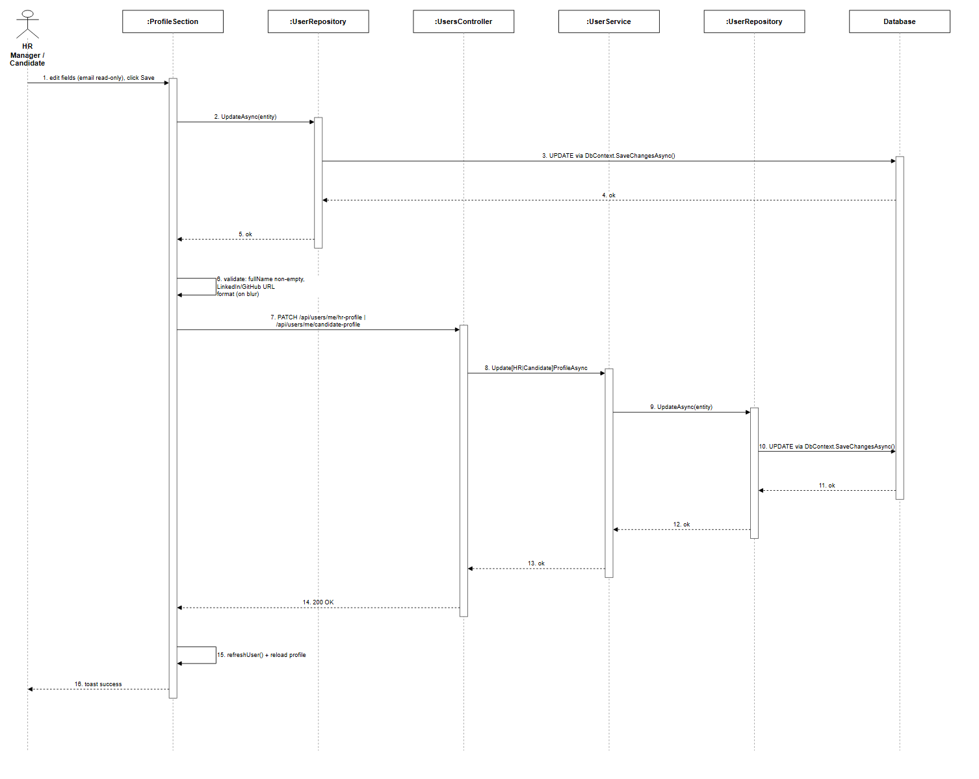
Figure 3.2.2: Update Profile Sequence Diagram (Link)

3.2.3 Change Password
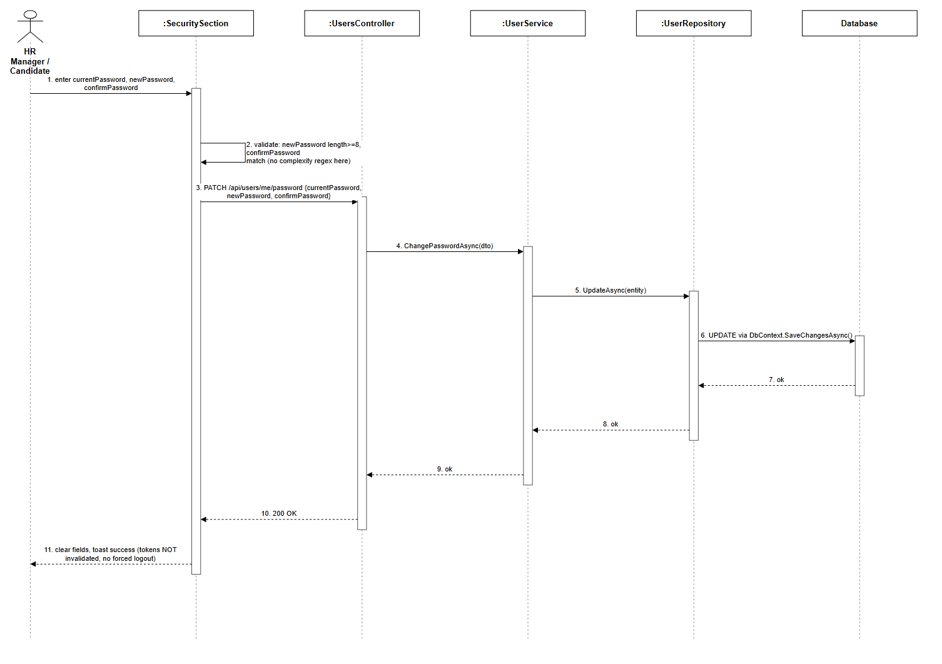
Figure 3.2.3: Change Password Sequence Diagram (Link)

3.3 User and Role Management

3.3.1 User & Role Management
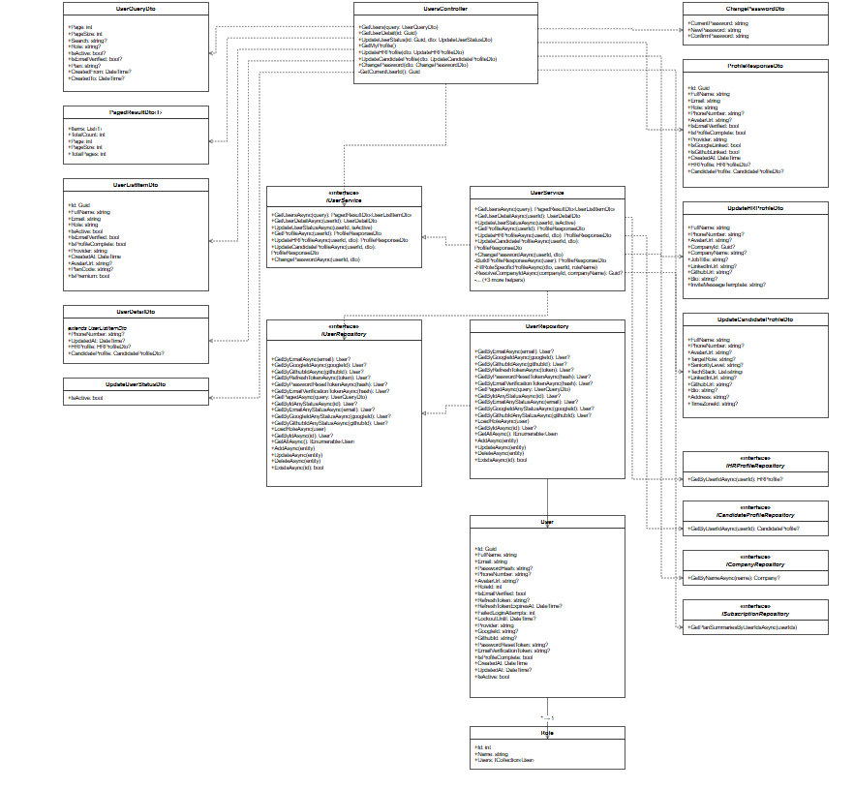
Figure 3.3.1: User & Role Management Class Diagram (Link)

3.3.2 View List User
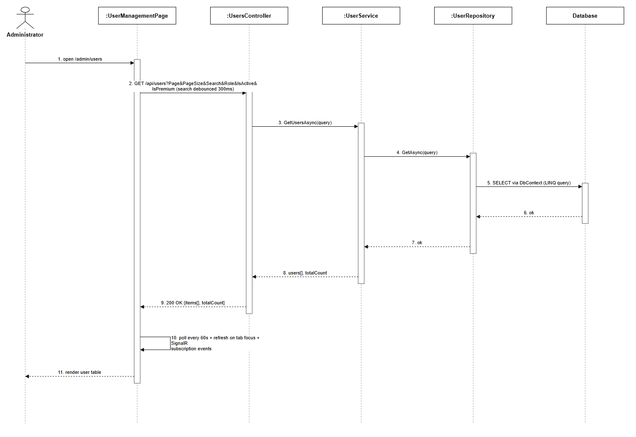
Figure 3.3.2: View List User Sequence Diagram (Link)

3.3.4 Suspend/Activate Account
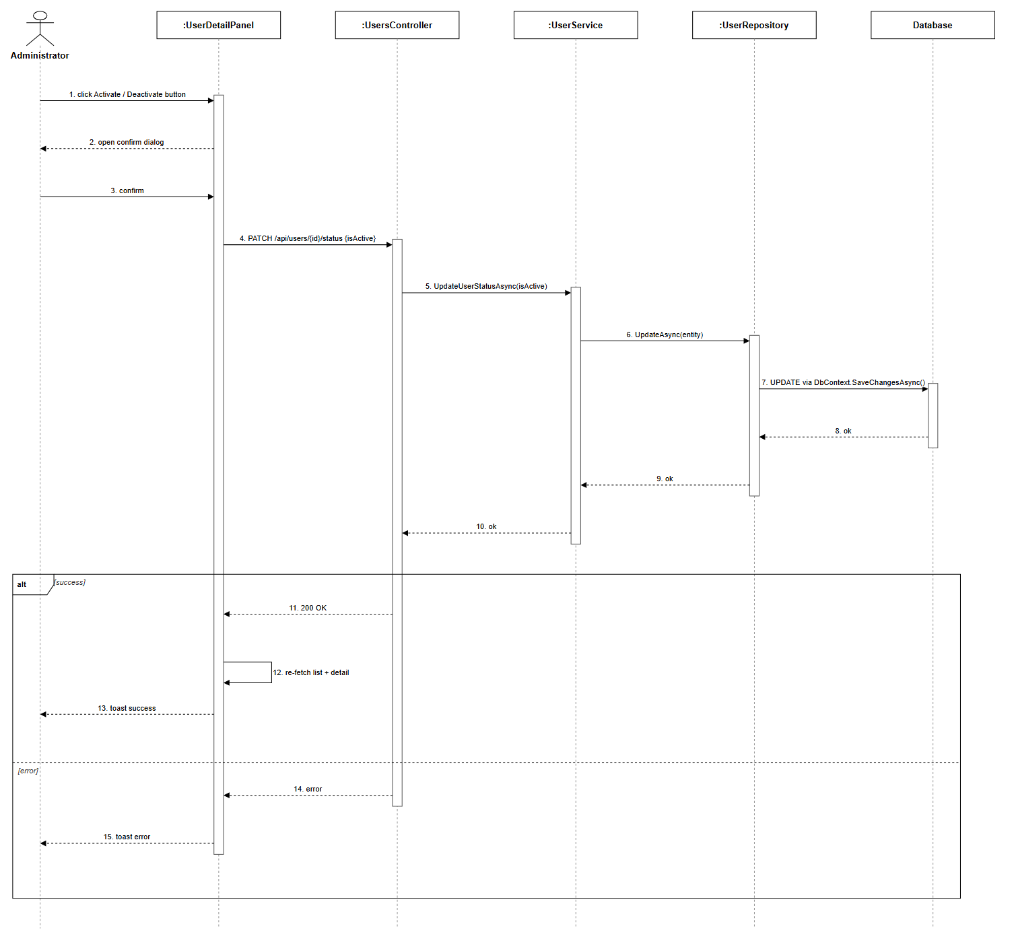
Figure 3.3.4: Suspend/Activate Account Sequence Diagram (Link)

3.3.5 View User Detail
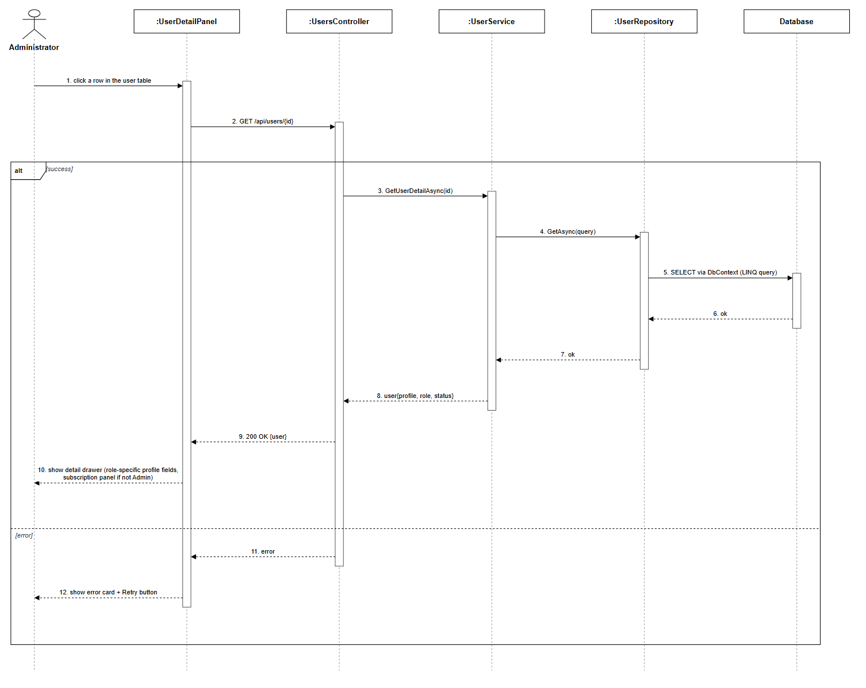
Figure 3.3.5: View User Detail Sequence Diagram (Link)

3.4 HR Company Management

3.4.1 HR Company Management
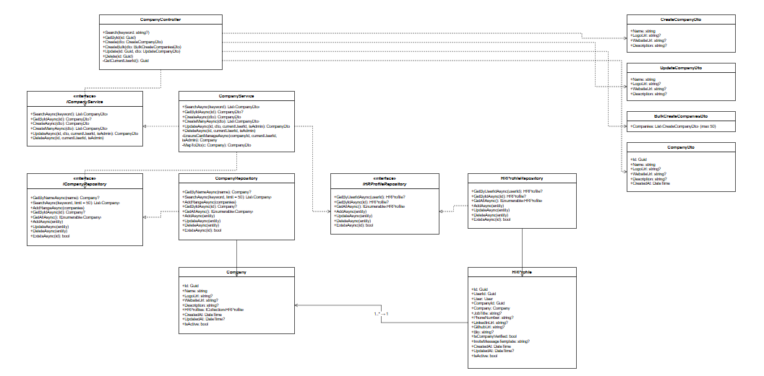
Figure 3.4.1: HR Company Management Class Diagram (Link)

3.4.2 View Company Profile
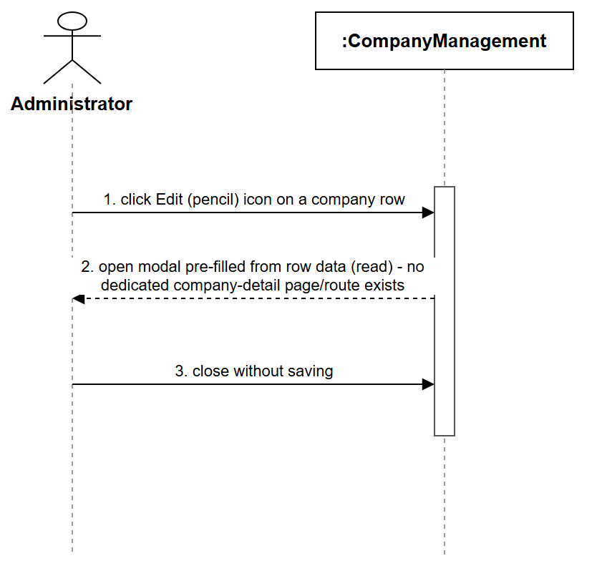
Figure 3.4.2: View Company Profile Sequence Diagram (Link)

3.4.3 Update Company Information
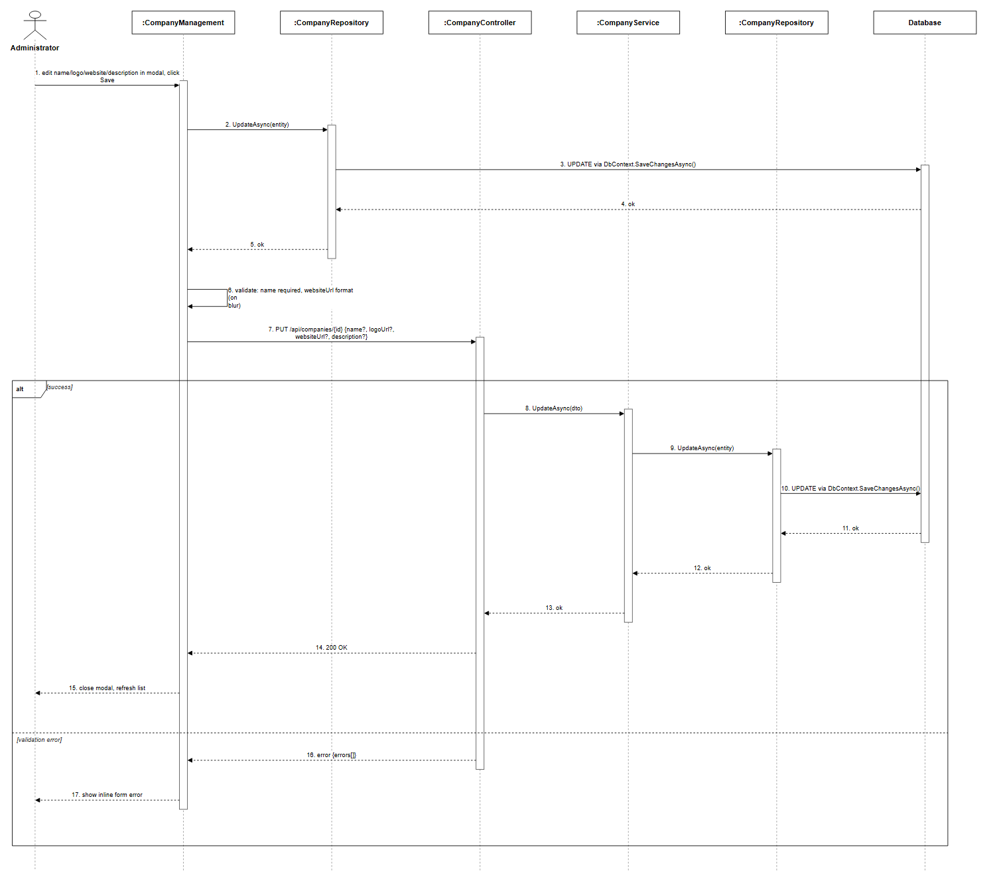
Figure 3.4.3: Update Company Information Sequence Diagram (Link)

3.4.4 View Company List
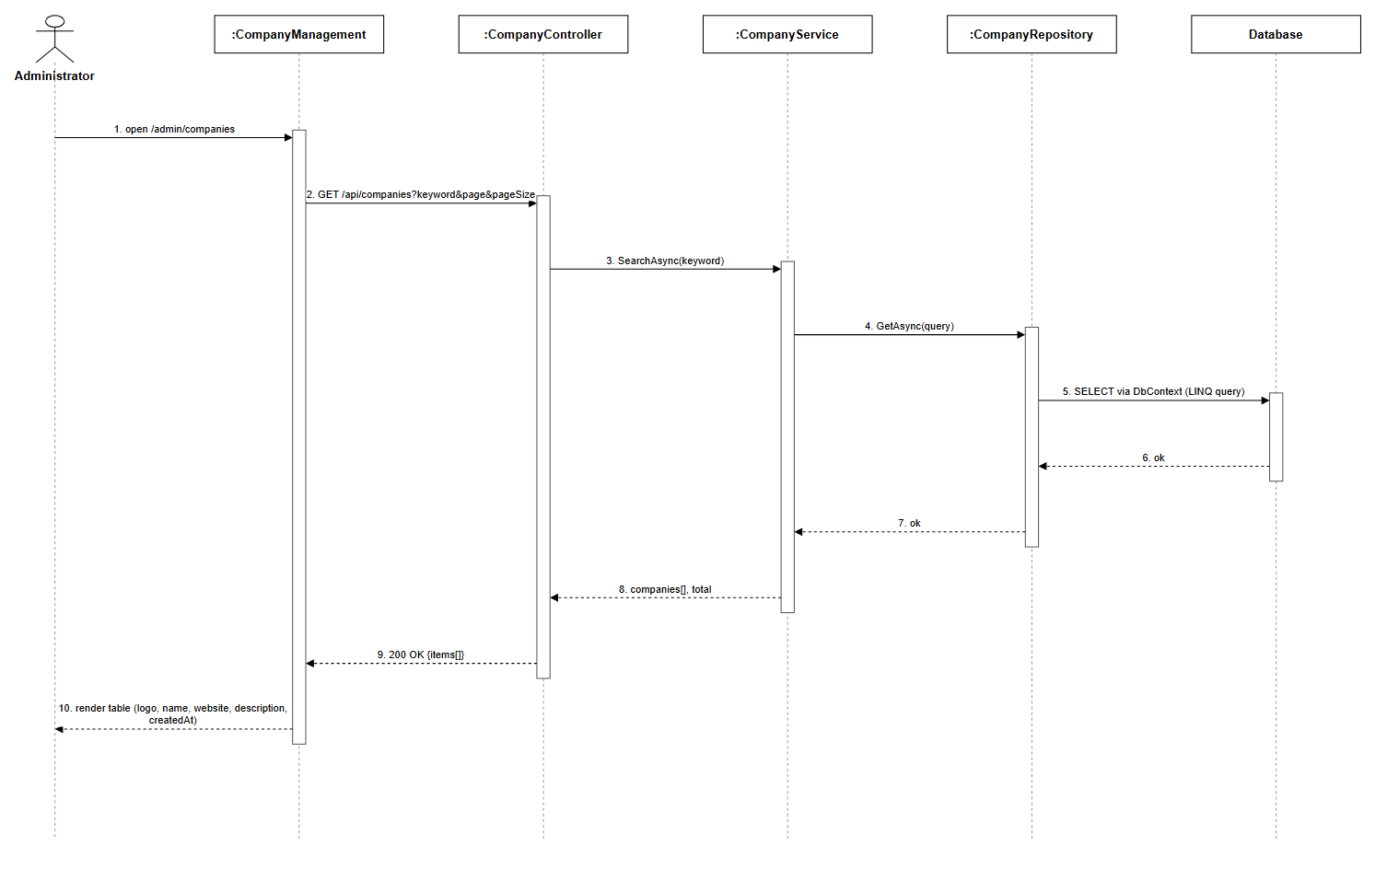
Figure 3.4.4: View Company List Sequence Diagram (Link)

3.5 Job Description Management

3.5.1 Create JD
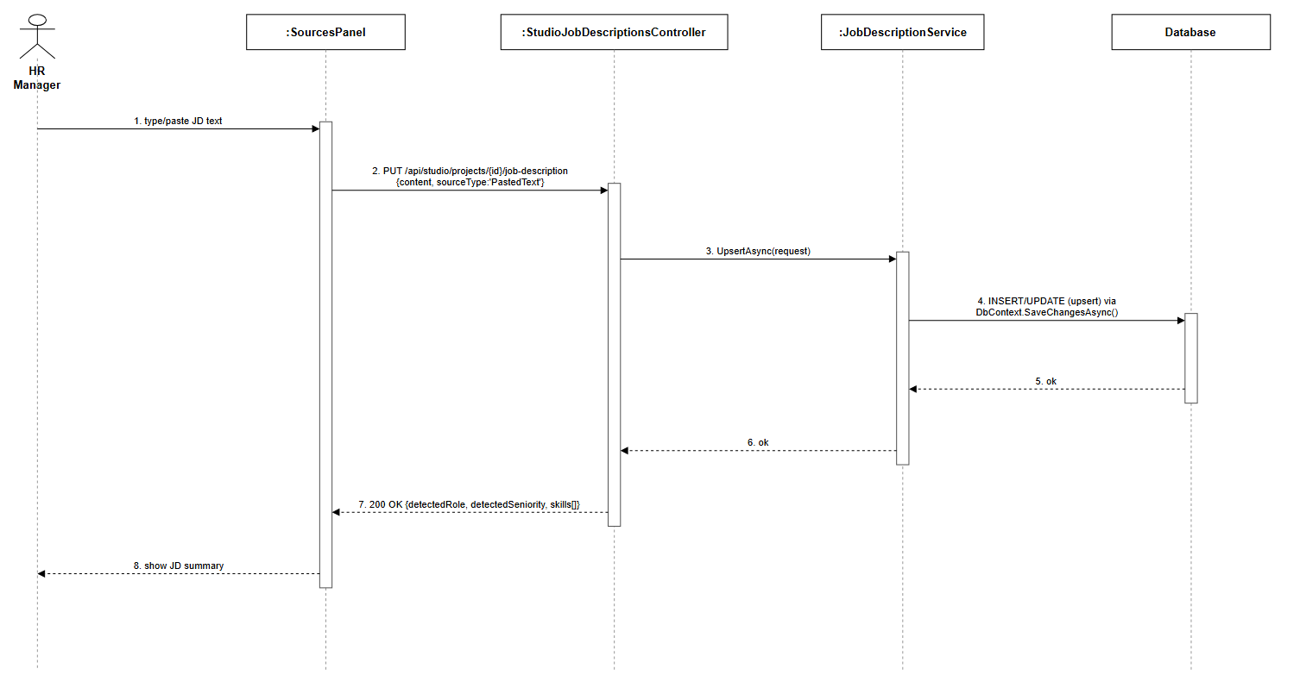
Figure 3.5.1: Create JD (Text) Sequence Diagram (Link)

3.5.2 Create JD (Upload File)
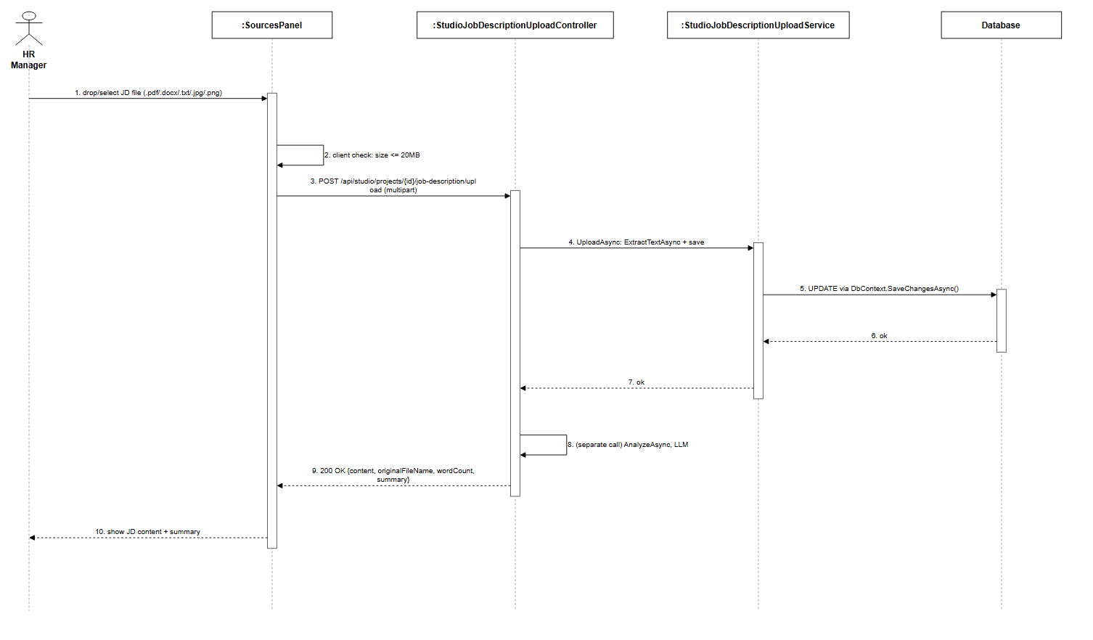
Figure 3.5.2: Create JD (Upload File) Sequence Diagram (Link)

3.5.3 Update JD when Failed
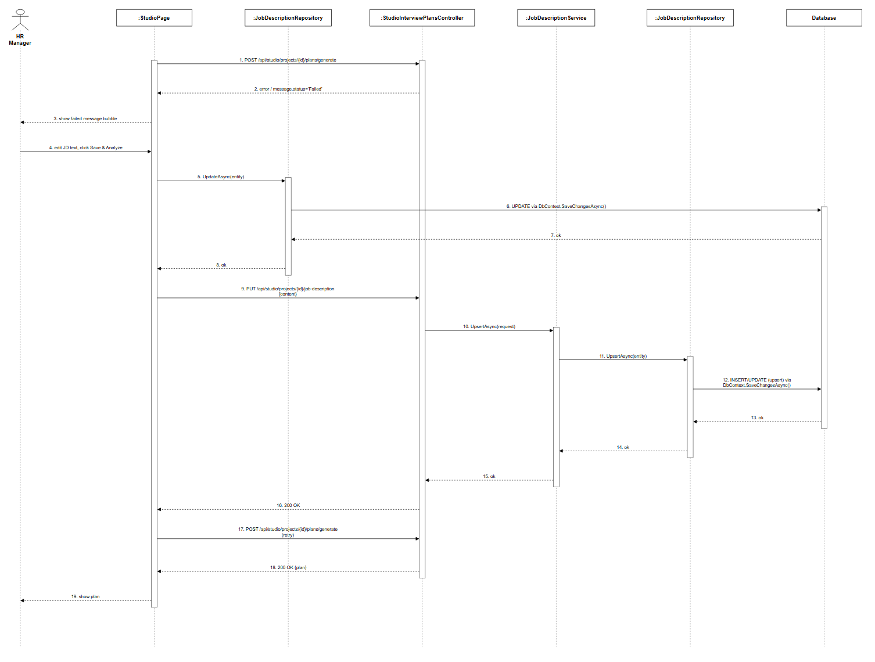
Figure 3.5.3: Update JD when Failed Sequence Diagram (Link)

3.5.4 List View JD Session
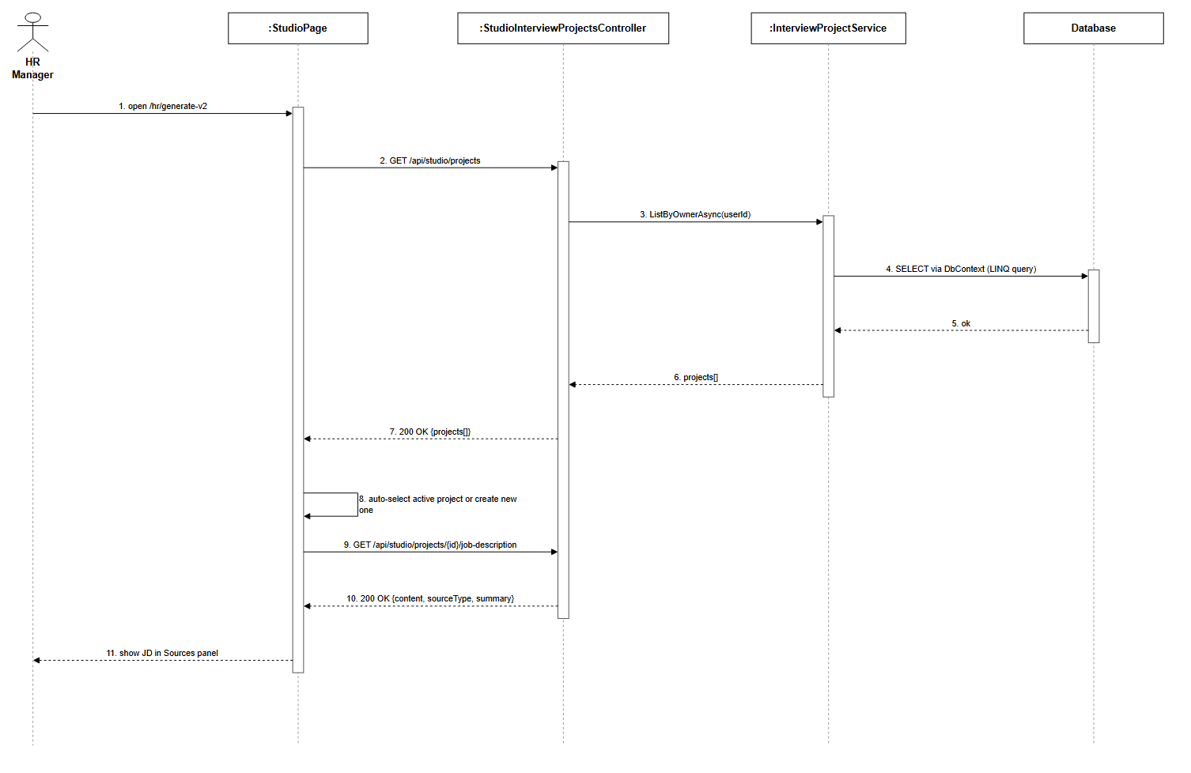
Figure 3.5.4: List View JD Session Sequence Diagram (Link)

3.5.5 Delete JD Session
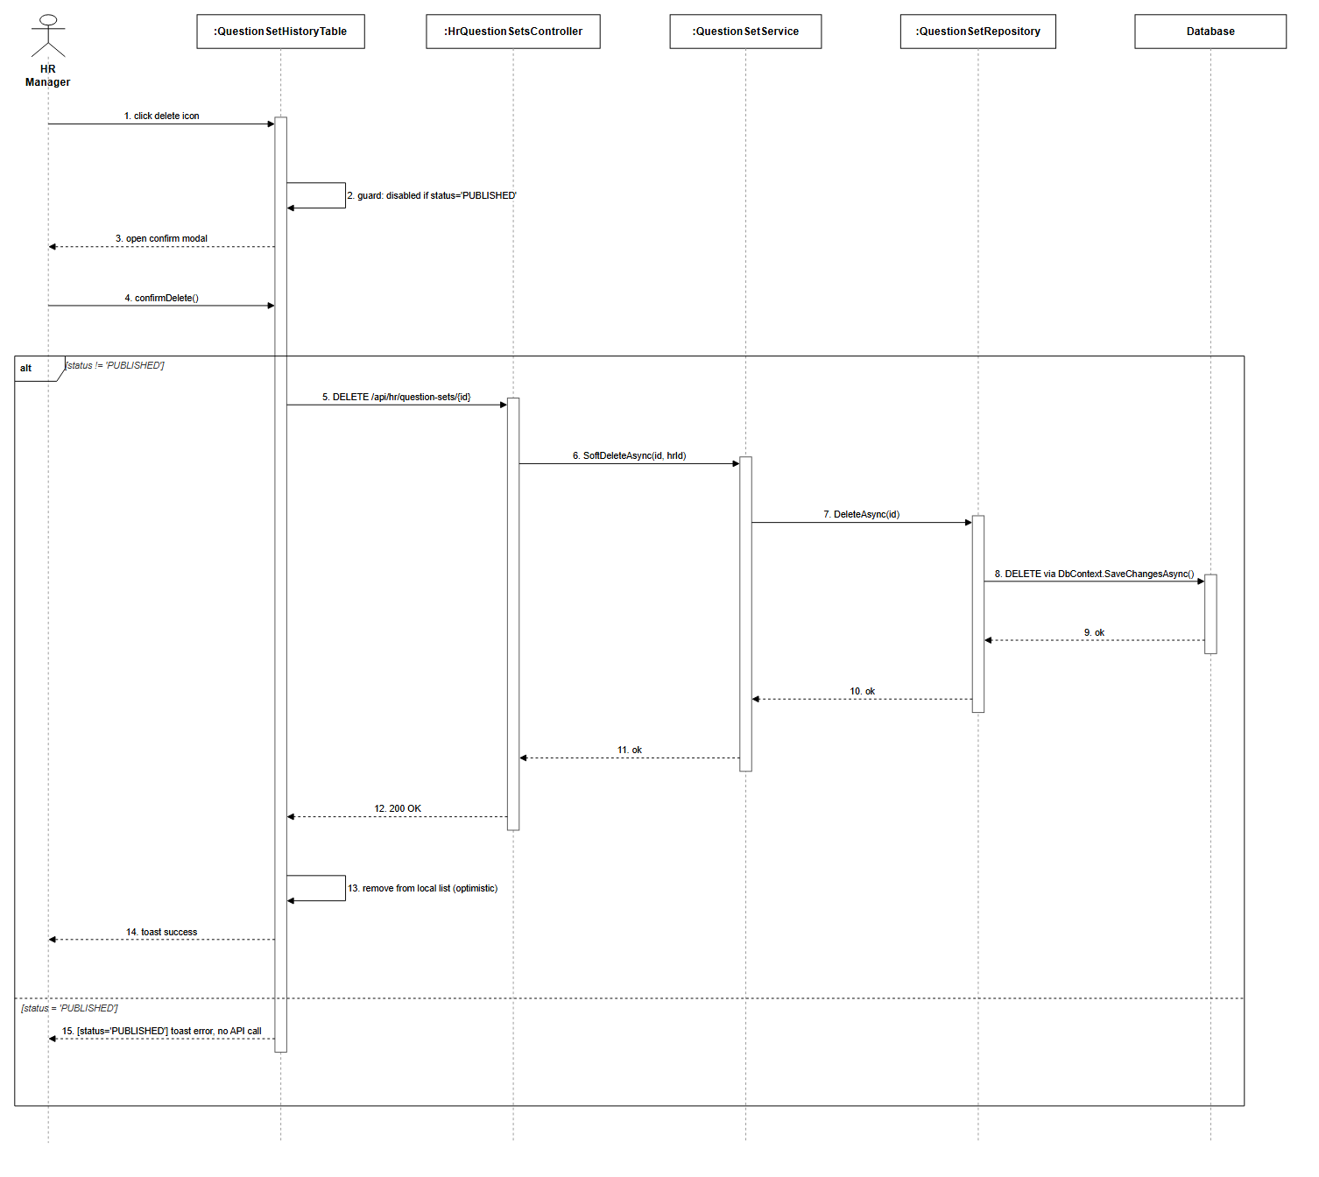
Figure 3.5.5: Delete JD Session Sequence Diagram (Link)

3.6 Knowledge Base Management

3.6.1 Upload Ingest HR
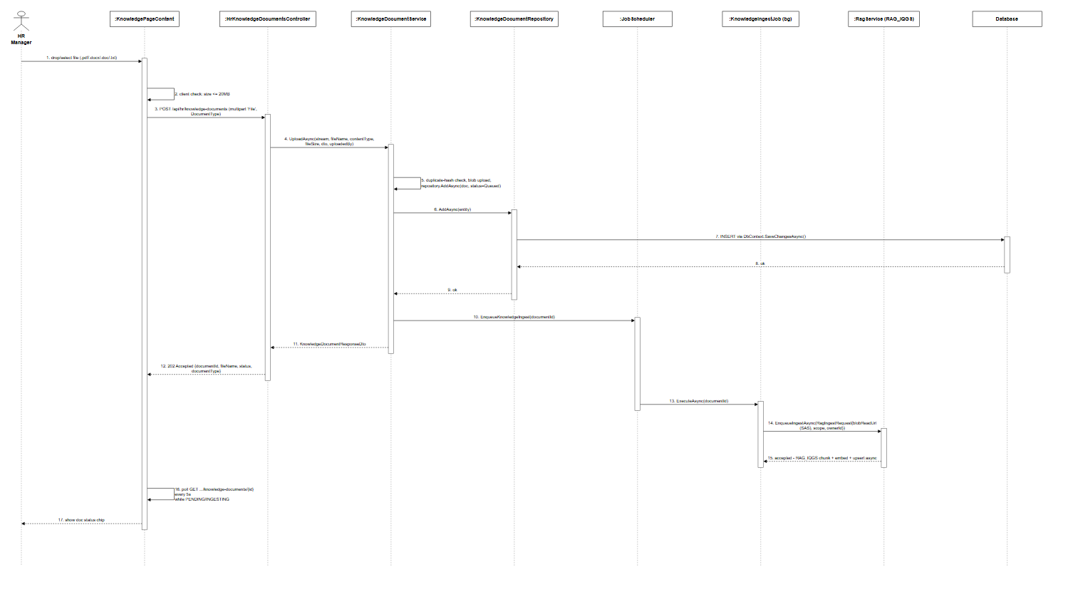
Figure 3.6.1: Upload Ingest HR Sequence Diagram (Link)

3.6.2 Upload Ingest Admin
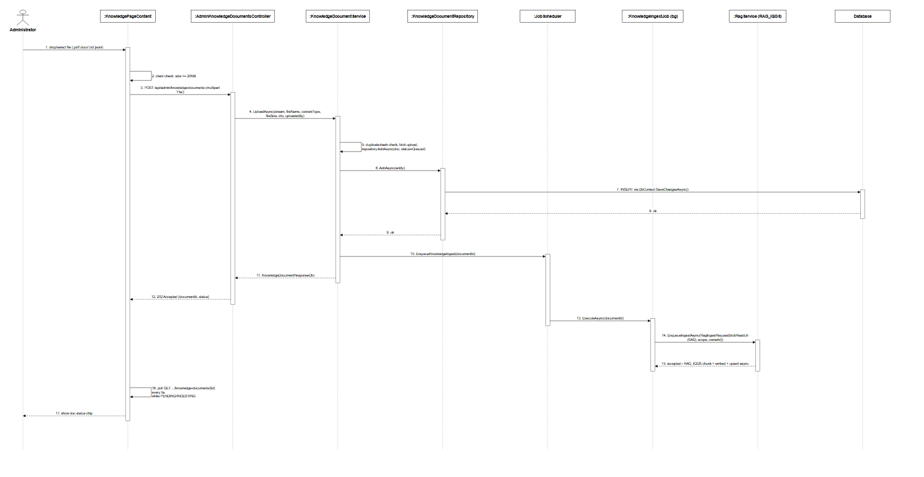
Figure 3.6.2: Upload Ingest Admin Sequence Diagram (Link)

3.6.3 Reingest Document
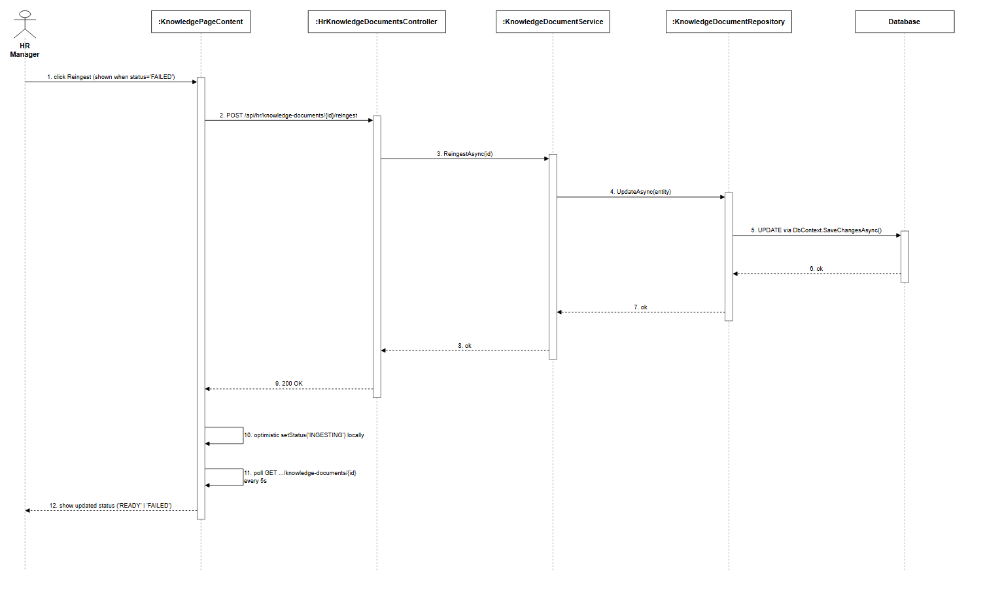
Figure 3.6.3: Reingest Document Sequence Diagram (Link)

3.6.4 List Get Document
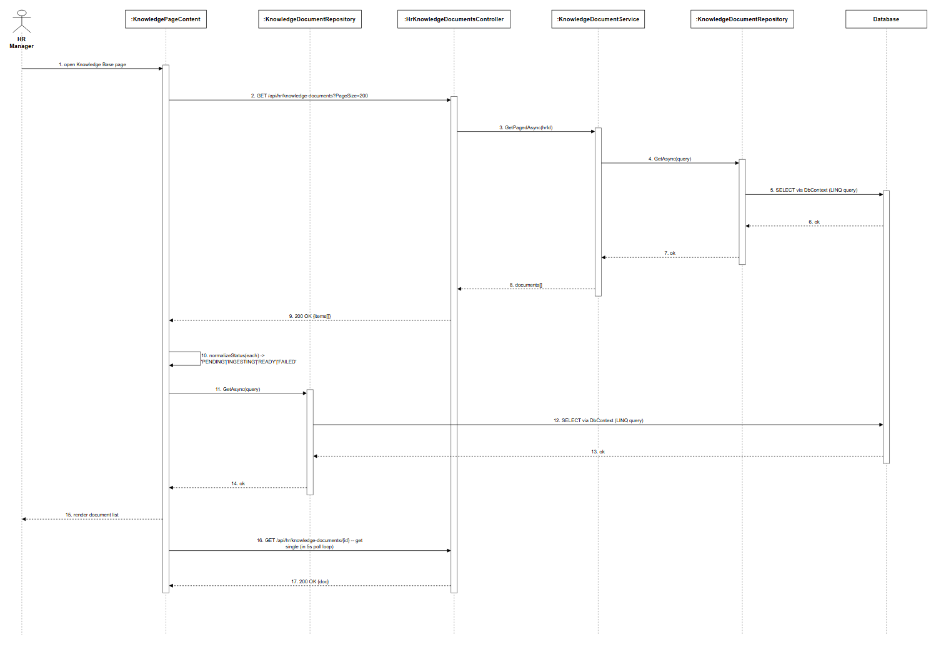
Figure 3.6.4: List Get Document Sequence Diagram (Link)

3.6.5 Delete Document
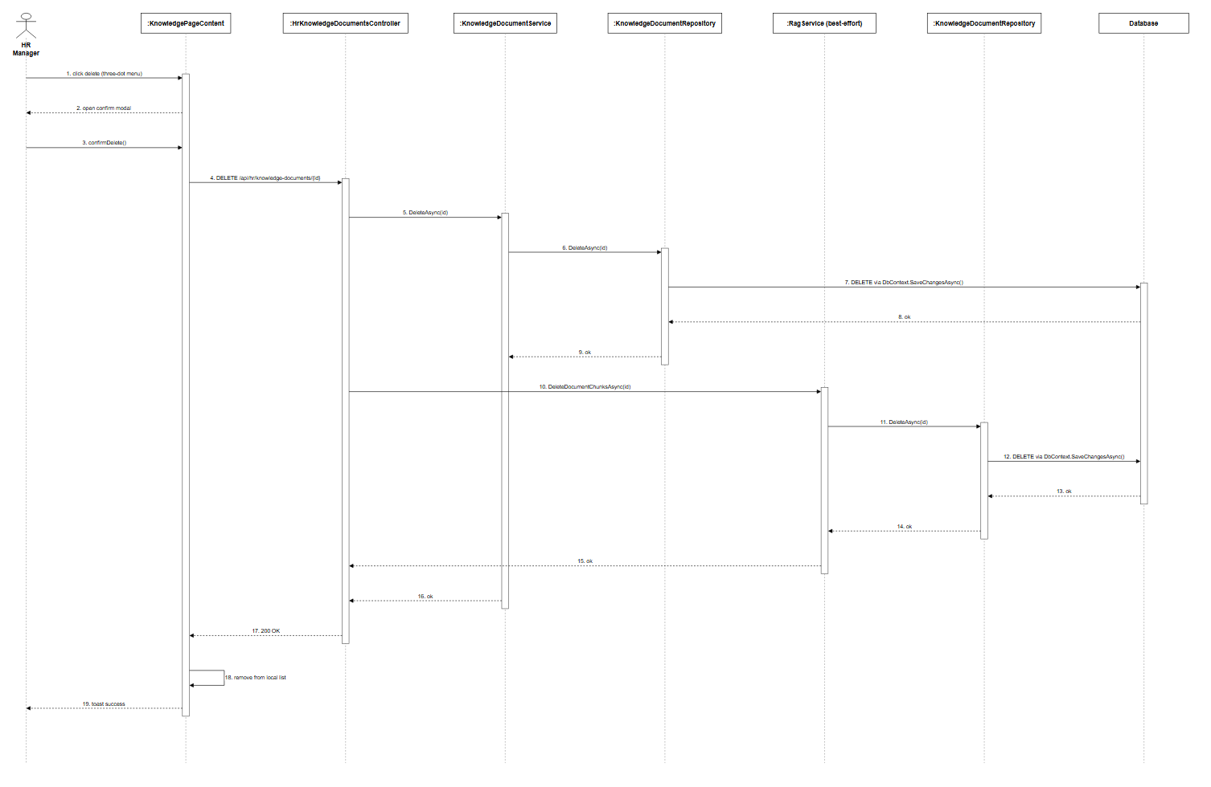
Figure 3.6.5: Delete Document Sequence Diagram (Link)

3.7 AI Question Generation Management

3.7.1 Generate Plan
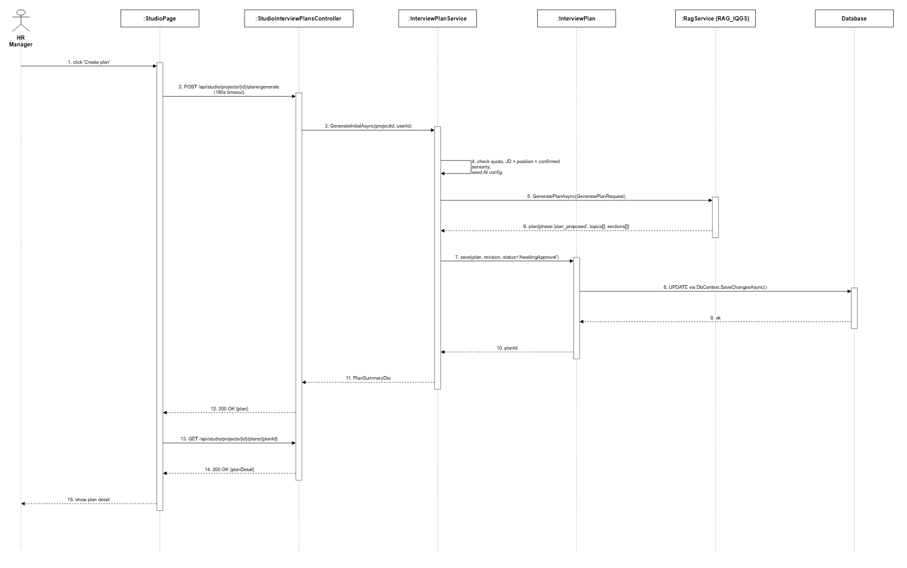
Figure 3.7.1: Generate Plan Sequence Diagram (Link)

3.7.2 Review Edit Plan
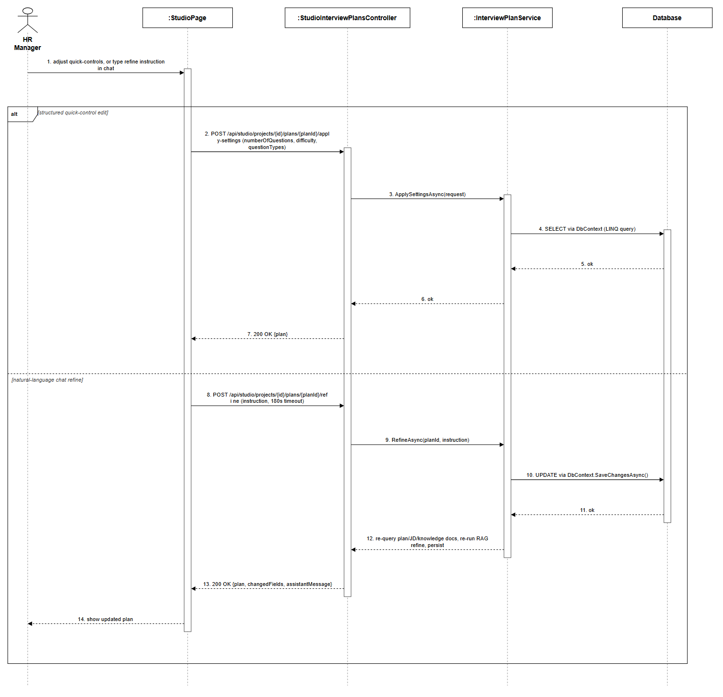
Figure 3.7.2: Review Edit Plan Sequence Diagram (Link)

3.7.3 Approve and Generate Questions
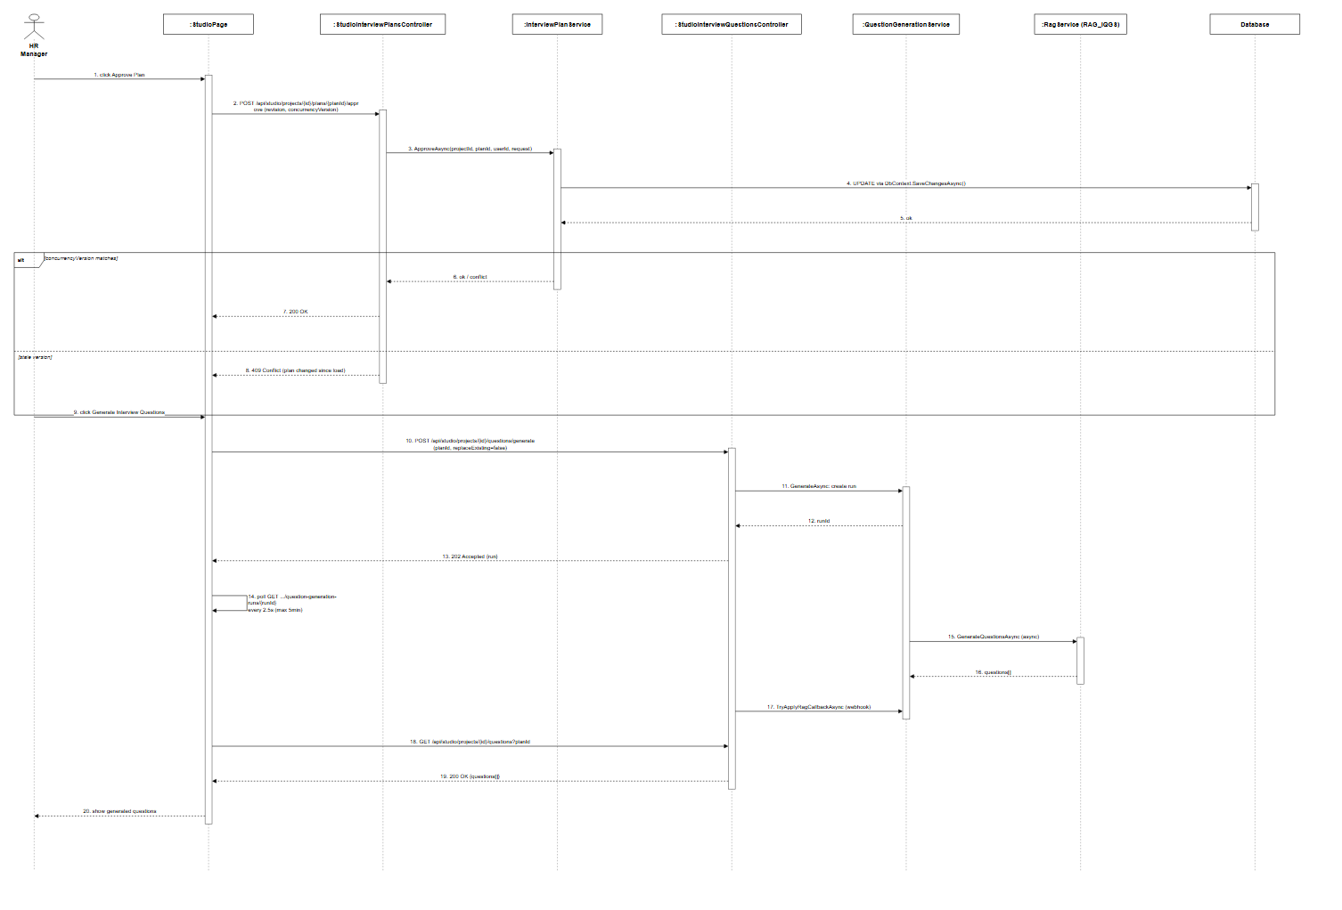
Figure 3.7.3: Approve and Generate Questions Sequence Diagram (Link)

3.7.4 Edit Questions
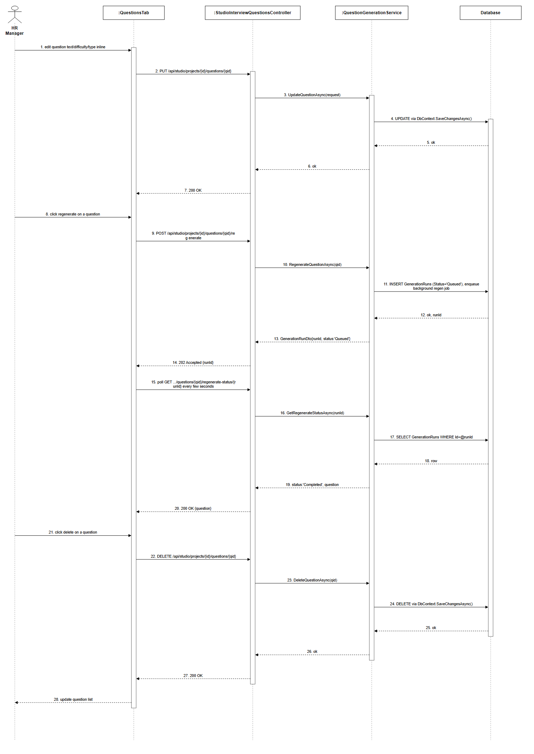
Figure 3.7.4: Edit Questions Sequence Diagram (Link)

3.7.5 Retry Plan or Questions
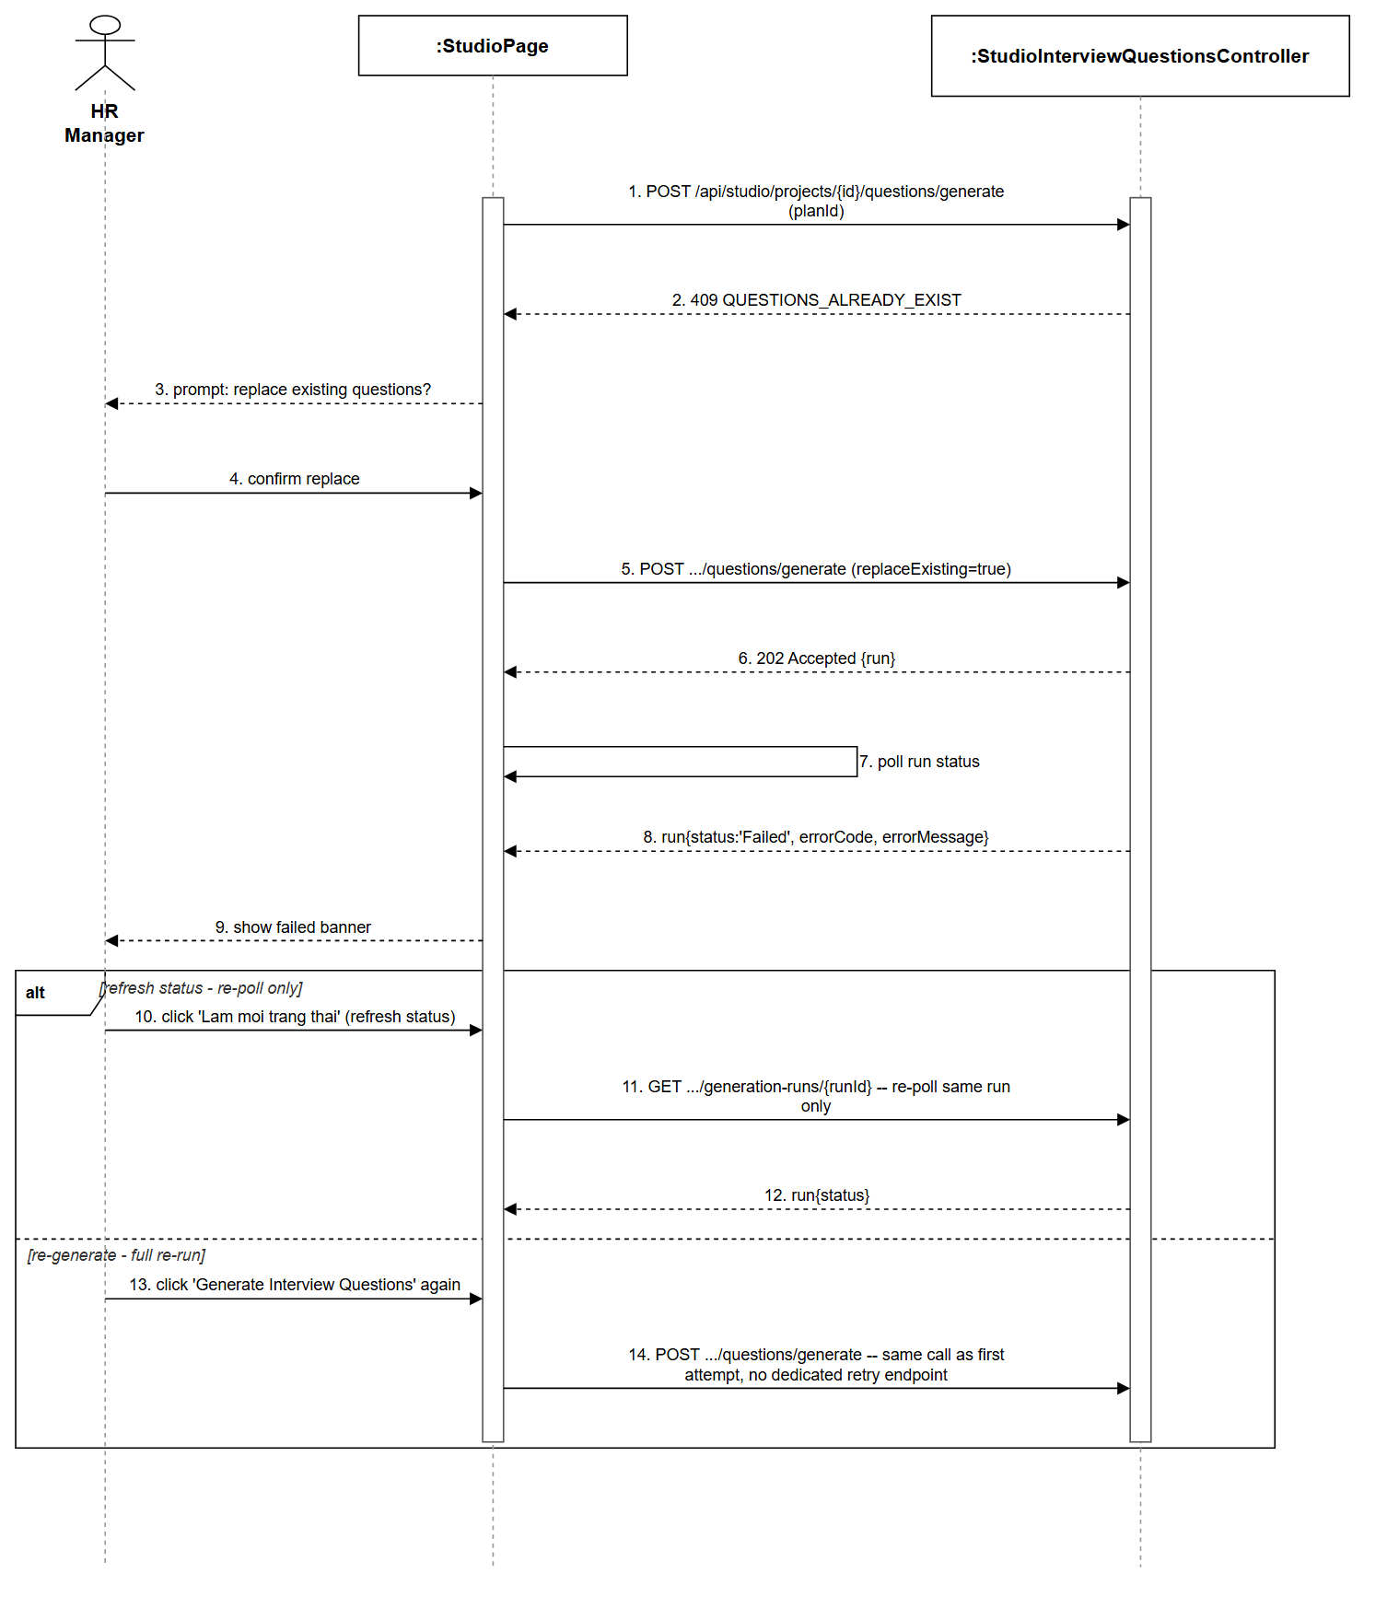
Figure 3.7.5: Retry Plan or Questions Sequence Diagram (Link)

3.8 Question Set Management

3.8.1 Save Draft
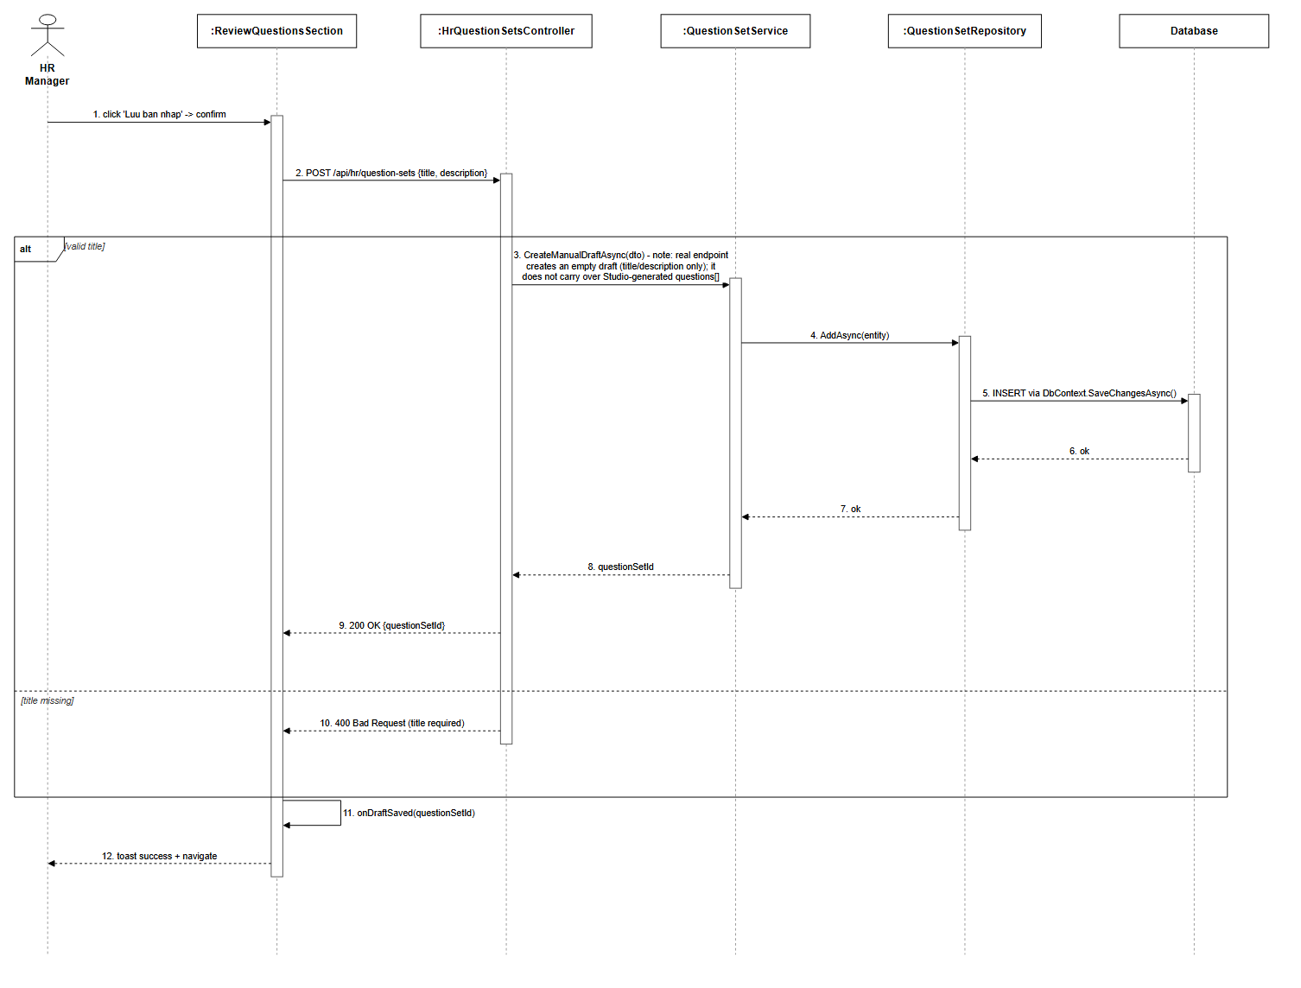
Figure 3.8.1: Save Draft Sequence Diagram (Link)

3.8.2 List Question Sets
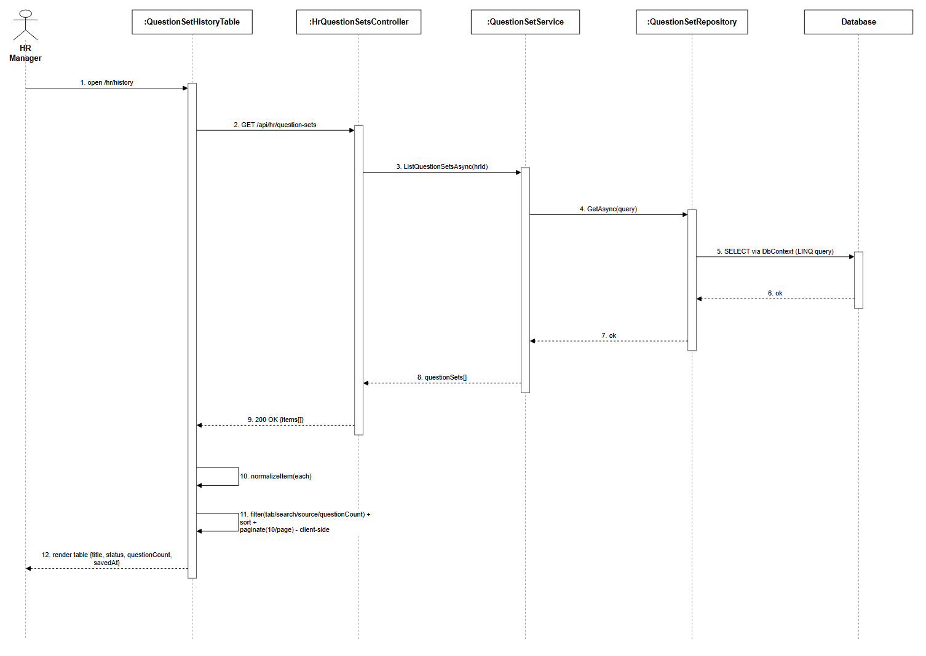
Figure 3.8.2: List Question Sets Sequence Diagram (Link)

3.8.3 View Question Set Detail
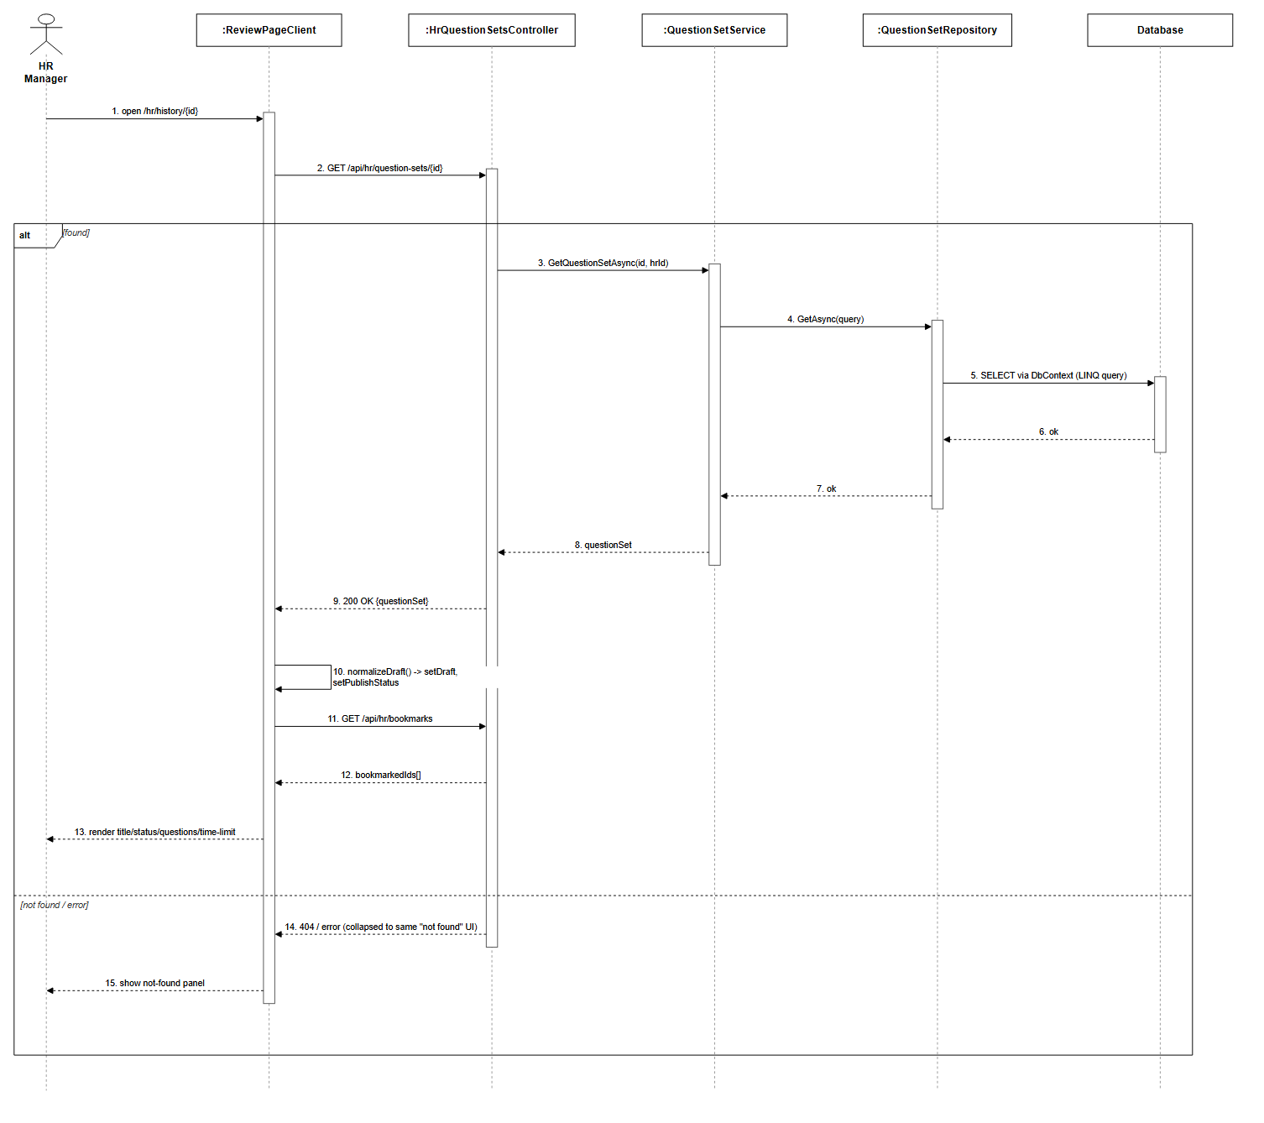
Figure 3.8.3: View Question Set Detail Sequence Diagram (Link)

3.9 Marketplace Management

3.9.1 Browse Question Sets

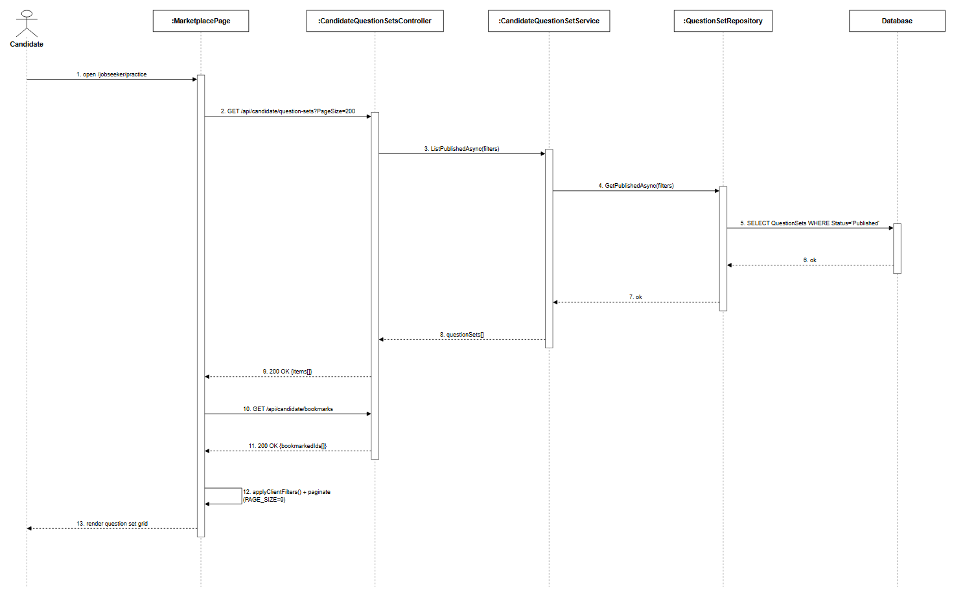
Figure 3.9.1: Browse Question Sets Sequence Diagram (Link)

3.9.2 Search & Filter Question Sets

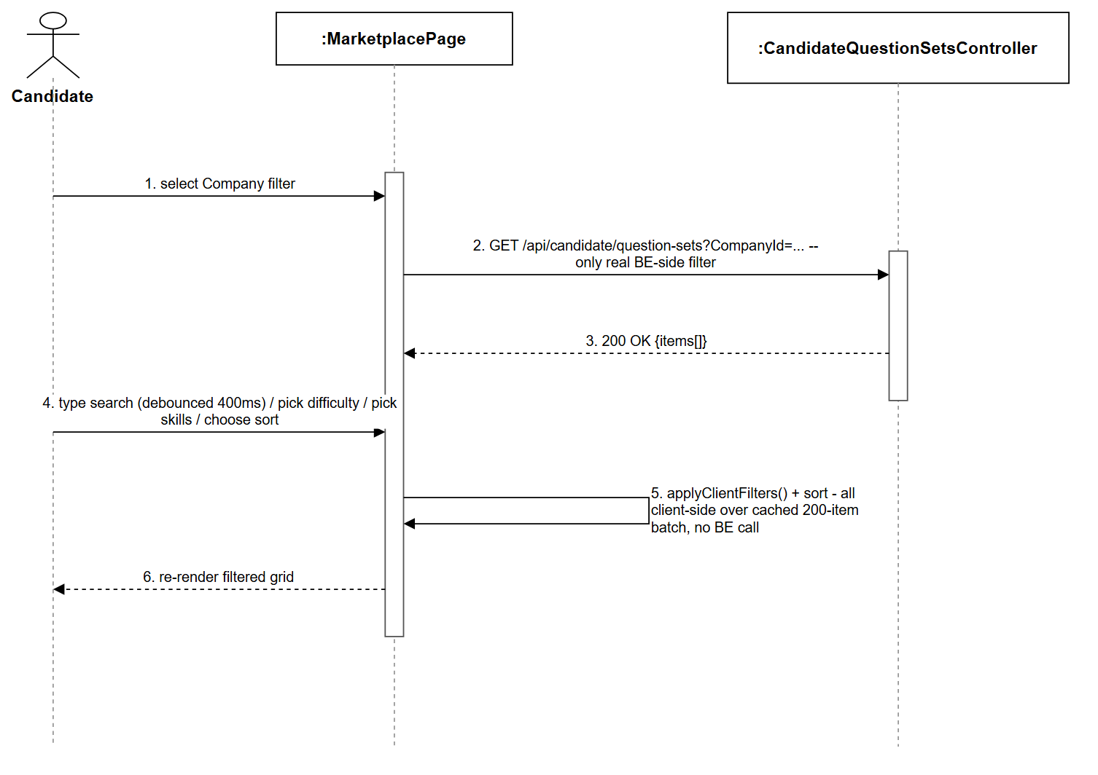
Figure 3.9.2: Search & Filter Question Sets Sequence Diagram (Link)

3.9.3 View Question Sets
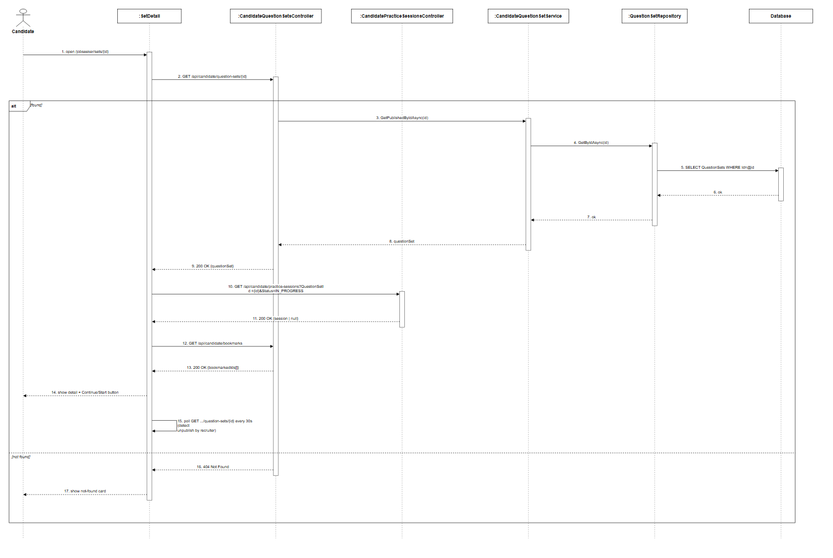
Figure 3.9.3: View Question Sets Sequence Diagram (Link)

3.9.4 Bookmark/Unbookmark Question Sets

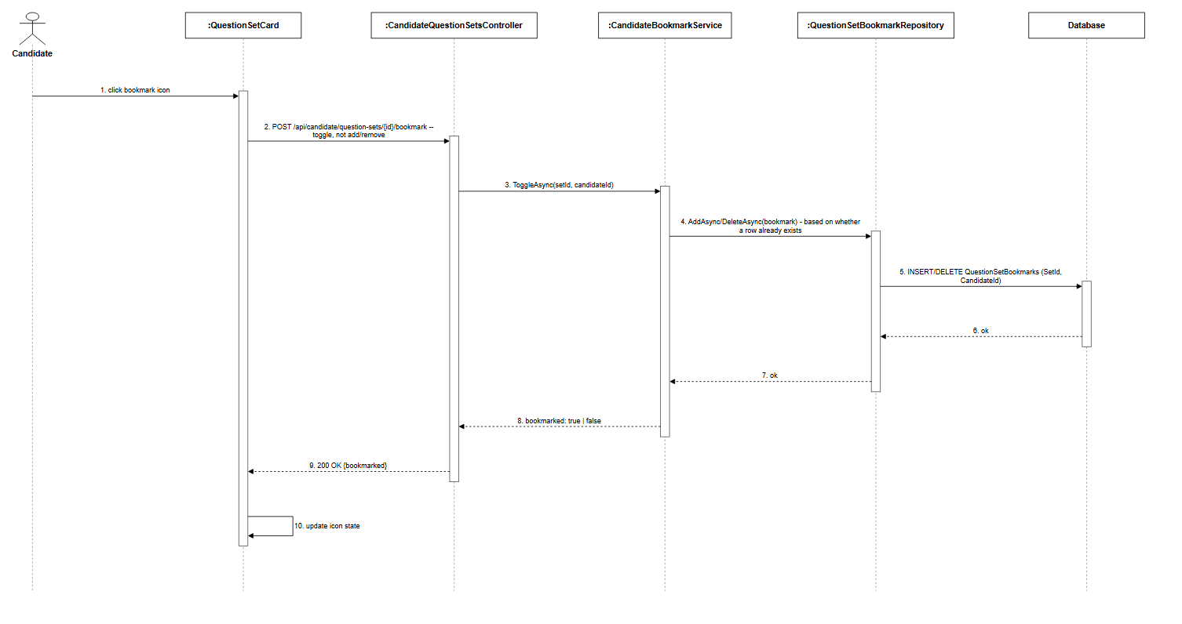
Figure 3.9.4: Bookmark/Unbookmark Question Sets Sequence Diagram (Link)

3.10 Practice Session Management

3.10.1 Start Practice Sessions
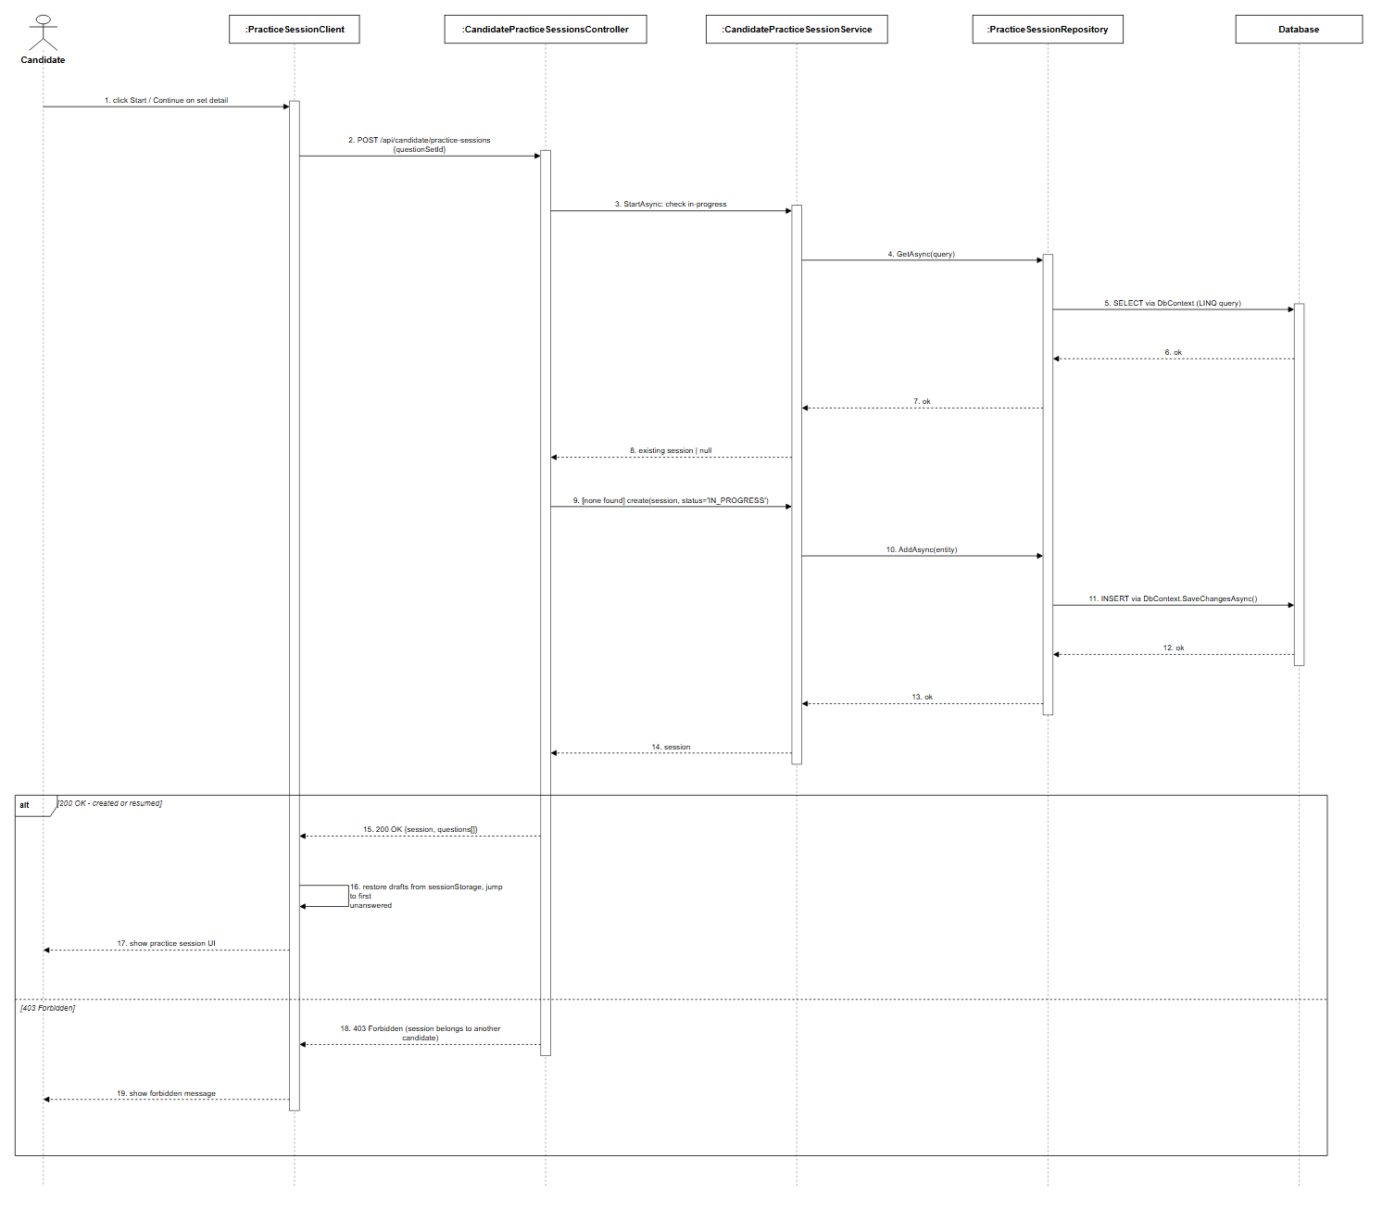
Figure 3.10.1: Start Practice Sessions Sequence Diagram (Link)

3.10.2 Answer Question & Navigate

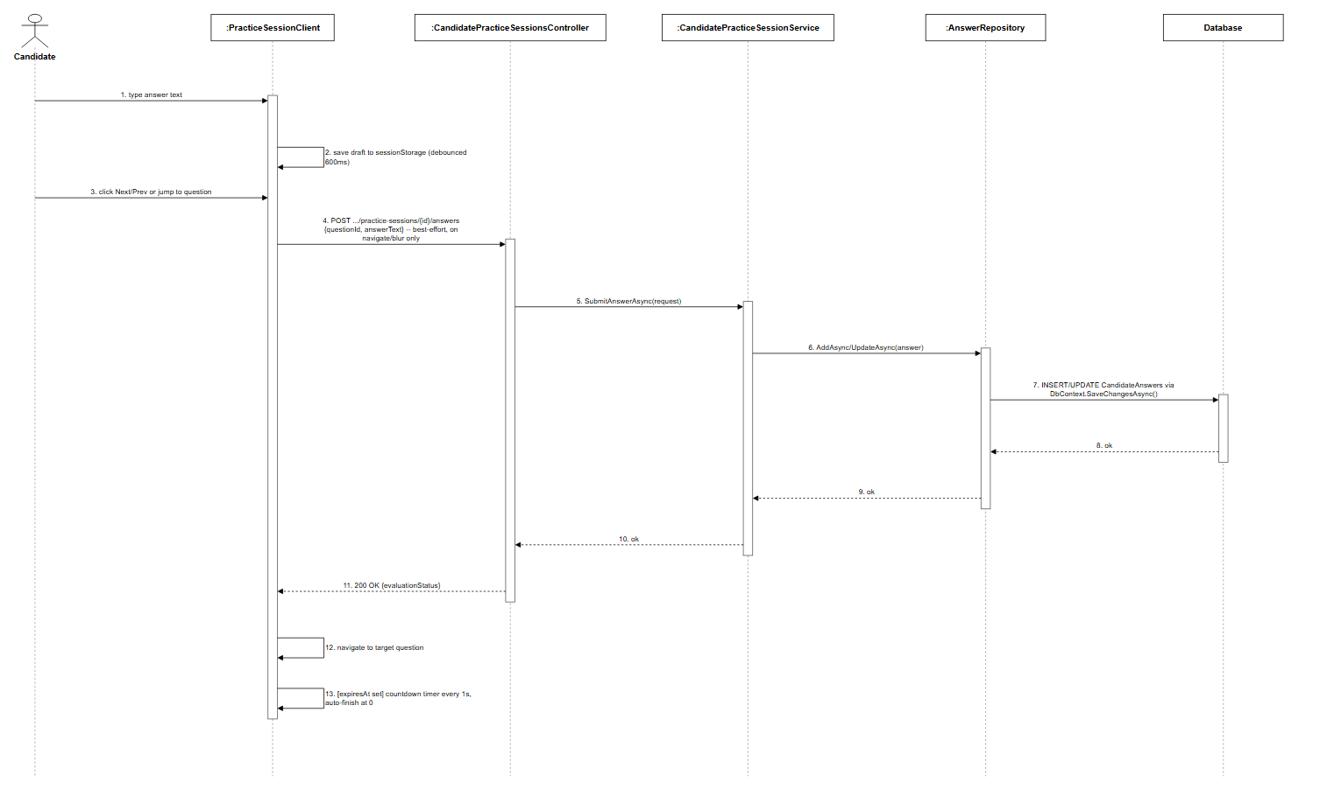
Figure 3.10.2: Answer Question & Navigate Sequence Diagram (Link)

3.10.3 Submit Answers

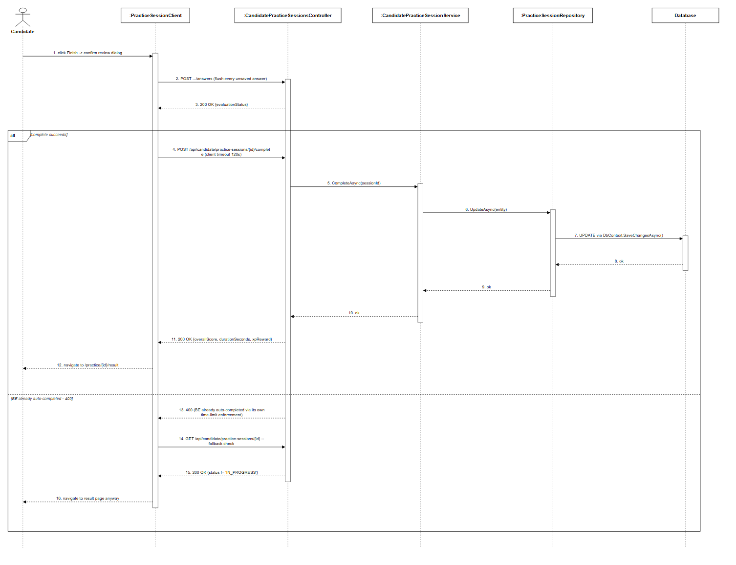
Figure 3.10.3: Submit Answers Sequence Diagram (Link)

3.10.4 View Practice History

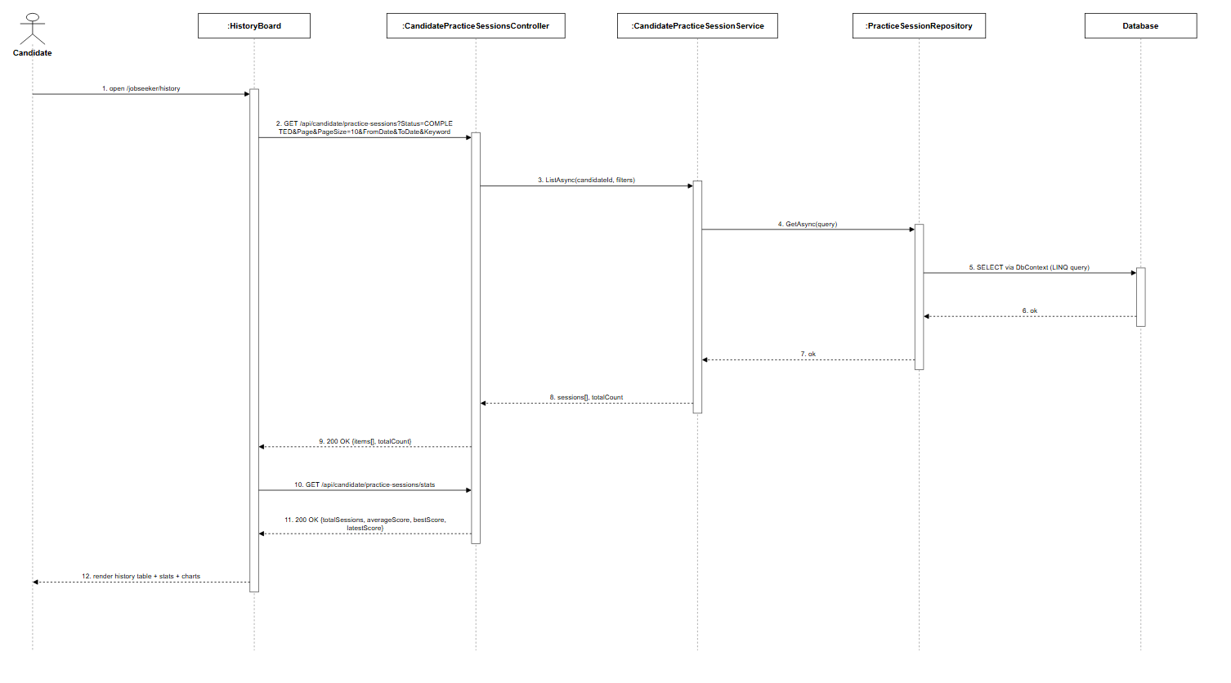
Figure 3.10.4: View Practice History Sequence Diagram (Link)

3.11 AI Answer Evaluation and Feedback Management

3.11.1 Evaluate Candidate Answer

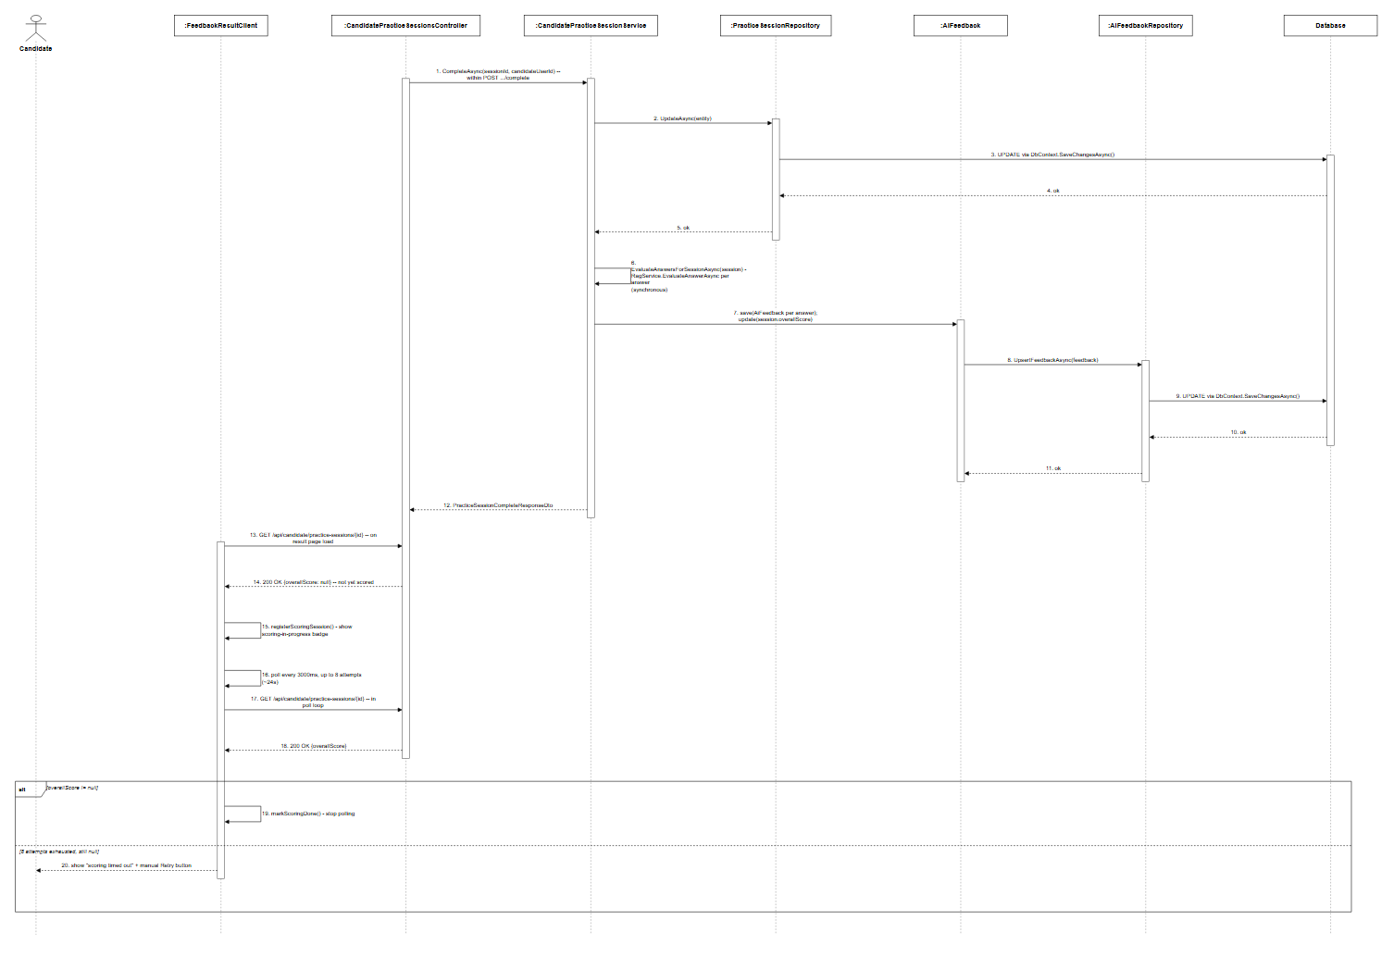
Figure 3.11.1: Evaluate Candidate Answer Sequence Diagram (Link)

3.11.2 View AI Feedback Result
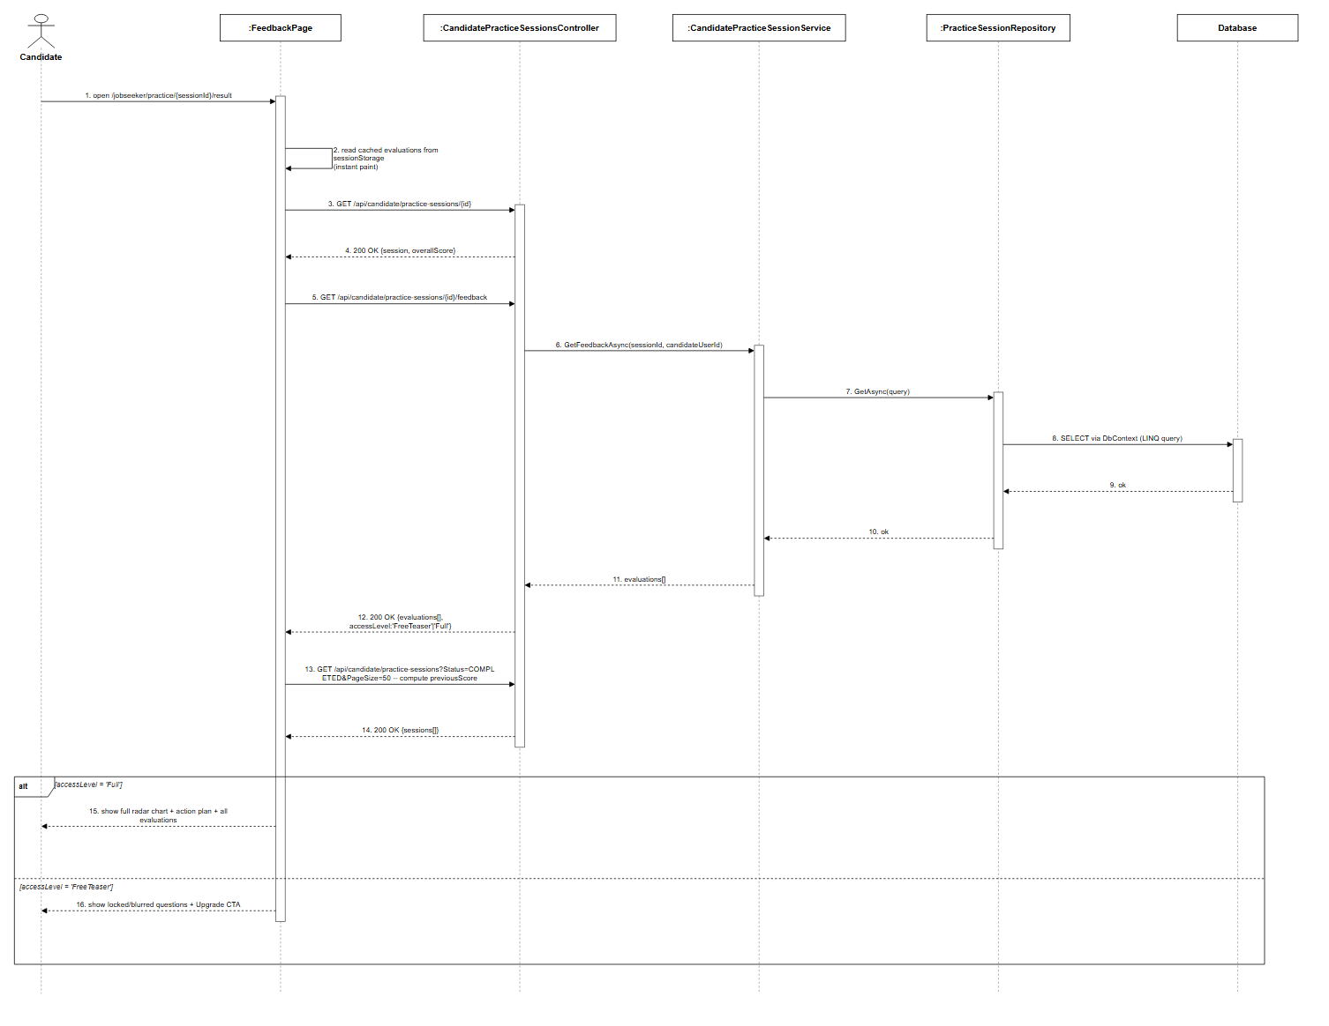
Figure 3.11.2: View AI Feedback Result Sequence Diagram (Link)

3.11.3 View Interview Summary

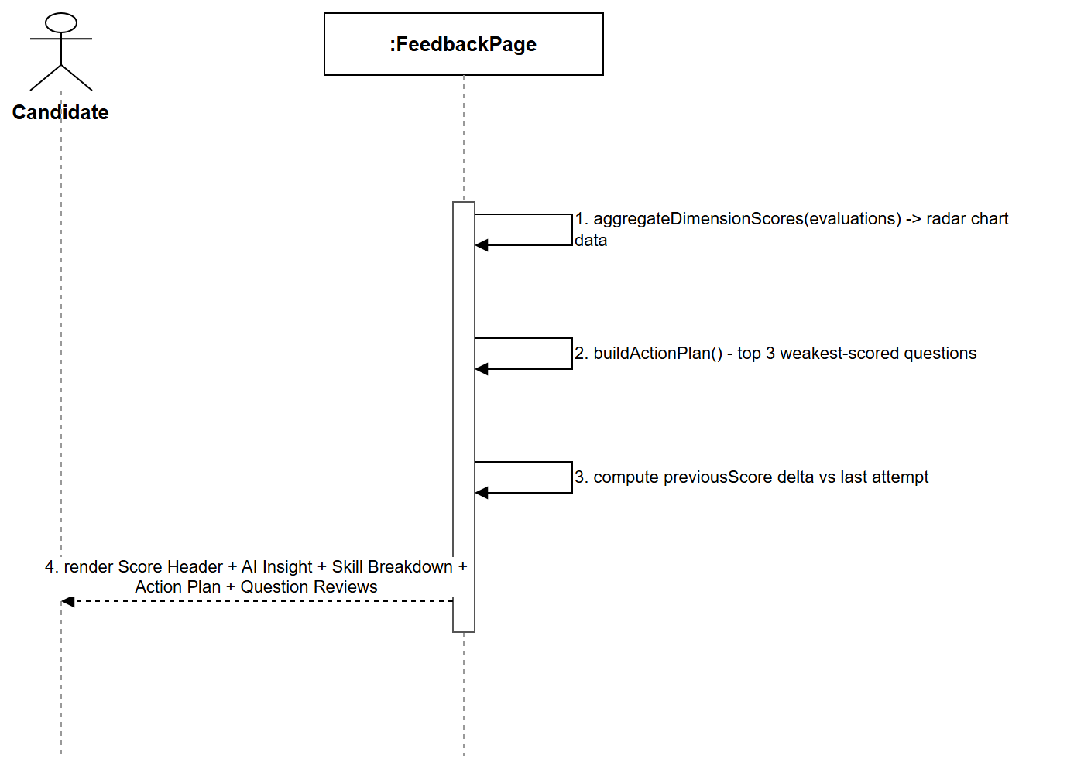
Figure 3.11.3: View Interview Summary Sequence Diagram (Link)

3.13 HR Analytics Management
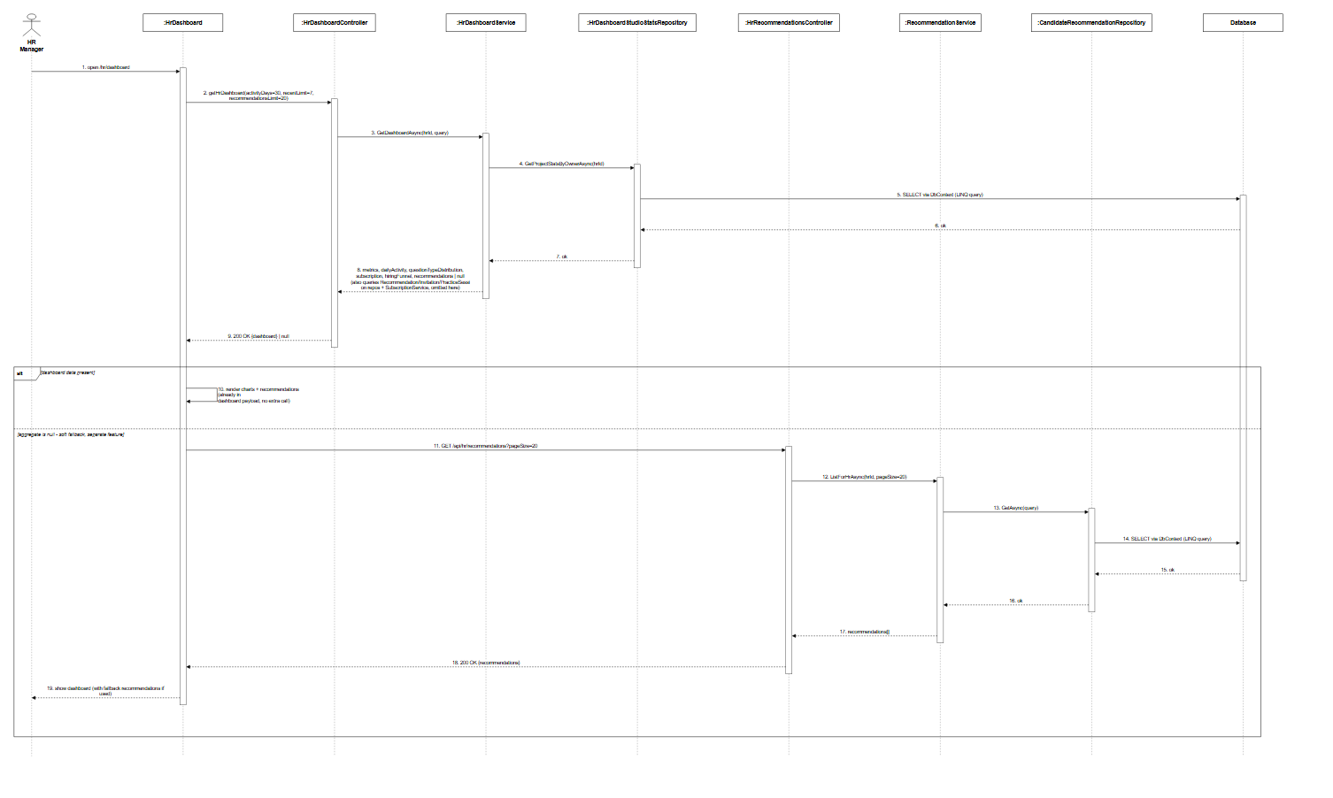
Figure 3.13: HR Analytics Management Sequence Diagram (Link)

3.14 RAG Quality Evaluation Management

3.15 Subscription and Payment Management
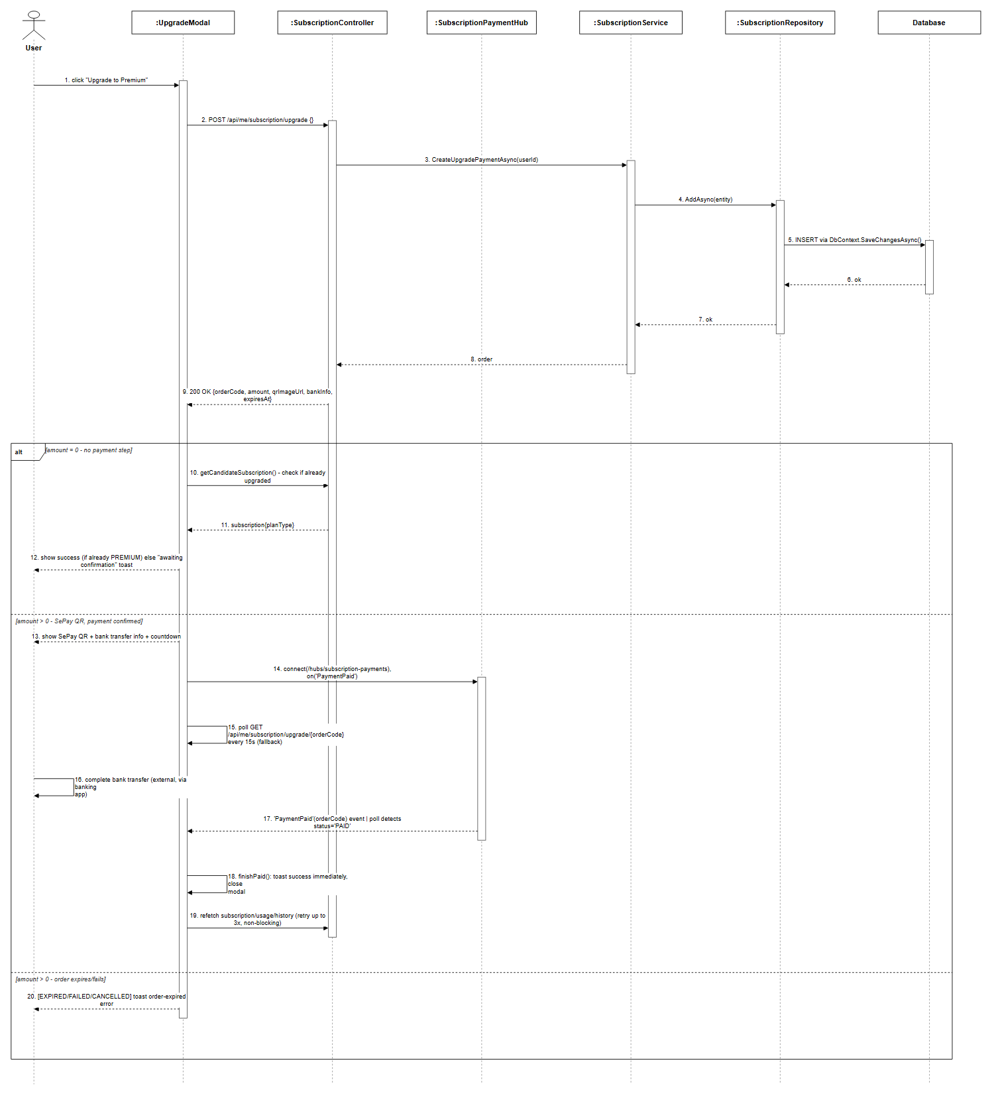
Figure 3.15: Subscription and Payment Management Sequence Diagram (Link)

3.16 Audit Log and Error Handling Management

3.16.1 HR Manager Audit Logging
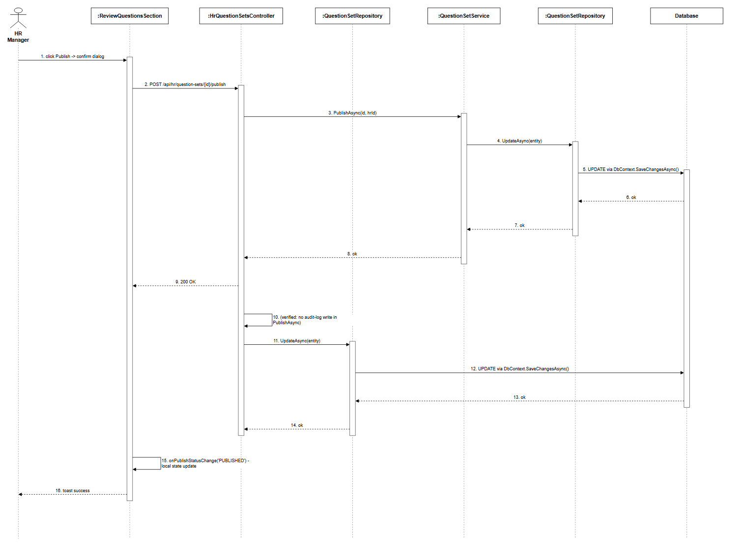
Figure 3.16.1: HR Manager Audit Logging Sequence Diagram (Link)

3.16.2 Candidate Audit Log and Error Handling
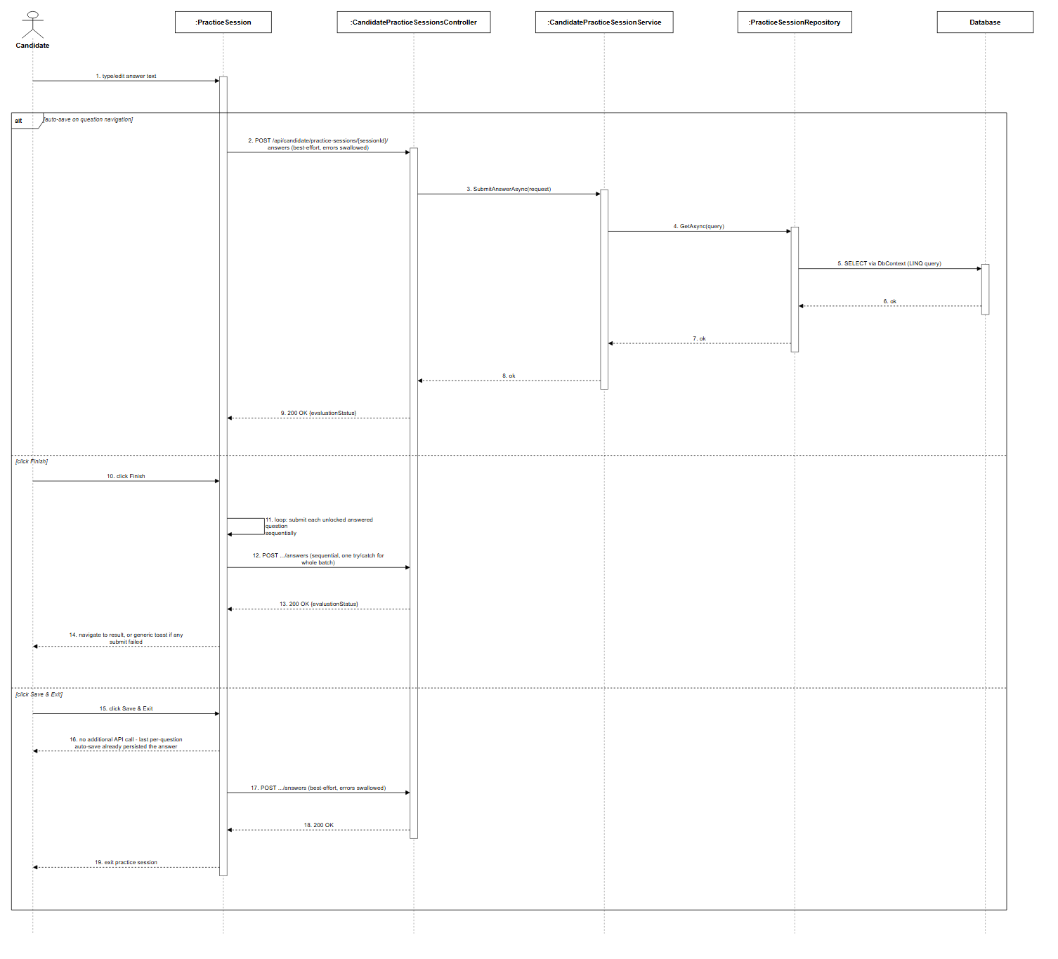
Figure 3.16.2: Candidate Audit Log and Error Handling Sequence Diagram (Link)

3.17 System Configuration Management

3.17.2 Administrator - System Configuration
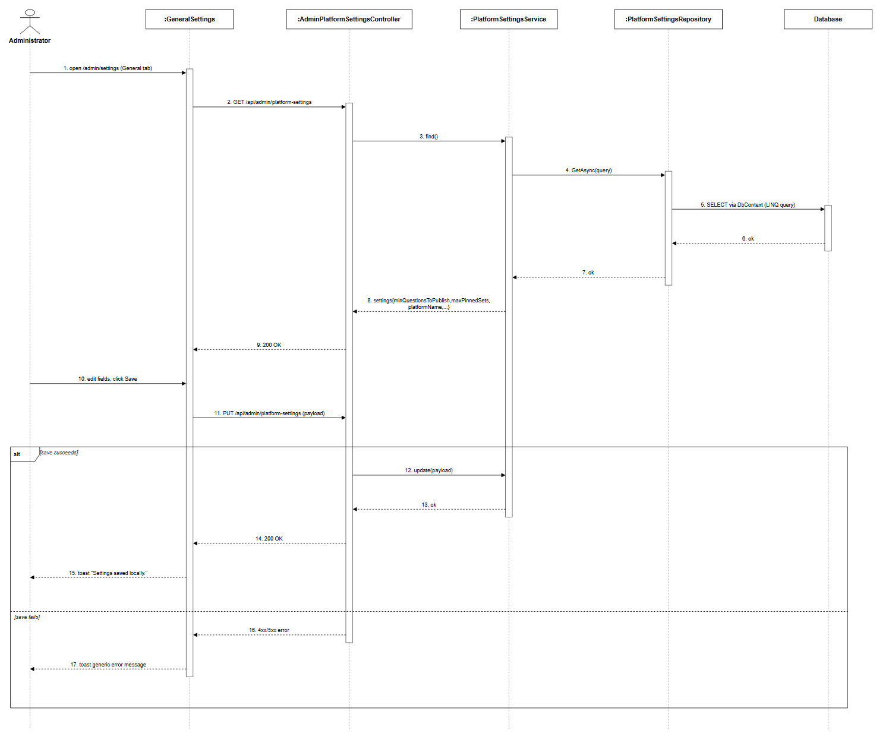
Figure 3.17.2: Administrator - System Configuration Sequence Diagram (Link)

3.18.1 Gamification - Progress, Daily Goal, XP History, Achievements
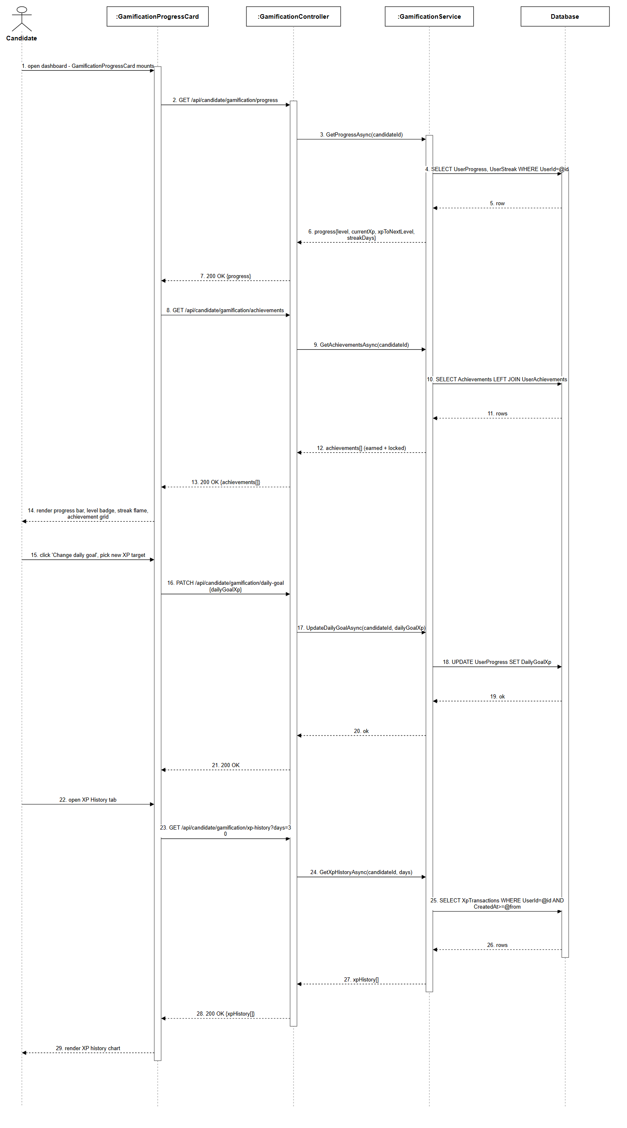
Figure 3.18.1: Gamification - Progress, Daily Goal, XP History, Achievements Sequence Diagram (Link)

3.19.1 AI Coach - Upload CV, Analysis, Roadmap
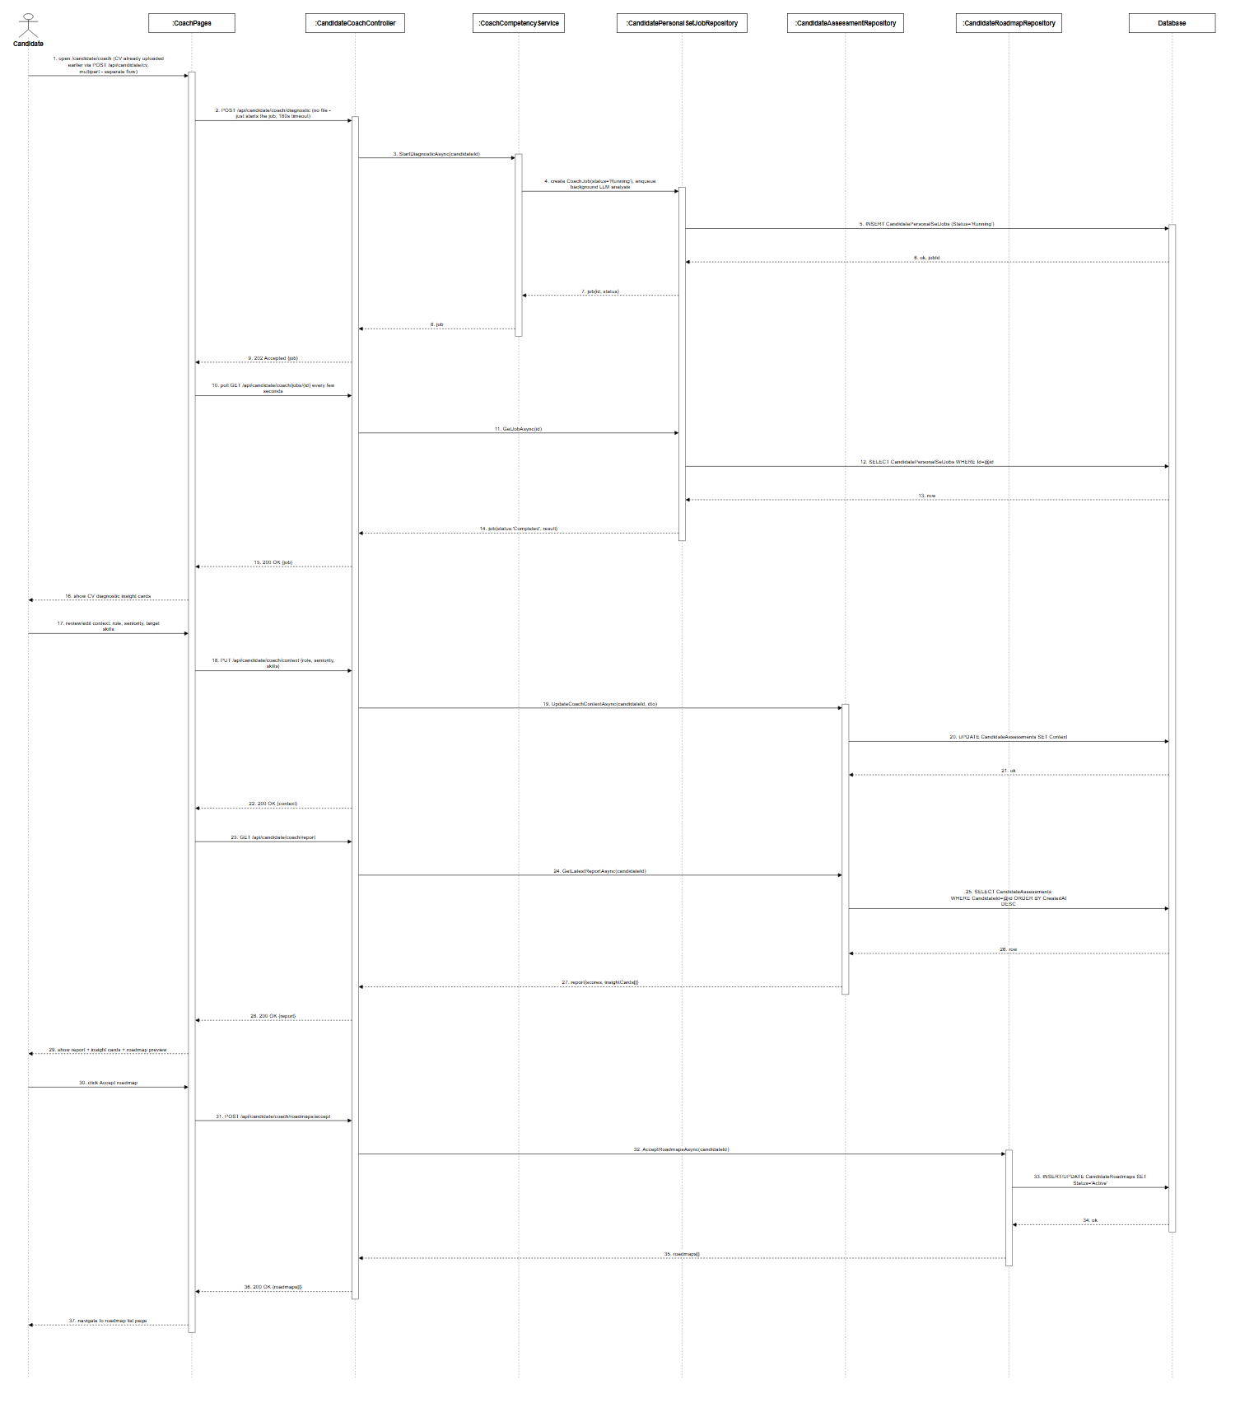
Figure 3.19.1: AI Coach - Upload CV, Analysis, Roadmap Sequence Diagram (Link)

3.20.1 Jobs Board - Browse Public JD, Take Assessment
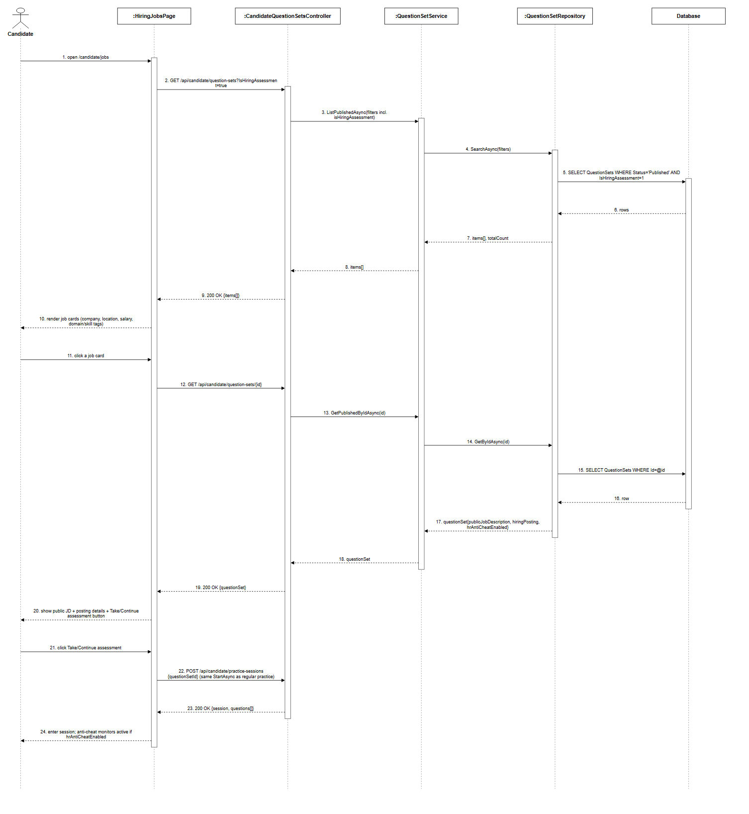
Figure 3.20.1: Jobs Board - Browse Public JD, Take Assessment Sequence Diagram (Link)

3.20.2 HR Public JD Editor and Hiring Assessment Mode
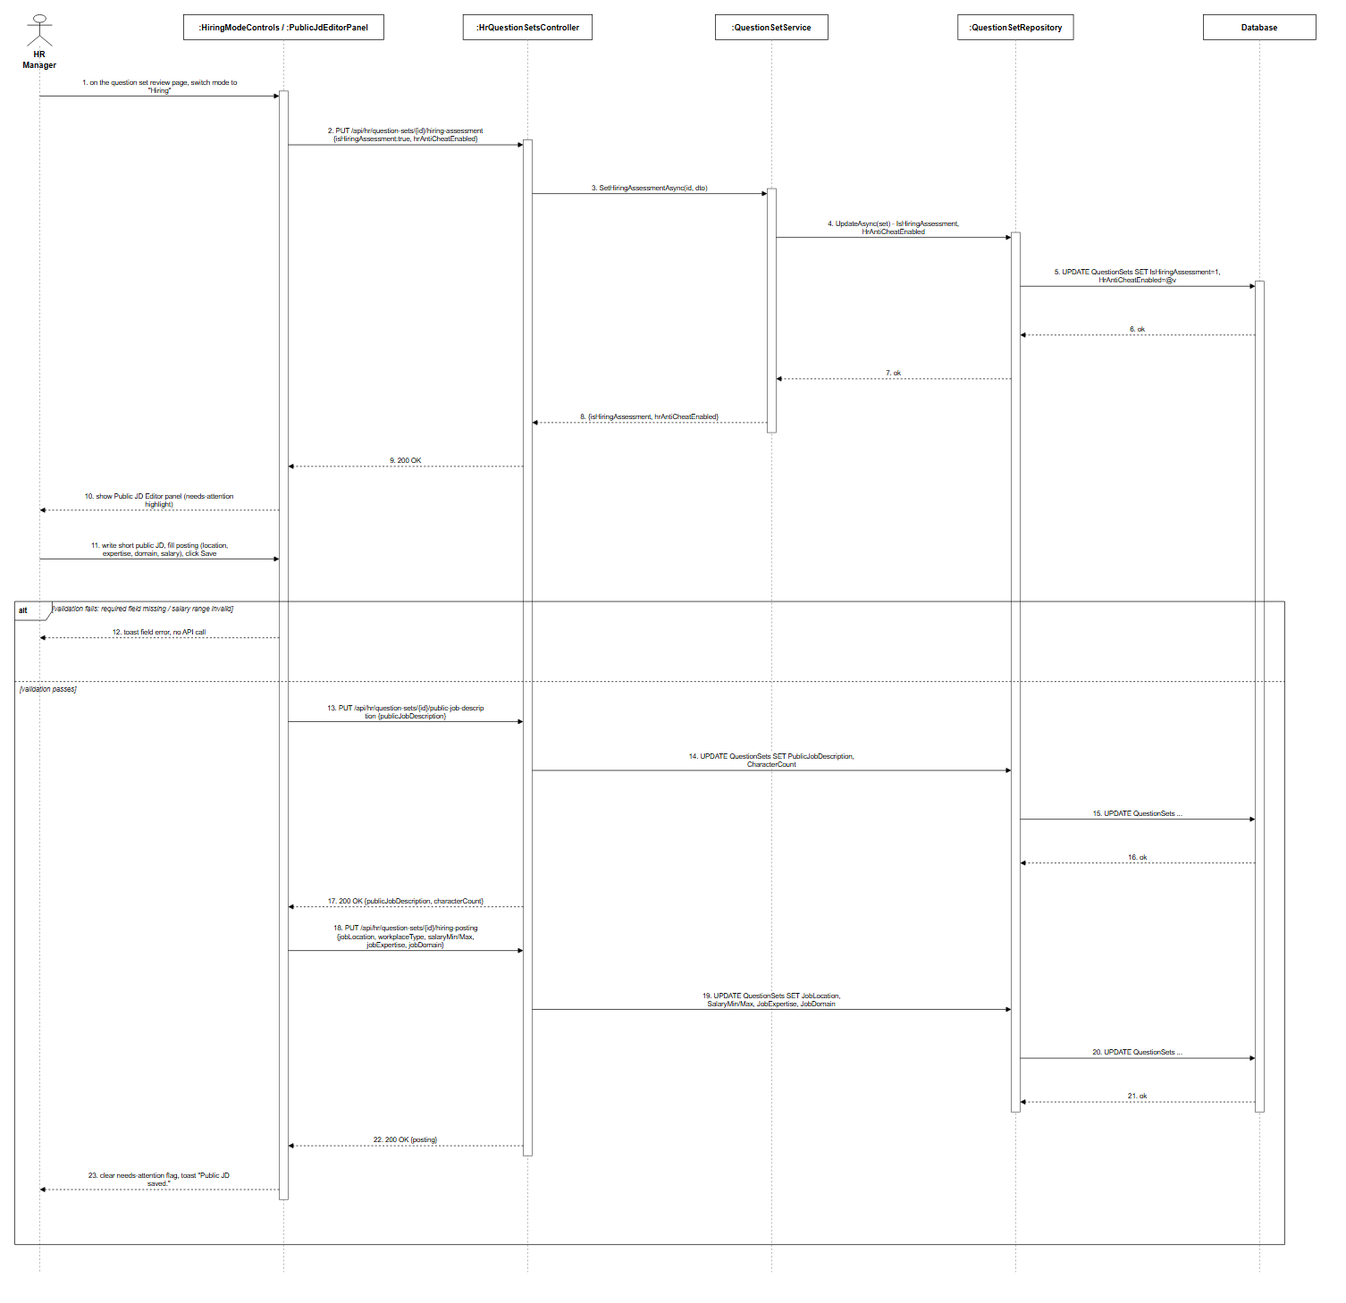
Figure 3.20.2: HR Public JD Editor and Hiring Assessment Mode Sequence Diagram (Link)

3.21.1 Interview Invitations - List, Accept, Decline
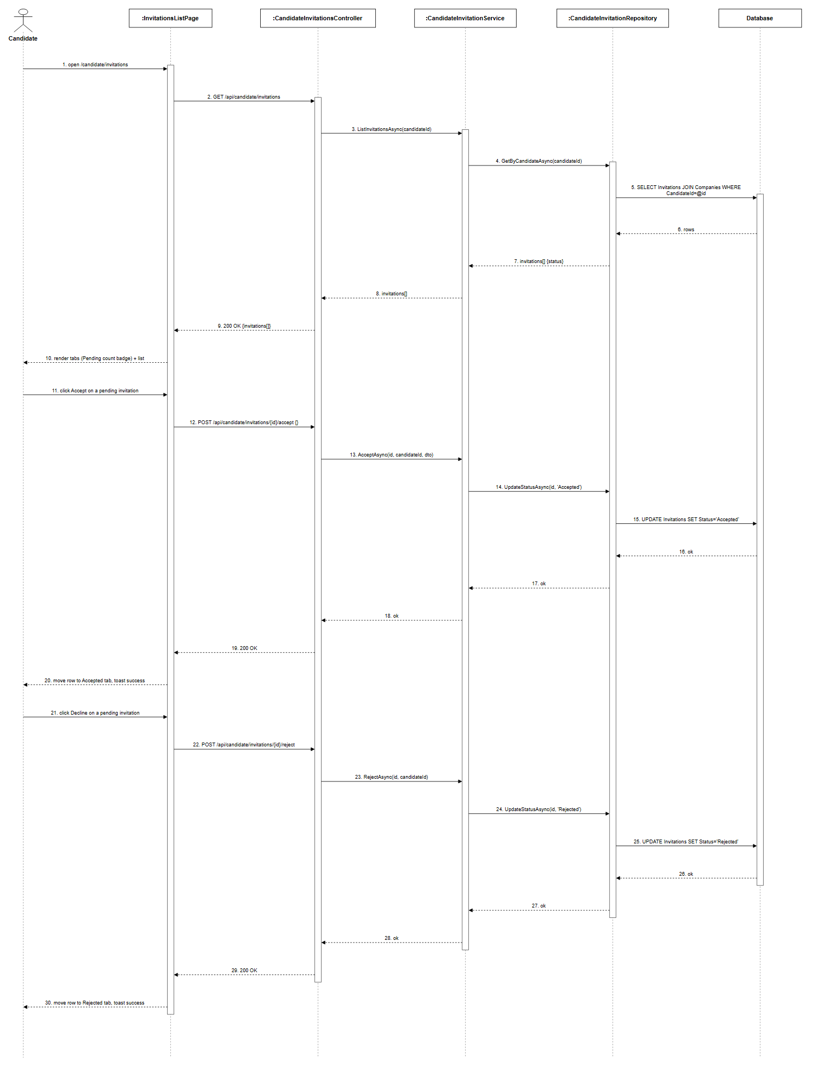
Figure 3.21.1: Interview Invitations - List, Accept, Decline Sequence Diagram (Link)

3.22.1 Export Question Set (Excel)
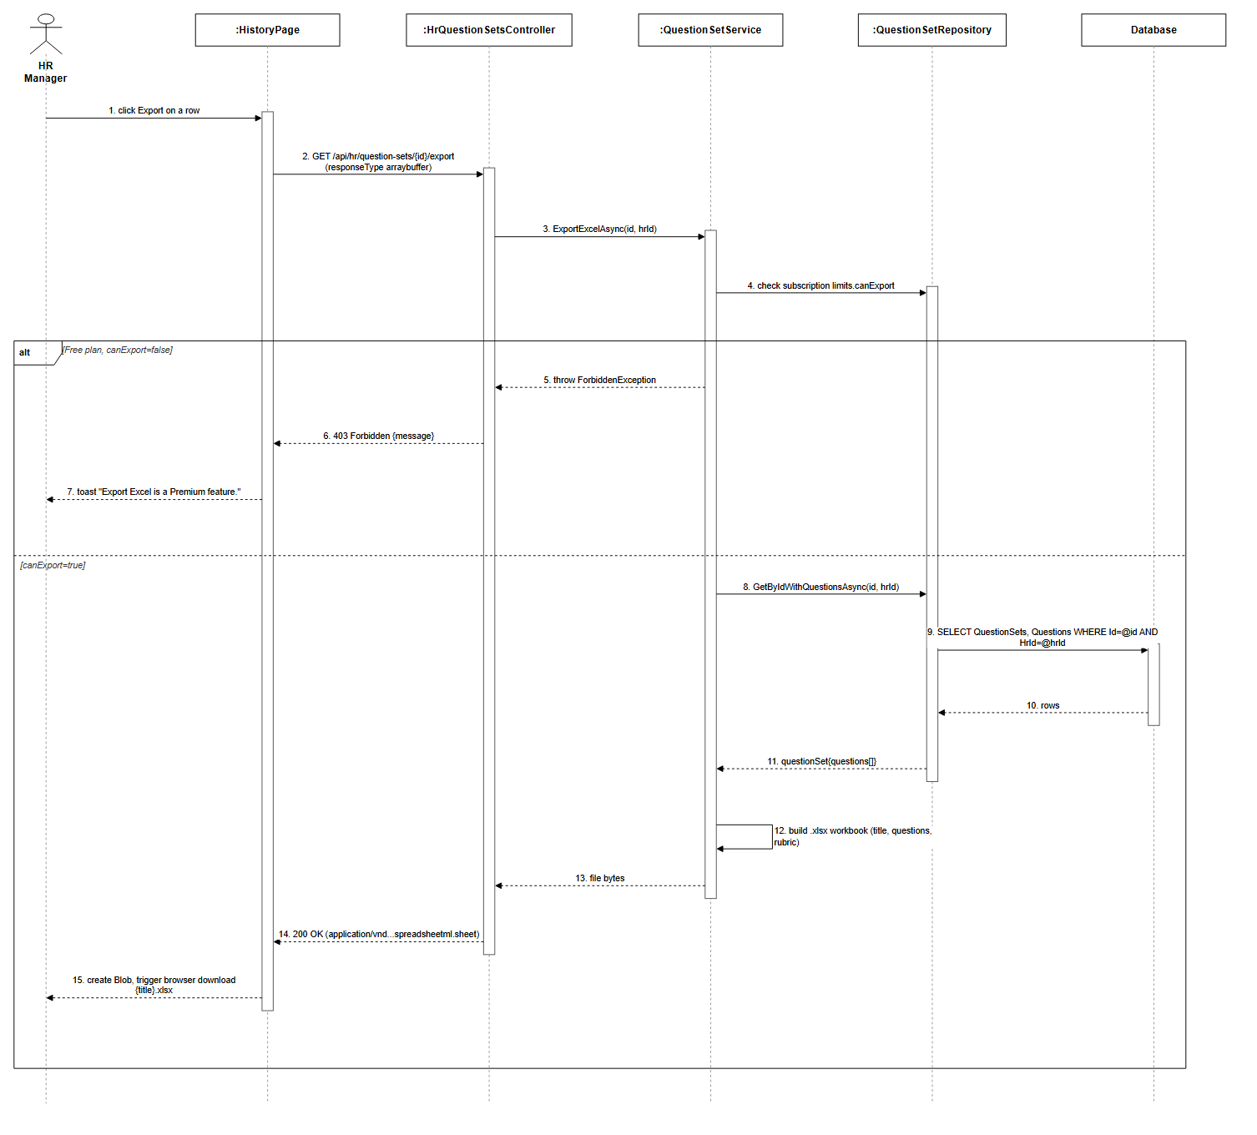
Figure 3.22.1: Export Question Set (Excel) Sequence Diagram (Link)

3.22.2 Manual Question Builder
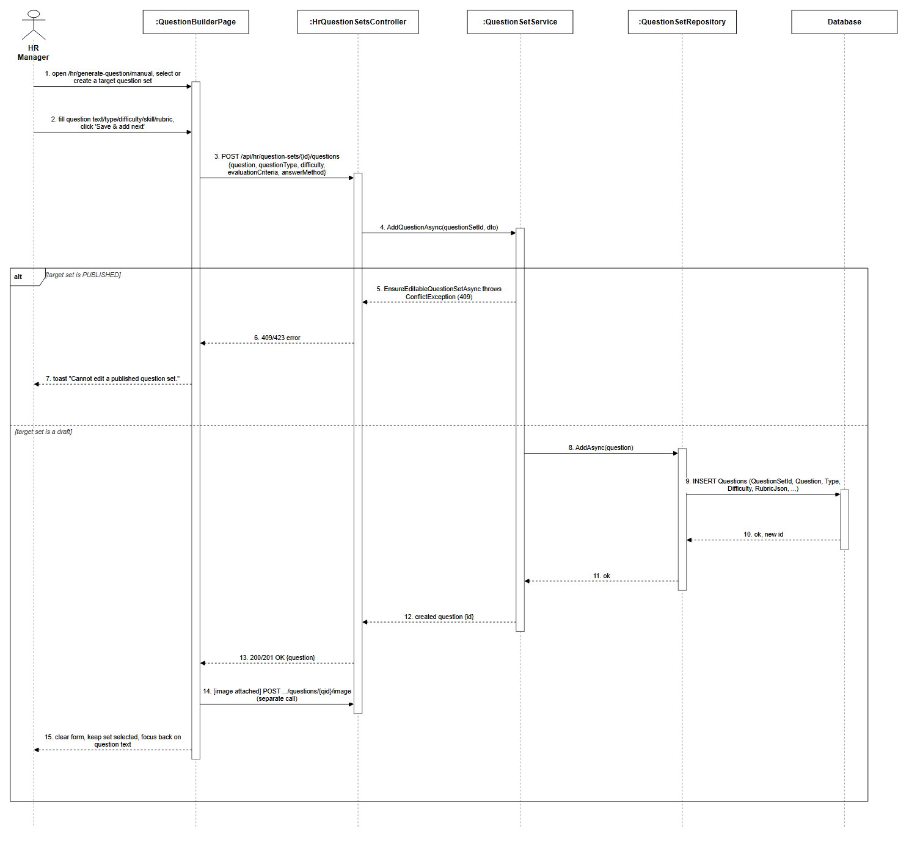
Figure 3.22.2: Manual Question Builder Sequence Diagram (Link)

3.23.1 Admin Roadmap Node Import (JSONL)
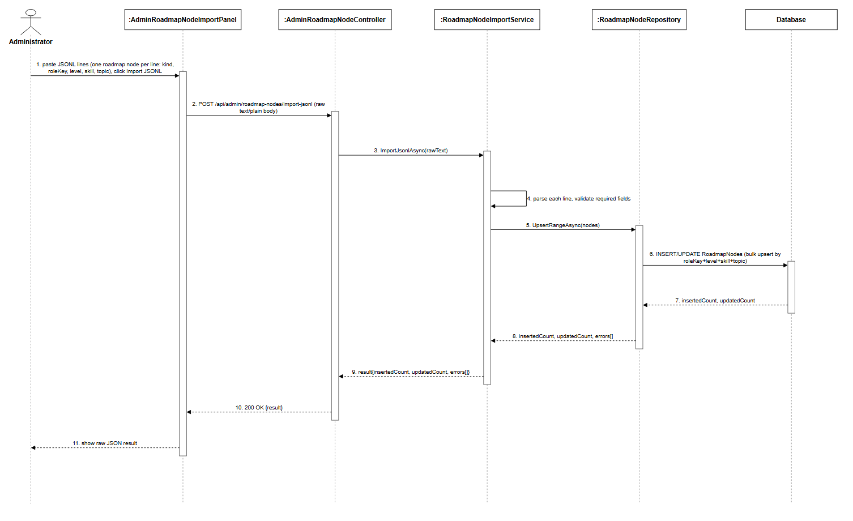
Figure 3.23.1: Admin Roadmap Node Import (JSONL) Sequence Diagram (Link)

3.24.1 Admin Grant/Revoke User Premium
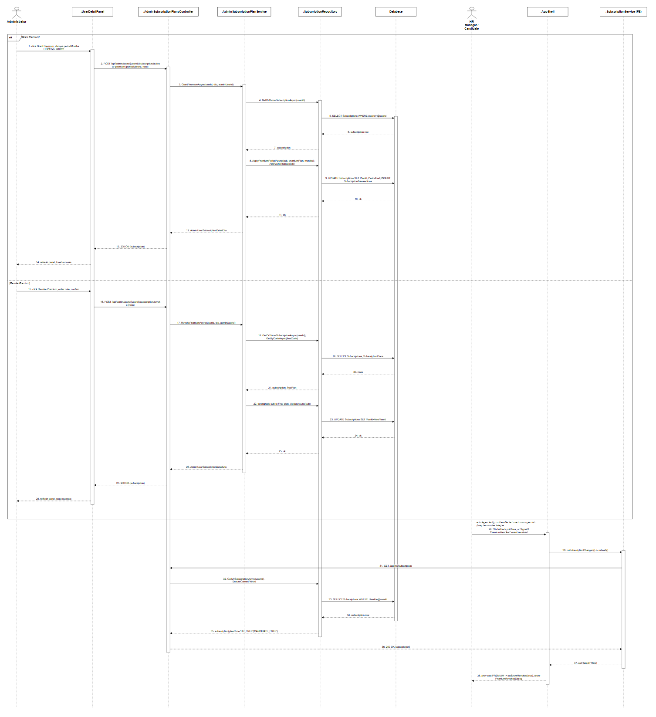
Figure 3.24.1: Admin Grant/Revoke User Premium Sequence Diagram (Link)

3.24.2 Admin Subscription Plans Management
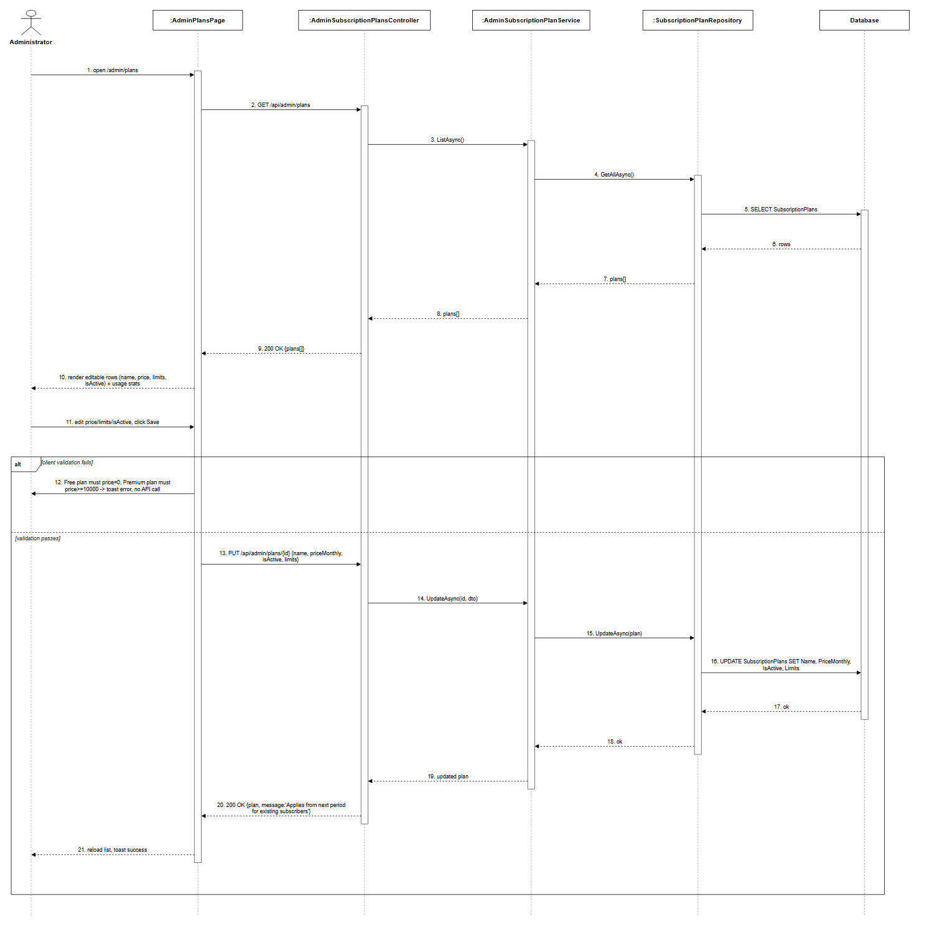
Figure 3.24.2: Admin Subscription Plans Management Sequence Diagram (Link)

3.25.1 Admin Marketplace Moderation
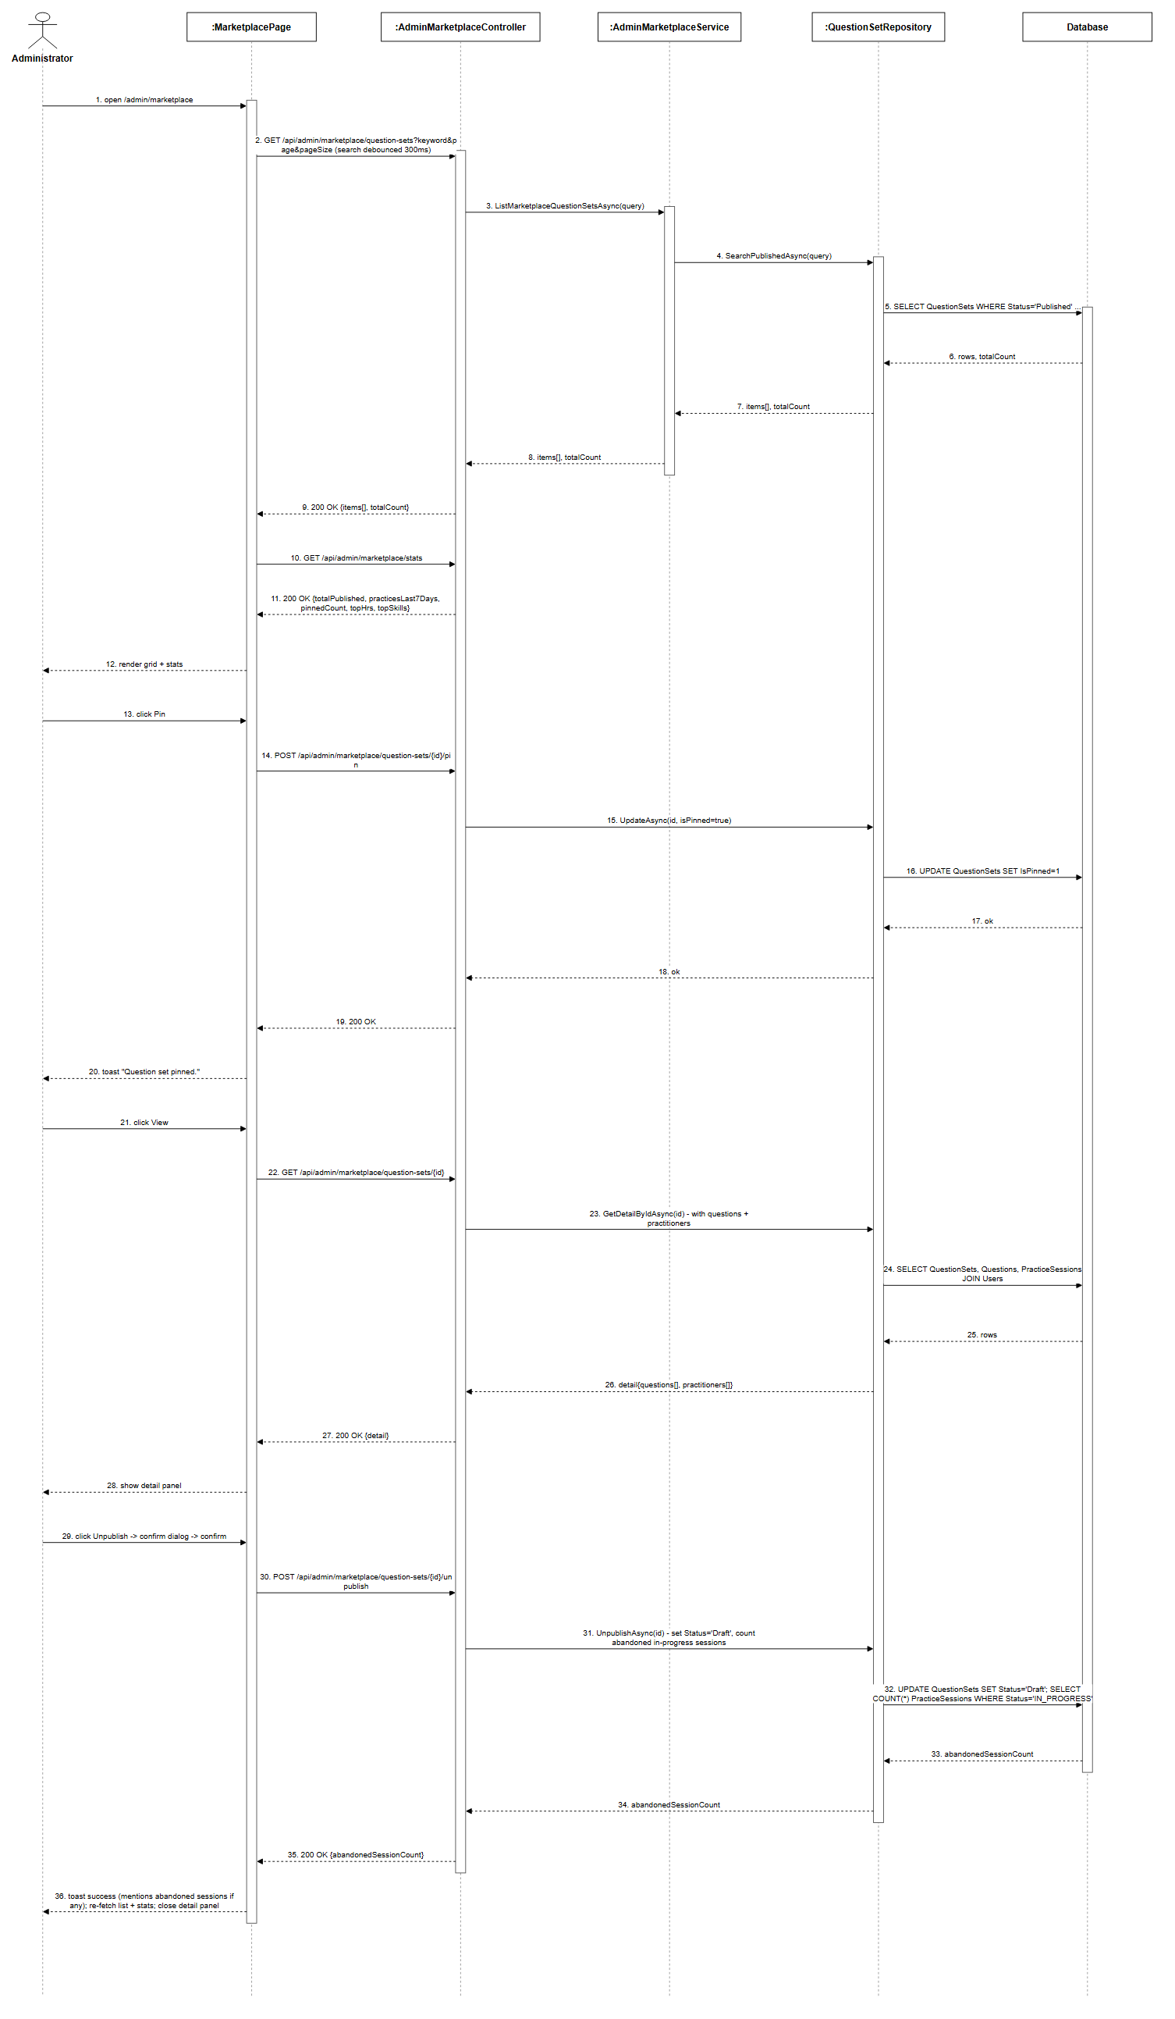
Figure 3.25.1: Admin Marketplace Moderation Sequence Diagram (Link)

3.26.1 Admin Dashboard
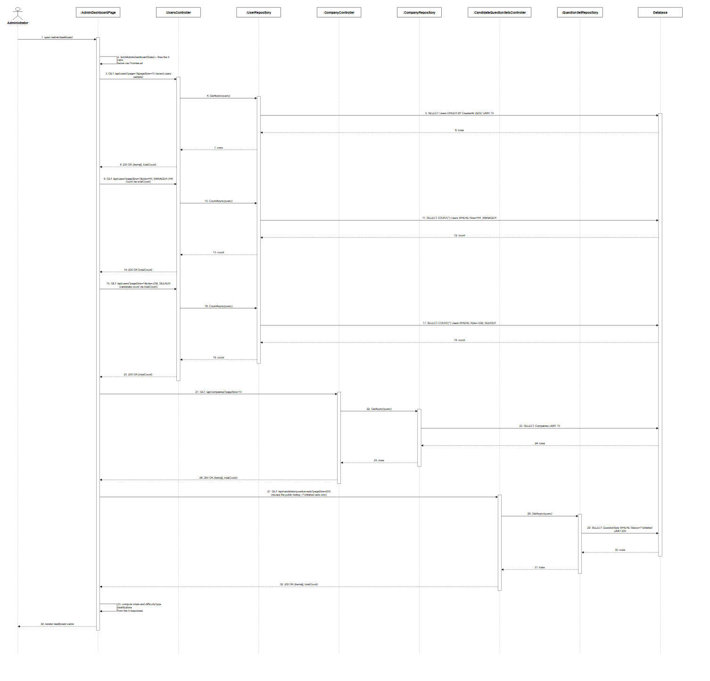
Figure 3.26.1: Admin Dashboard Sequence Diagram (Link)

3.26.2 Admin Feedbacks Management
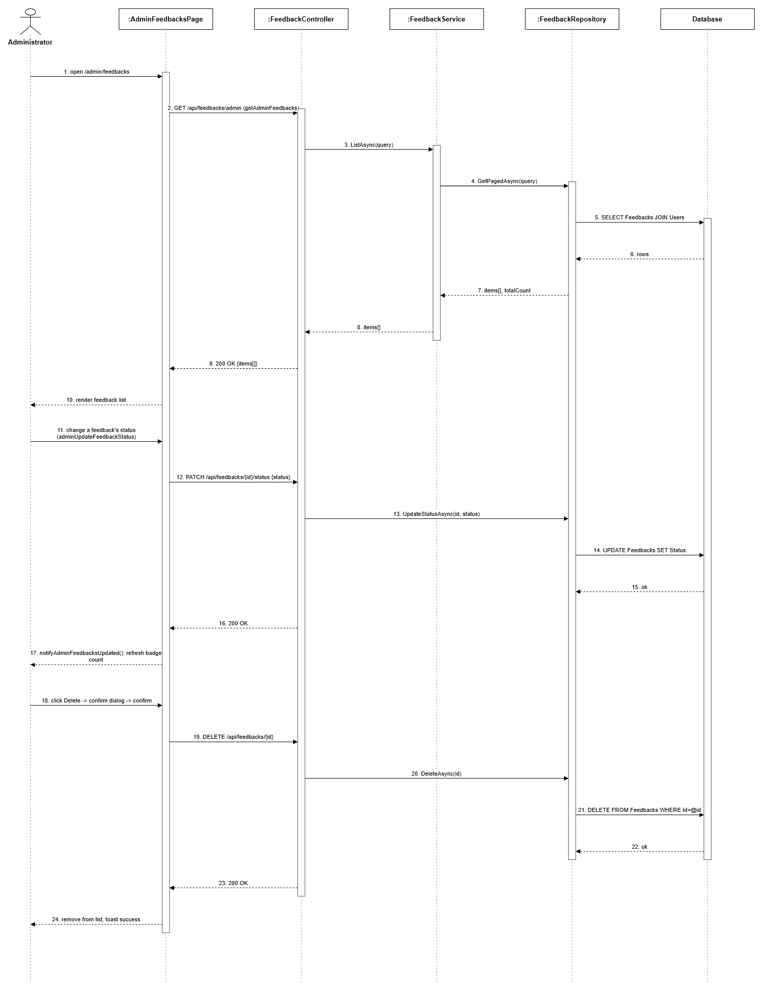
Figure 3.26.2: Admin Feedbacks Management Sequence Diagram (Link)

3.27.1 AI Configuration (Read-Only RAG Status Panel)
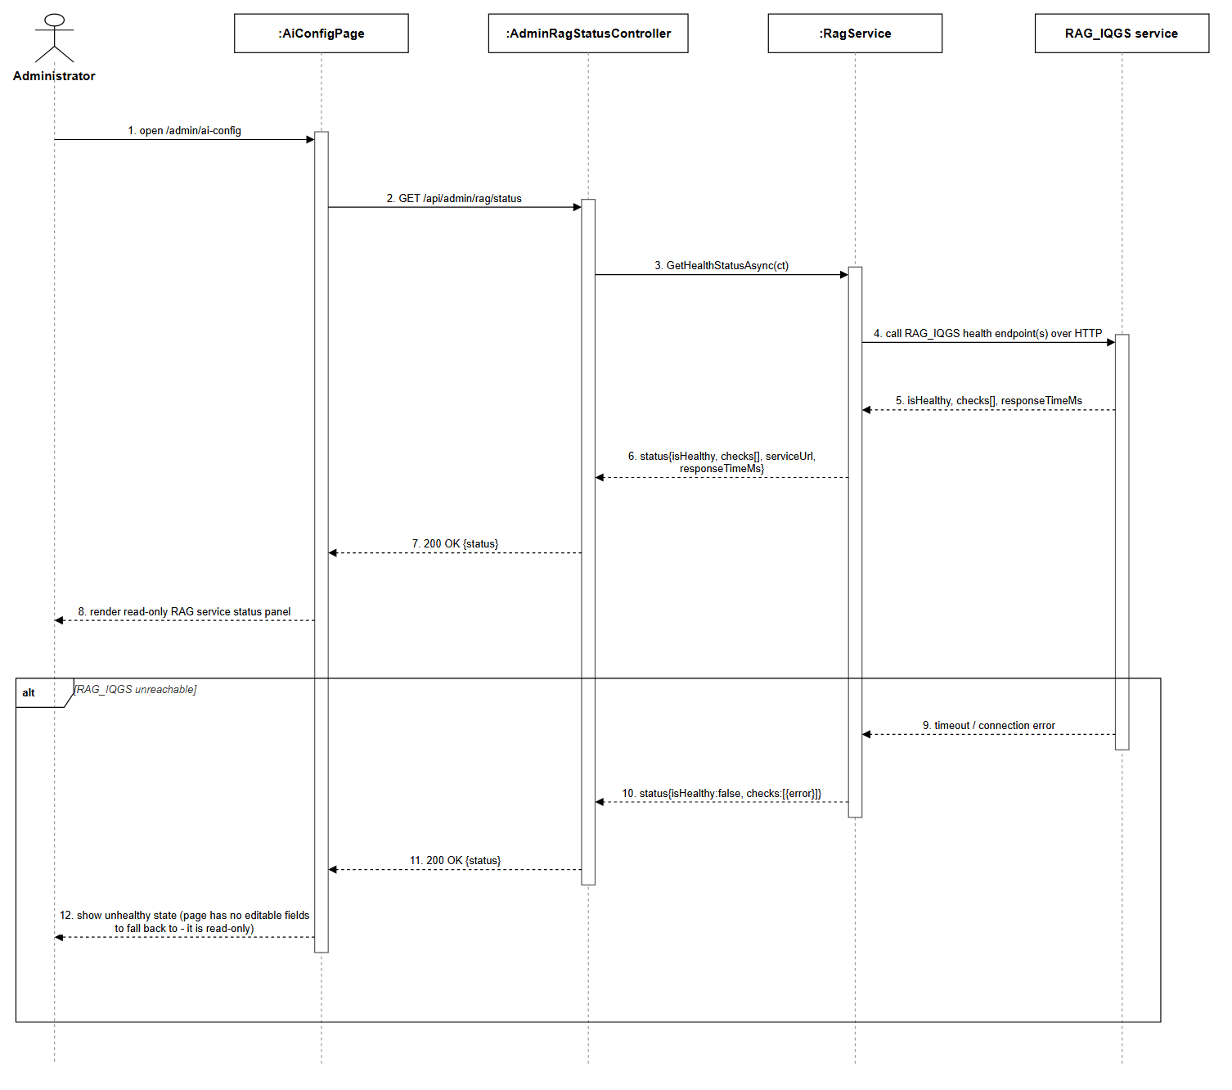
Figure 3.27.1: AI Configuration (Read-Only RAG Status Panel) Sequence Diagram (Link)

3.28.1 HR Published Insights
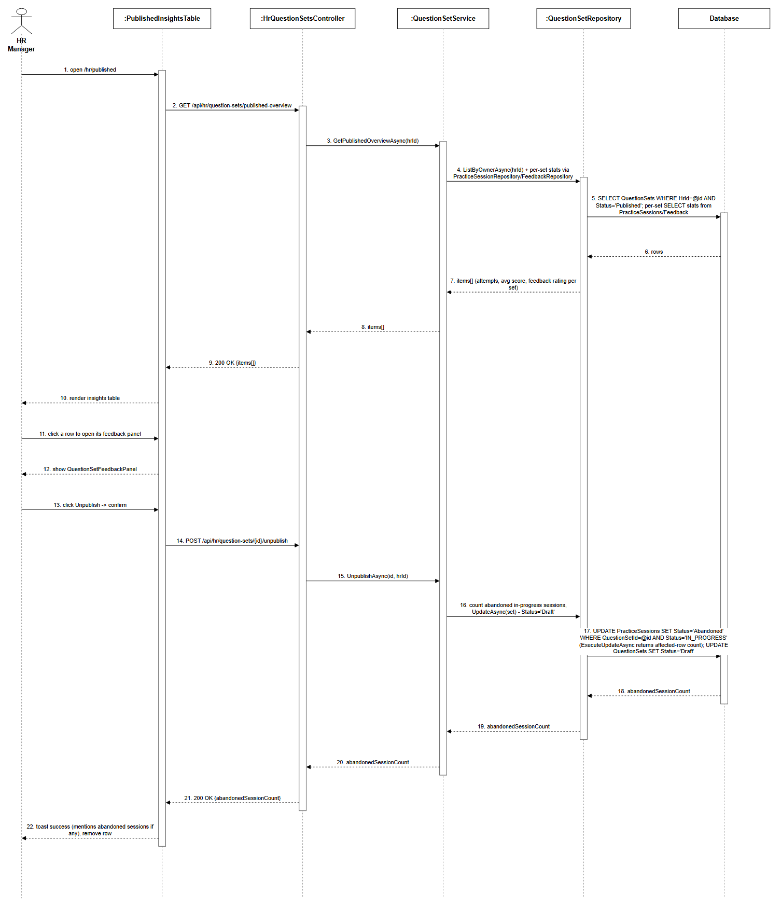
Figure 3.28.1: HR Published Insights Sequence Diagram (Link)

3.28.2 HR Candidate Recommendations
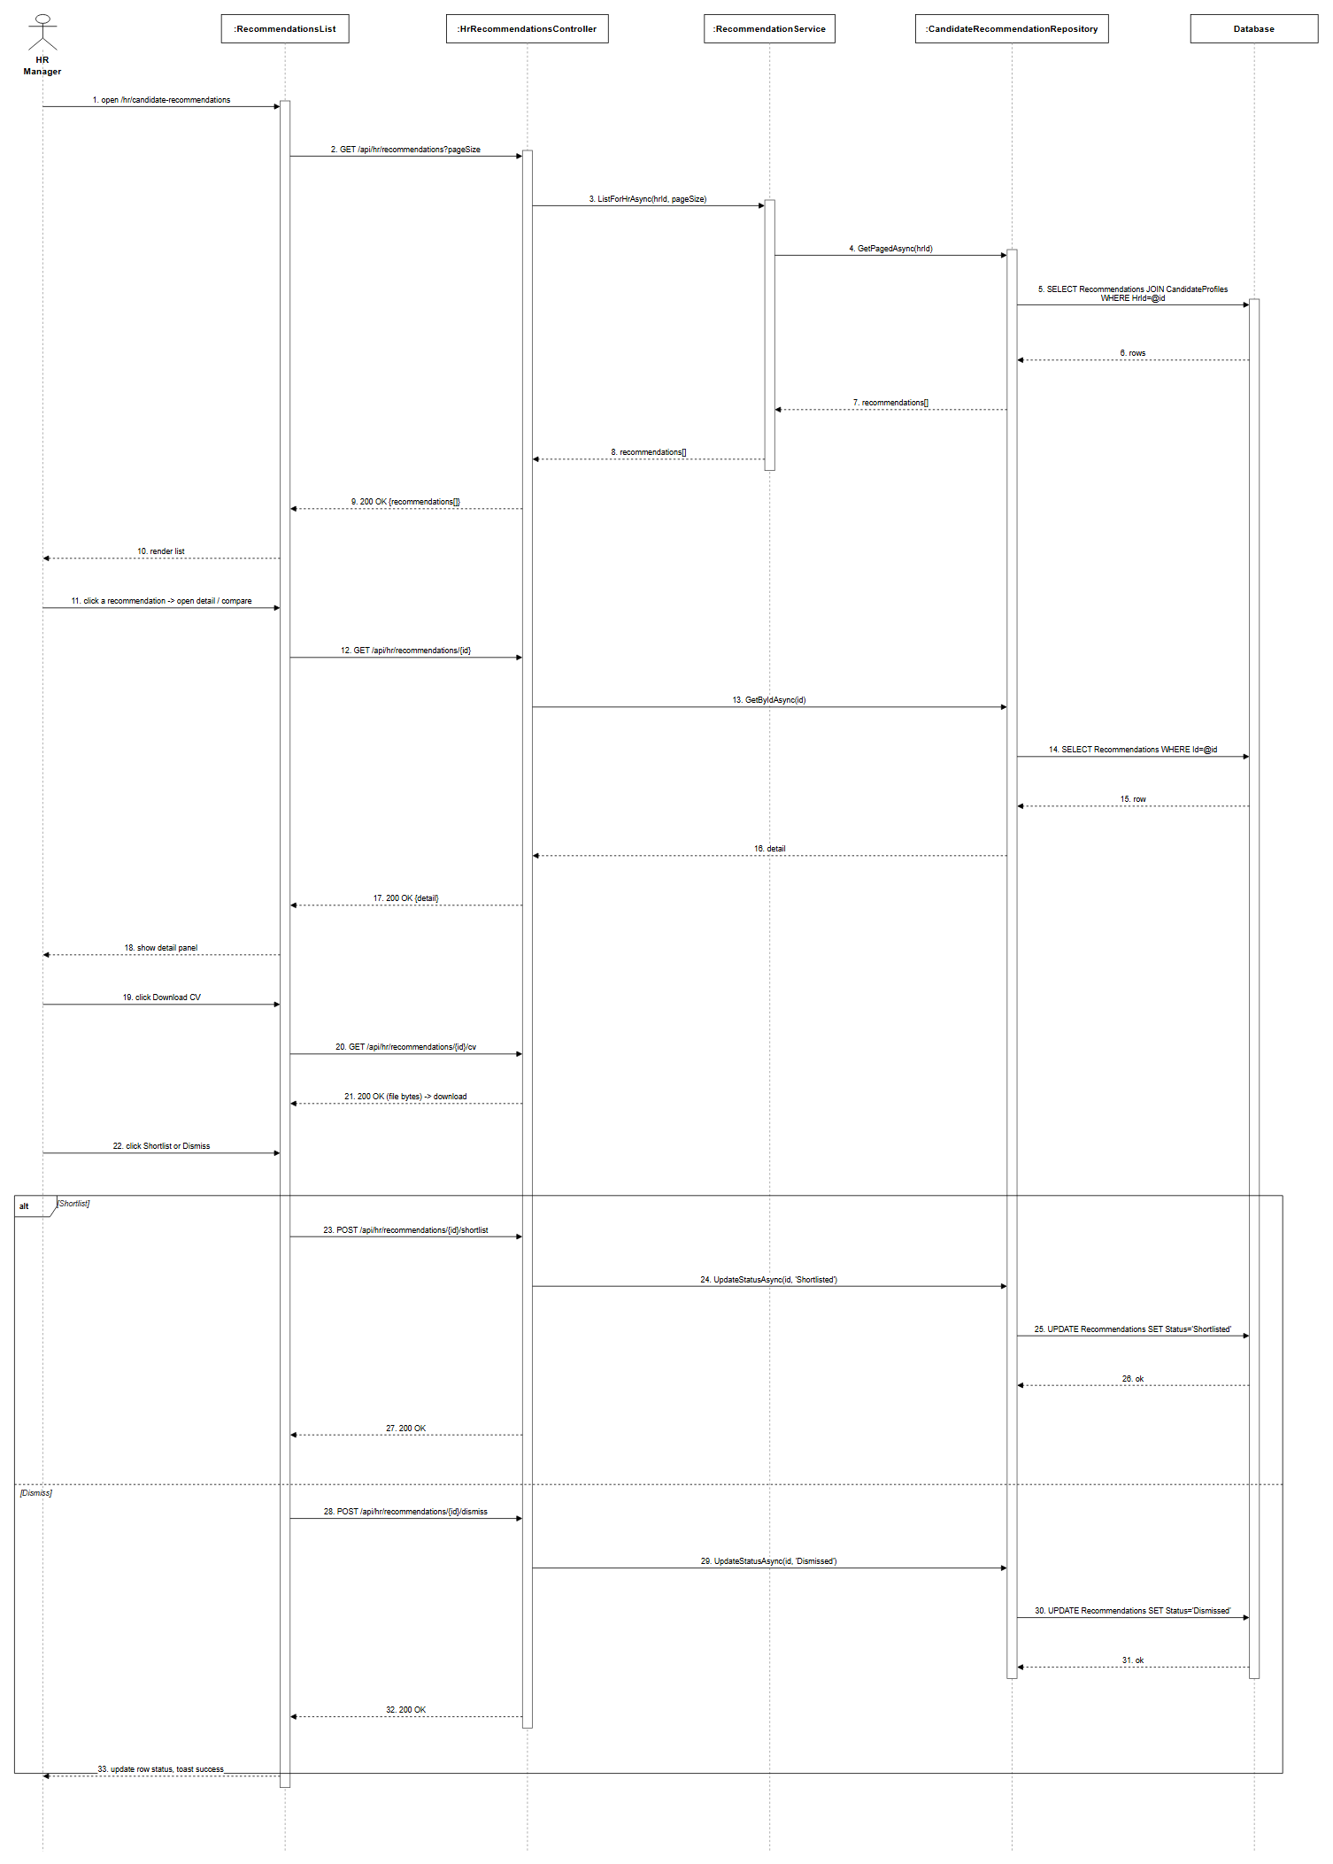
Figure 3.28.2: HR Candidate Recommendations Sequence Diagram (Link)

3.28.3 HR Question Set Practitioners
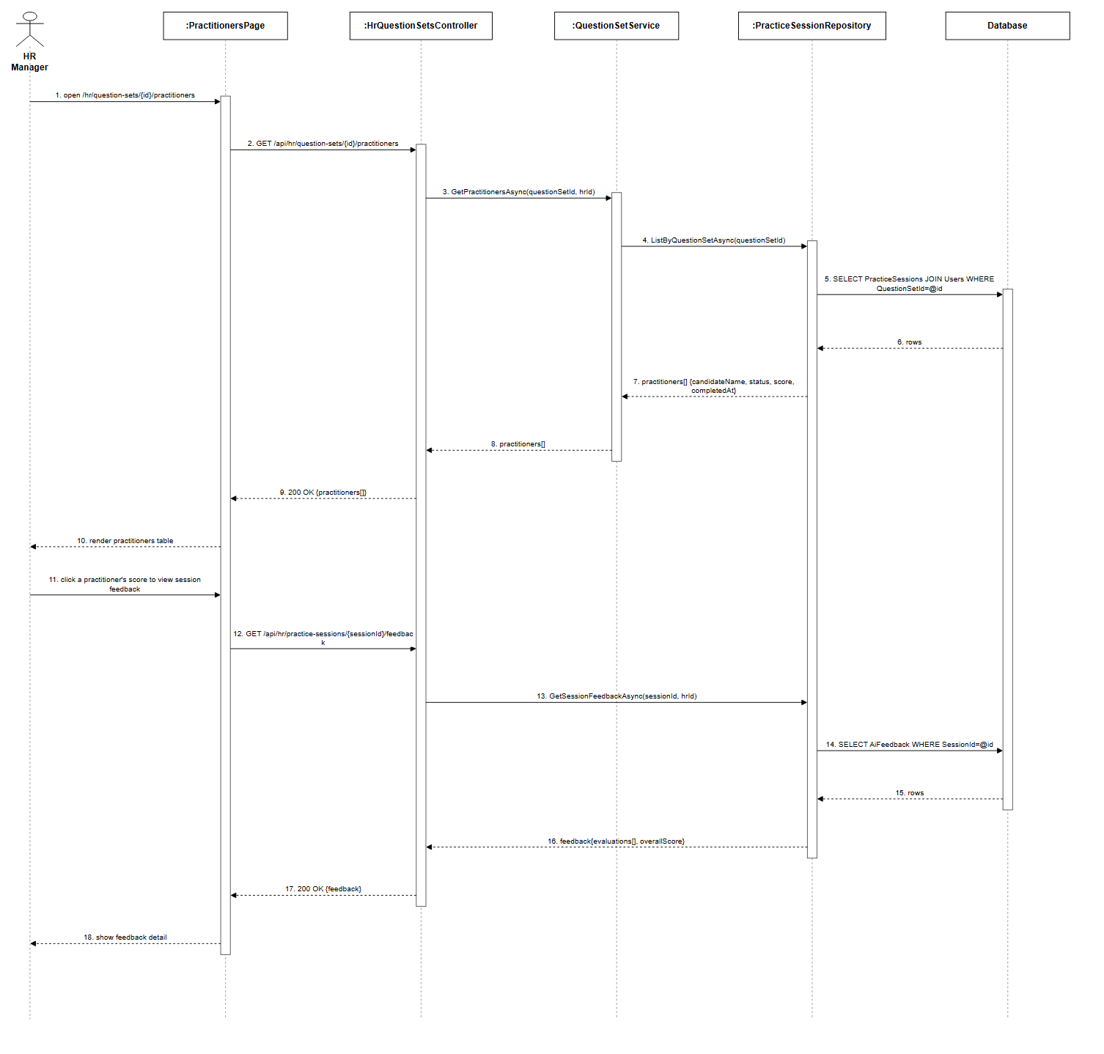
Figure 3.28.3: HR Question Set Practitioners Sequence Diagram (Link)

3.29.1 HR Talent Search and Invite
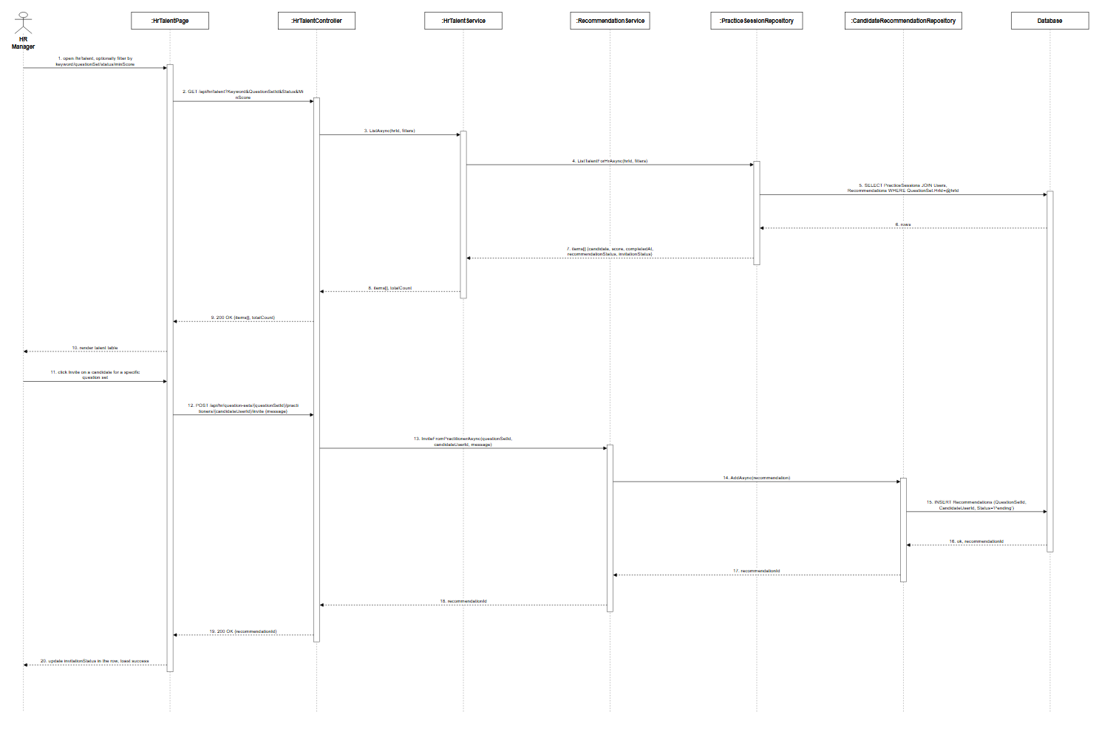
Figure 3.29.1: HR Talent Search and Invite Sequence Diagram (Link)

3.29.2 HR Candidate Overview
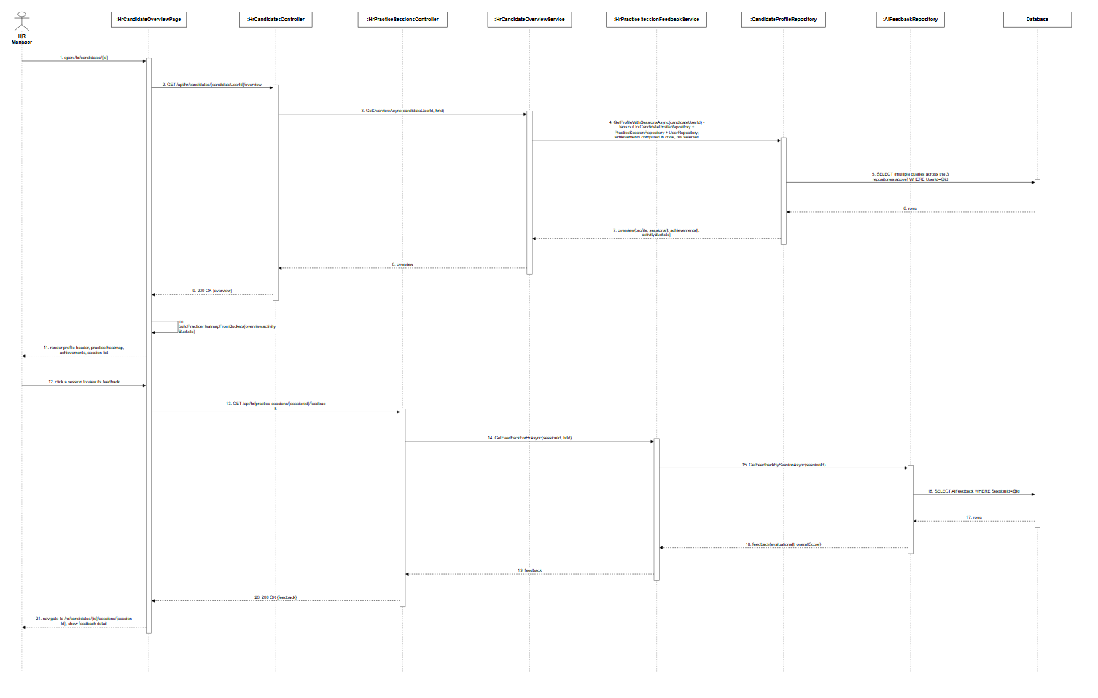
Figure 3.29.2: HR Candidate Overview Sequence Diagram (Link)

3.30.1 Candidate Dashboard
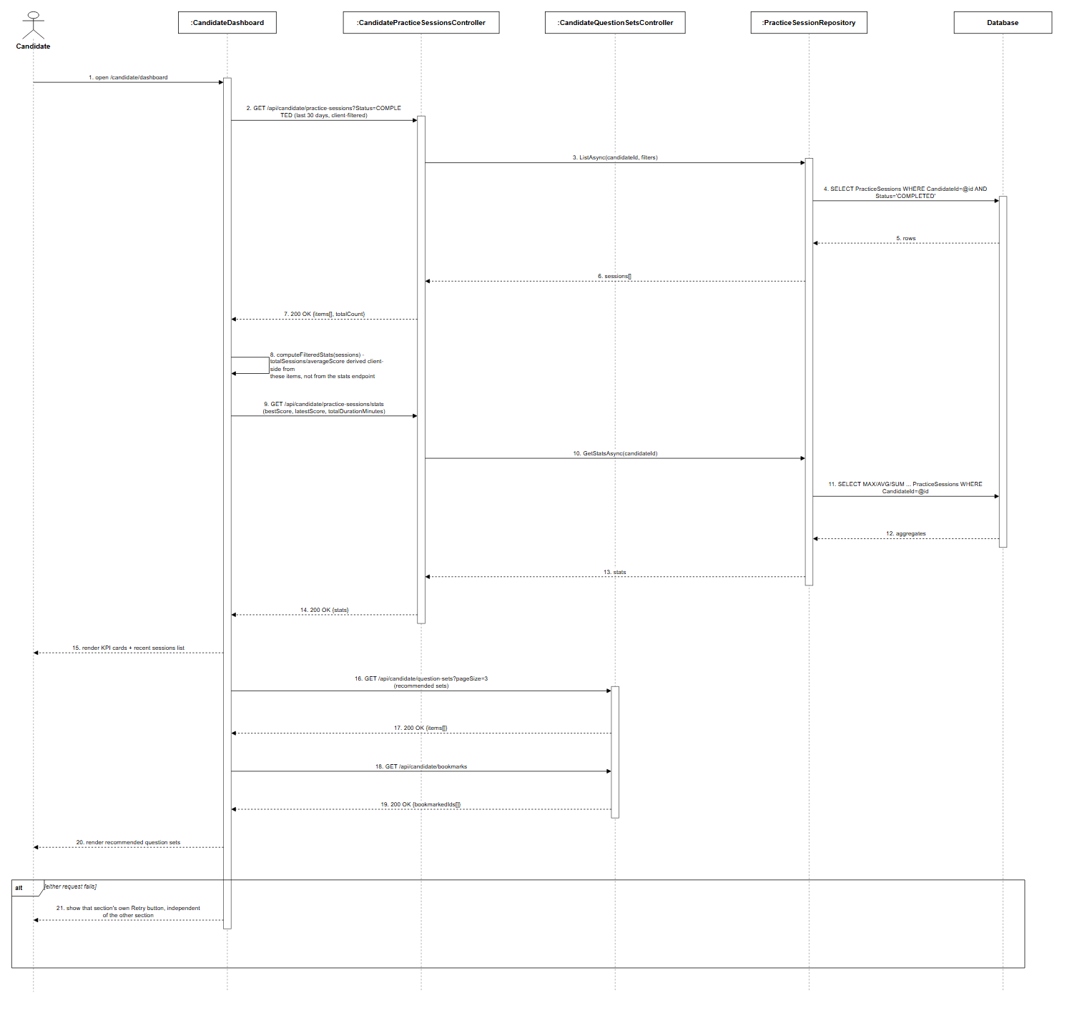
Figure 3.30.1: Candidate Dashboard Sequence Diagram (Link)

